DRAFT ORDER

ANTI-SOCIAL BEHAVIOUR, CRIME AND POLICING ACT 2014
SECTION 59

PUBLIC SPACES PROTECTION ORDER
This order is made by the London Borough of Hackney (the ‘Council’) and shall be known as the Public Spaces Protection Order (Alcohol) 2021.

PRELIMINARY
1. The Council, in making this Order is satisfied on reasonable grounds that:
The activities identified below have been carried out in public places within the Council’s area and have had a detrimental effect on the quality of life of those in the locality,
and that:
the effect, or likely effect, of the activities:
is, or is likely to be, of a persistent or continuing nature,
is, or is likely to be, such as to make the activities unreasonable, and
justifies the restrictions imposed by the notice.
2. The Council is satisfied that the prohibitions imposed by this Order are reasonable to impose in order to prevent the detrimental effect of these activities from continuing, occurring or recurring, or to reduce that detrimental effect or to reduce the risk of its continuance, occurrence or recurrence.
3. The Council has had regard to the rights and freedoms set out in the European Convention on Human Rights. The Council has had particular regard to the rights and freedoms set out in Article 10 (right of freedom of expression) and Article 11 (right of freedom of assembly) of the European Convention on Human Rights and has concluded that the restrictions on such rights and freedoms imposed by this Order are lawful, necessary and proportionate.

THE ACTIVITIES
4. The Activities prohibited by this Order are:
i. consuming, or having an open container for alcohol in the London Fields Restricted Area.
ii. failing to comply with a direction not to consume, in breach of this order, alcohol, or anything which an authorised person reasonably believes to be alcohol where the authorised person reasonably believes that a person has engaged in anti-social behaviour.
iii. failing to surrender a container of alcohol (whether open or not) when asked to do so by an authorised person.

THE PROHIBITIONS
5. A person shall not engage in any of the Activities listed at paragraph 4(i) and 4(iii) anywhere within the Restricted Area known as London Fields and marked on the map at Schedule 1 of this order and labelled “The London Fields Restricted Area”.
6. A person shall not engage in any of the Activities listed at paragraph 4(ii) – 4(iii) anywhere within the Restricted Area as shown on the map at Schedule 2 of this order and labelled “The Borough-Wide Restricted Area”.
7. This Prohibition is subject to the Exception stated below.

THE REQUIREMENT
8. A person who is believed to have engaged in a breach of this Order is required to give their name and address to a police officer, police community support officer or other person designated by the Council.

THE EXCEPTION
9. Nothing in this order shall apply to a person who a person who is consuming alcohol on premises listed in section 62 of the 2014 Act, the full text of section 62 appears at Schedule 3 of this Order.

DEFINITIONS
10. In this Order the following words or phrases are defined as follows:
‘Alcohol’ has the same meaning as in section 191 of the Licensing Act 2003, the full text of s.191 appears at the end of this Order.
‘Anti-social behaviour’ means conduct that has caused or is likely to cause nuisance, annoyance, harassment, alarm or distress to any person.
‘Authorised Officer’ means an employee or agent of the Authority who is authorised for the purpose of giving directions under this Order.
‘Council’ means the London Borough of Hackney.
‘Restricted Area’ means the parts of the London Borough of Hackney as shown on the maps at Schedules 1 and 2 of this order and labelled ”The London Fields Restricted Area” and “The Borough-Wide Restricted Area” and shaded with a red boundary line.
‘2014 Act’ means the Anti-Social Behaviour, Crime and Policing Act 2014.

PERIOD FOR WHICH THIS ORDER HAS EFFECT
11. This Order is made on [ date to be inserted ] and will come into force at midnight on [ date to be inserted ] and will expire at midnight on [ date to be inserted ].
12. At any point before the expiry of this three-year period the Council can extend the Order by up to three years if they are satisfied on reasonable grounds that this is necessary to prevent the activities identified in the Order from occurring or recurring or to prevent an increase in the frequency or seriousness of those activities after that time.

WHAT HAPPENS IF YOU FAIL TO COMPLY WITH THIS ORDER?

ALCOHOL
Section 63 of the Anti-Social Behaviour Crime, and Policing Act 2014 provides that where a constable or authorised person has reason to believe that a person has been consuming alcohol in breach of this PSPO or intends to consume alcohol in circumstances which would be a breach of this PSPO, the constable or authorised person may require that person not to consume alcohol or anything which is reasonably believed to be alcohol and/or surrender anything believed to be alcohol or a container for alcohol. Failure to comply without having a reasonable excuse is an offence. A requirement is not valid if, when asked to do to, the constable or authorised person, fails to show evidence of their authorisation. Section 62 (set out in full below) contains a list of exceptions where the ban on consuming alcohol does not apply).

CRIMINAL OFFENCE
Section 67 of the Anti-Social Behaviour Crime, and Policing Act 2014 says that it is a criminal offence for a person without reasonable excuse:
- to do anything that the person is prohibited from doing by a public spaced protection order, or
- to fail to comply with a requirement to which the person is subject under a public spaces protection order.

PENALTY
A person who is guilty of an offence under this Order shall be liable to a £100.00 Fixed Penalty Notice, or upon summary conviction to a fine not exceeding level 3 (currently £1000) on the standard scale.

APPEALS
Any challenge to this order must be made in the High Court by an interested person within six weeks of it being made. An interest person is someone who lives in, regularly works in or visits the Restricted Areas. This means that only those who are directly affected by the restrictions have the power to challenge. The right to challenge also exists where an order is varied by the Council. Interested persons can challenge the validity of this order on two grounds: that the Council did not have the power to make the order, or to include particular prohibitions or requirements; or that one of the requirements of the legislation has not been complied with. When an application is made the High Court can decide to suspend the operation of the order pending the court’s decision, in part or in totality. The High Court has the ability to uphold or quash the order or any of its prohibitions or requirements.

Schedule 1 – LONDON FIELDS - RESTRICTED AREA – MAP
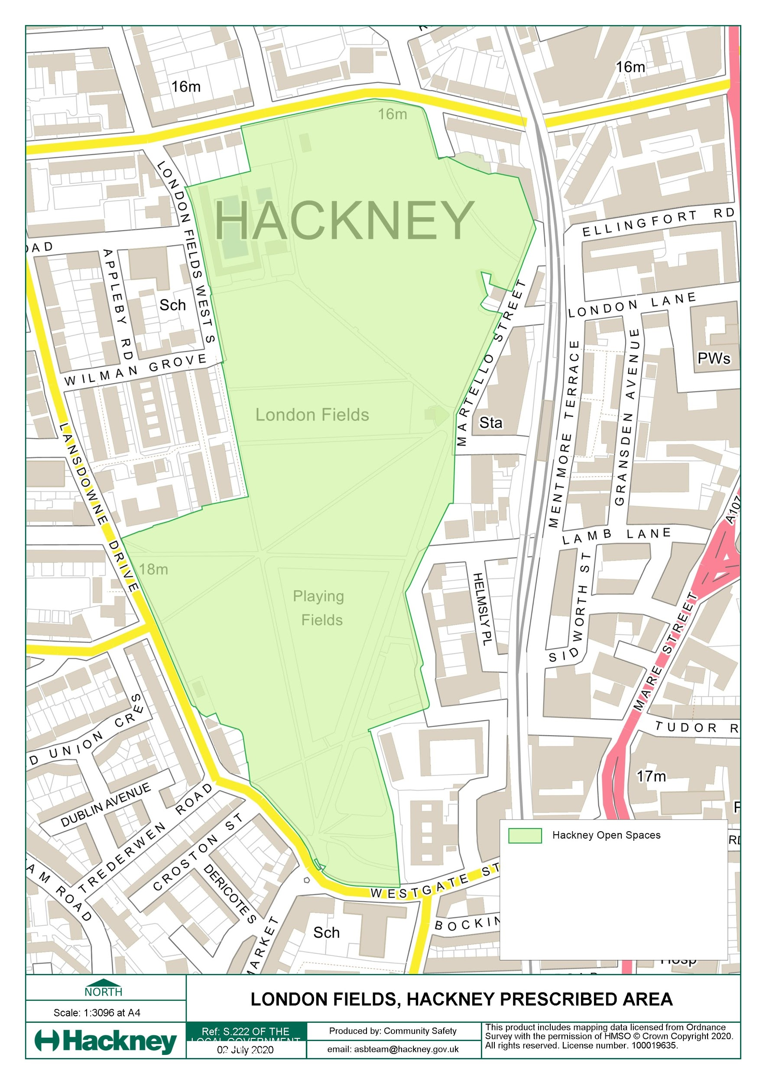

Schedule 2 – BOROUGH WIDE - RESTRICTED AREA – MAP

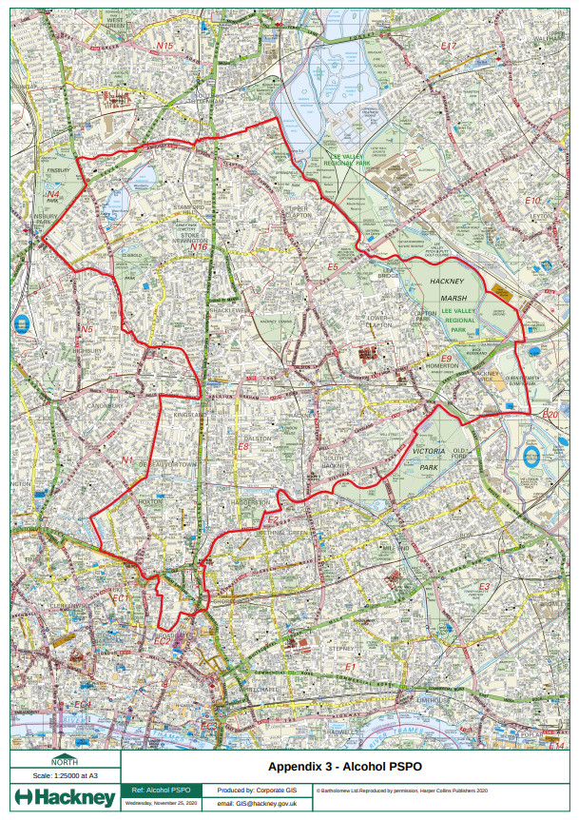

Schedule 3 - LEGISLATION

Section 62 – Anti-Social Behaviour, Crime and Policing Act 2014
Premises etc to which alcohol prohibition does not apply
(1) A prohibition in a public spaces protection order on consuming alcohol does not apply to—
(a) premises (other than council-operated licensed premises) authorised by a premises licence to be used for the supply of alcohol;
(b) premises authorised by a club premises certificate to be used by the club for the supply of alcohol;
(c) a place within the curtilage of premises within paragraph (a) or (b);
(d) premises which by virtue of Part 5 of the Licensing Act 2003 may at the relevant time be used for the supply of alcohol or which, by virtue of that Part, could have been so used within the 30 minutes before that time;
(e) a place where facilities or activities relating to the sale or consumption of alcohol are at the relevant time permitted by virtue of a permission granted under section 115E of the Highways Act 1980 (highway-related uses).
(2) A prohibition in a public spaces protection order on consuming alcohol does not apply to council-operated licensed premises—
(a) when the premises are being used for the supply of alcohol, or
(b) within 30 minutes after the end of a period during which the premises have been used for the supply of alcohol.
(3) In this section—
“club premises certificate” has the meaning given by section 60 of the Licensing Act 2003;
“premises licence” has the meaning given by section 11 of that Act;
“supply of alcohol” has the meaning given by section 14 of that Act.
(4) For the purposes of this section, premises are “council-operated licensed premises” if they are authorised by a premises licence to be used for the supply of alcohol and—
(a) the licence is held by a local authority in whose area the premises (or part of the premises) are situated, or
(b) the licence is held by another person but the premises are occupied by a local authority or are managed by or on behalf of a local authority.

Section 63 - Anti-Social Behaviour, Crime and Policing Act 2014
Consumption of alcohol in breach of prohibition in order
(1) This section applies where a constable or an authorised person reasonably believes that a person (P)—
(a) is or has been consuming alcohol in breach of a prohibition in a public spaces protection order, or
(b) intends to consume alcohol in circumstances in which doing so would be a breach of such a prohibition.
In this section “authorised person” means a person authorised for the purposes of this section by the local authority that made the public spaces protection order (or authorised by virtue of section 69(1)).
(2) The constable or authorised person may require P—
(a) not to consume, in breach of the order, alcohol or anything which the constable or authorised person reasonably believes to be alcohol;
(b) to surrender anything in P's possession which is, or which the constable or authorised person reasonably believes to be, alcohol or a container for alcohol.
(3) A constable or an authorised person who imposes a requirement under subsection (2) must tell P that failing without reasonable excuse to comply with the requirement is an offence.
(4) A requirement imposed by an authorised person under subsection (2) is not valid if the person—
(a) is asked by P to show evidence of his or her authorisation, and
(b) fails to do so.
(5) A constable or an authorised person may dispose of anything surrendered under subsection (2)(b) in whatever way he or she thinks appropriate.
(6) A person who fails without reasonable excuse to comply with a requirement imposed on him or her under subsection (2) commits an offence and is liable on summary conviction to a fine not exceeding level 2 on the standard scale.

Offences
67 - Anti-Social Behaviour, Crime and Policing Act 2014
Offence of failing to comply with order
(1) It is an offence for a person without reasonable excuse—
(a) to do anything that the person is prohibited from doing by a public spaces protection order, or
(b) to fail to comply with a requirement to which the person is subject under a public spaces protection order.
(2) A person guilty of an offence under this section is liable on summary conviction to a fine not exceeding level 3 on the standard scale.
(3) A person does not commit an offence under this section by failing to comply with a prohibition or requirement that the local authority did not have power to include in the public spaces protection order.
(4) Consuming alcohol in breach of a public spaces protection order is not an offence under this section (but see section 63).

191 – Licensing Act 2003
Meaning of “alcohol”
(1) In this Act, “alcohol” means spirits, wine, beer, cider or any other fermented, distilled or spirituous liquor in any state , but does not include—
(a) alcohol which is of a strength not exceeding 0.5% at the time of the sale or supply in question,
(b) perfume,
(c) flavouring essences recognised by the Commissioners of Customs and Excise as not being intended for consumption as or with dutiable alcoholic liquor,
(d) the aromatic flavouring essence commonly known as Angostura bitters,
(e) alcohol which is, or is included in, a medicinal product or a veterinary medicinal product,
(f) denatured alcohol,
(g) methyl alcohol,
(h) naphtha, or
(i) alcohol contained in liqueur confectionery.
(2) In this section—
“denatured alcohol” has the same meaning as in section 5 of the Finance Act 1995 (c. 4);
“dutiable alcoholic liquor” has the same meaning as in the Alcoholic Liquor Duties Act 1979 (c. 4);
“liqueur confectionery” means confectionery which—
(a) contains alcohol in a proportion not greater than 0.2 litres of alcohol (of a strength not exceeding 57%) per kilogram of the confectionery, and
(b) either consists of separate pieces weighing not more than 42g or is designed to be broken into such pieces for the purpose of consumption;
“medicinal product” has the same meaning as in section 130 of the Medicines Act 1968 (c. 67)
“strength” is to be construed in accordance with section 2 of the Alcoholic Liquor Duties Act 1979; and
“veterinary medicinal product” has the same meaning as in regulation 2 of the Veterinary Medicines Regulations 2006.

