Butterfield Green - Survey results

A small scale consultation was held at the Apple Day event in October 2014. The survey was also available on the Councils Online Consultation Site Citizen Space. In total there were 29 responses to the user survey. The consultation results were placed in the Butterfield Green Management Plan and will be used to improve the green space and inform funding applications to improve the space.

Uses

The survey has revealed that the majority of people use the site once a week.

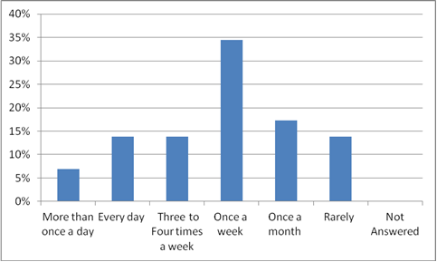

People tend to stay on site between 15 minutes and 1 hour.

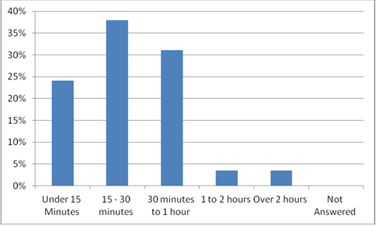

An overwhelming number of respondents live within one mile of the park, revealing the space as a true neighbourhood park.

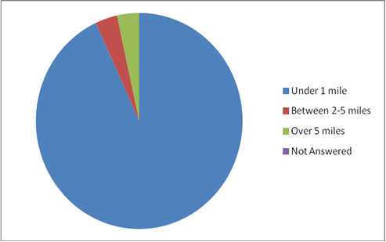

The main reasons for using Butterfield Green is for a walk (83%) the other reasons are shown below;
For a walk | 83%
To relax | 41%
Walk the dog | 3%
Visit the play area | 34%
Take a short cut | 38%
Picnic | 3%
To keep fit | 7%
To use Sport facilities | 3%
Meeting friends | 14%
Attend an activity | 7%
Running | 0%
To enjoy nature, fresh air and wildlife | 45%
Educational activity | 0%
Volunteering | 10%
Other | 10%

For a walk | 83%
To relax | 41%
Walk the dog | 3%
Visit the play area | 34%
Take a short cut | 38%
Picnic | 3%
To keep fit | 7%
To use Sport facilities | 3%
Meeting friends | 14%
Attend an activity | 7%
Running | 0%
To enjoy nature, fresh air and wildlife | 45%
Educational activity | 0%
Volunteering | 10%
Other | 10%
For a walk | 83%
To relax | 41%
Walk the dog | 3%
Visit the play area | 34%
Take a short cut | 38%
Picnic | 3%
To keep fit | 7%
To use Sport facilities | 3%
Meeting friends | 14%
Attend an activity | 7%
Running | 0%
To enjoy nature, fresh air and wildlife | 45%
Educational activity | 0%
Volunteering | 10%
Other | 10%

Likes
Respondents were asked what they like most about Butterfield Green, the word cloud below shows the most frequently mentioned likes;
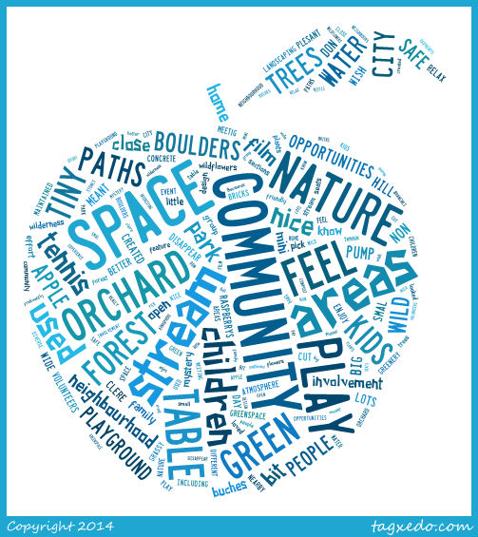

Dislikes
Respondents were asked what they do not like about Butterfield Green, the word cloud below shows the most frequently mentioned dislikes.

Future improvements

When people were asked what improvements they would like to see in Butterfield Green there was general enthusiasm for increased sport facilities of a trim trail (41%) and outdoor gym (48%) and also a climbing wall (31%). 48% of respondents would also like to see improved planting at Butterfield Green.

 | For a walk |  | 83%
 | To relax |  | 41%
 | Walk the dog |  | 3%
 | Visit the play area |  | 34%
 | Take a short cut |  | 38%
 | Picnic |  | 3%
 | To keep fit |  | 7%
 | To use Sport facilities |  | 3%
 | Meeting friends |  | 14%
 | Attend an activity |  | 7%
 | Running |  | 0%
 | To enjoy nature, fresh air and wildlife |  | 45%
 | Educational activity |  | 0%
 | Volunteering |  | 10%
 | Other |  | 10%
For a walk |  | 83%
To relax |  | 41%
Walk the dog |  | 3%
Visit the play area |  | 34%
Take a short cut |  | 38%
Picnic |  | 3%
To keep fit |  | 7%
To use Sport facilities |  | 3%
Meeting friends |  | 14%
Attend an activity |  | 7%
Running |  | 0%
To enjoy nature, fresh air and wildlife |  | 45%
Educational activity |  | 0%
Volunteering |  | 10%
Other |  | 10%

 | For a walk |  | 83%
 | To relax |  | 41%
 | Walk the dog |  | 3%
 | Visit the play area |  | 34%
 | Take a short cut |  | 38%
 | Picnic |  | 3%
 | To keep fit |  | 7%
 | To use Sport facilities |  | 3%
 | Meeting friends |  | 14%
 | Attend an activity |  | 7%
 | Running |  | 0%
 | To enjoy nature, fresh air and wildlife |  | 45%
 | Educational activity |  | 0%
 | Volunteering |  | 10%
 | Other |  | 10%
For a walk |  | 83%
To relax |  | 41%
Walk the dog |  | 3%
Visit the play area |  | 34%
Take a short cut |  | 38%
Picnic |  | 3%
To keep fit |  | 7%
To use Sport facilities |  | 3%
Meeting friends |  | 14%
Attend an activity |  | 7%
Running |  | 0%
To enjoy nature, fresh air and wildlife |  | 45%
Educational activity |  | 0%
Volunteering |  | 10%
Other |  | 10%

