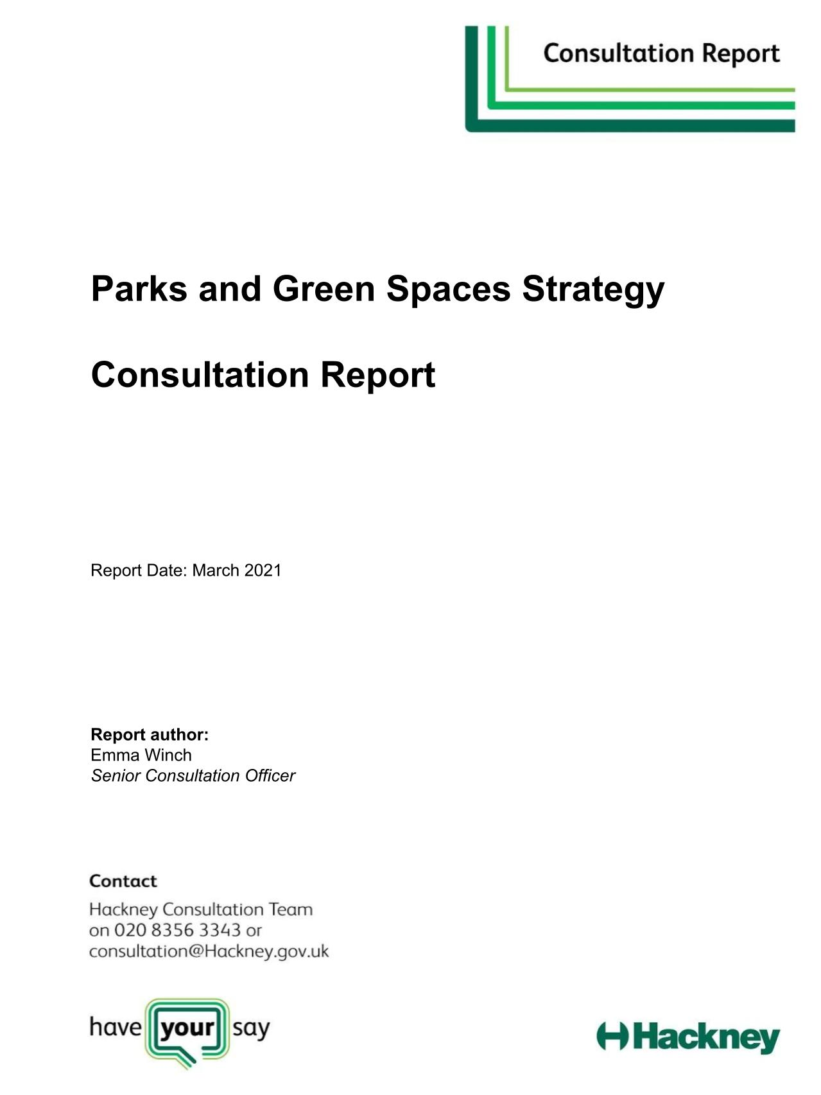

Contents

Introduction and project background 2
Purpose of report 2
The need for a new strategy 2
Drafting the new strategy: the process 3
Key objectives for draft strategy consultation 5

Section 1: Consultation and engagement 6
Consultation and COVID-19 6
Consultation overview 7
Consultation methods 8
Section 2: Data collection methodology 9
Online survey 9
Focus group, sessions and other data collection methods 10
Key highlights and messages identified in the consultation data 12

Section 3: Citizen Space survey responses 13
Local parks and green spaces 14
Responses to the vision and focus of the strategy 16
Responses to the strategy commitments 18
Responses to the strategy themes and other comments 19

Section 4: Key themes emerging from the data 23
Environmental sustainability 24
Community involvement 25
Other themes emerging from the data 26

Section 5: Focus groups and other feedback 36
Who took part? 36
What we asked people and what they told us 38
Quick polls and emailed feedback 46

Section 6: Drafting the final strategy 47
Feedback about the strategy approach 47
Updating the strategy 48

Introduction

Purpose of this report

Hackney Council has not had a Parks and Green Spaces Strategy since 2013. In 2019 it was agreed that a new strategy was needed to guide the work of the Parks and Green Spaces Service over the next ten years.

This report summarises the engagement methods and feedback received during the Hackney Parks and Green Spaces draft strategy consultation which launched on 16/11/2020 and closed on 18/01/2021.

The report sets out how the Council engaged with a wide range of residents, staff, stakeholders, and local communities to hear the views and feedback of 645 participants who completed the online questionnaire, 307 who took part in focus groups, polls or via other online methods and 15 who responded by email or in phone surveys.

During the 6 week consultation, 967 people participated in the consultation and the comments, data and insight they shared with us are analysed in this report.

Hackney Parks and Green Spaces Strategy 2021 - 2031

Project background

The need for a new strategy

The world is a very different place since the last Parks and Green Spaces Strategy was in place, specifically:

- Technology has changed. People are using electric bikes, electric scooters and drones in our parks and green spaces. Affordable electric strimmers, leaf blowers and electric vehicles are all now available. Mobile phones enable quicker, more efficient communication with park users, but users in turn often expect quicker responses.
- There is a greater focus on sustainability. Hackney Council declared a climate emergency in 2020, and our residents are increasingly concerned about air pollution, the use of chemicals, single use plastics and the loss of biodiversity.
- People are using our parks and green spaces differently. There has been an increase in cyclists, in professional dog walkers and people using outdoor gym equipment.
- As Hackney’s population continues to grow and it becomes an increasingly desirable place to live, work and visit, the pressure on its parks and green spaces has grown. The increase in use of our parks and green spaces often means more litter, more damage to facilities, greater compaction of the ground and higher operating costs.
- Coupled with an increase in use, austerity has meant that we need to think differently about how our service is delivered. We may need to work more in partnership with volunteer groups to help look after our green spaces, and look at alternative income generation models to maintain our existing high standards.
- The integration of Hackney’s Parks and Green Spaces Service with the Housing Grounds Maintenance Service is due to be undertaken in 2021. A strategy is required to provide direction to the joint service, with commitments that cover both services, and that recognise that all Parks and Green Spaces in Hackney are part of a wider network of green infrastructure.

Drafting the new strategy: the process

Stage One: Rethinking Parks and Green Spaces focus group (December 2019)

Starting with a blank page, a focus group of residents, staff, young people and subject experts helped us discuss, debate and decide the topics the new strategy needed to cover. The focus group told us what they loved about parks and green spaces, the challenges they experienced in parks and green spaces, their ideas and solutions for some of the issues they had experienced or identified and the changes they would like to see over the next ten years. The focus group also suggested who we should be speaking to, how and where we should be hearing from them and the themes and issues we should be asking people about.

Stage Two: Research and engagement (January - March 2020)

During this period we read everything that was shared with us, and organised over 50 meetings and focus group sessions with key staff, stakeholders and local people. We continued with the ‘blank page’ approach to these meetings, meeting people and hearing their ideas they have for improving parks and green spaces with and for residents.

Some of the people and groups we met and heard from during this stage were:

- Hackney Youth Parliament
- Residents
- Climate, biodiversity & environmental sustainability campaign groups
- Local growers and gardening groups
- Sports and leisure groups
- Housing and Grounds Maintenance
- National Lottery Heritage Foundation
- Park User Groups
- Colleagues in Planning, Heritage and Culture, Public Health, Events, Policy
- Park staff
- Politicians
- Play specialists
- Trainees and apprentices
- Regeneration Officers
- Sports clubs / sports officers
- Volunteering organisations
- Hackney Dementia Alliance
- HitSquad (Health Integration Team) providers/parents/carers of SEND children

These meetings and the insight, feedback and ideas that were shared about Hackney’s parks and green spaces helped us create a draft vision and set of commitments.

Stage Three: The draft strategy (March - October 2020)

We distilled everything that people told us and created a first draft of the strategy. The draft contained 30 commitments grouped under three themes - ensuring our communities are more actively involved in our parks, ensuring that our parks and green spaces are activated, and ensuring that the service is more environmentally sustainable.

The strategy was designed from the outset to be concise, readable and attractive. It relies heavily on graphics to make it an accessible document that the public will engage with and is focused largely on the actions that we will implement over the next ten years.

Stage Four: Consultation on the draft strategy
(November 2020 - January 2021)

The public consultation was designed to test the strategy - to check we’d heard people right and to identify gaps in the vision, focus, chapters and commitments.

Although the pandemic changed the way we undertook engagement, we were able to adapt and meet with large numbers of people virtually.

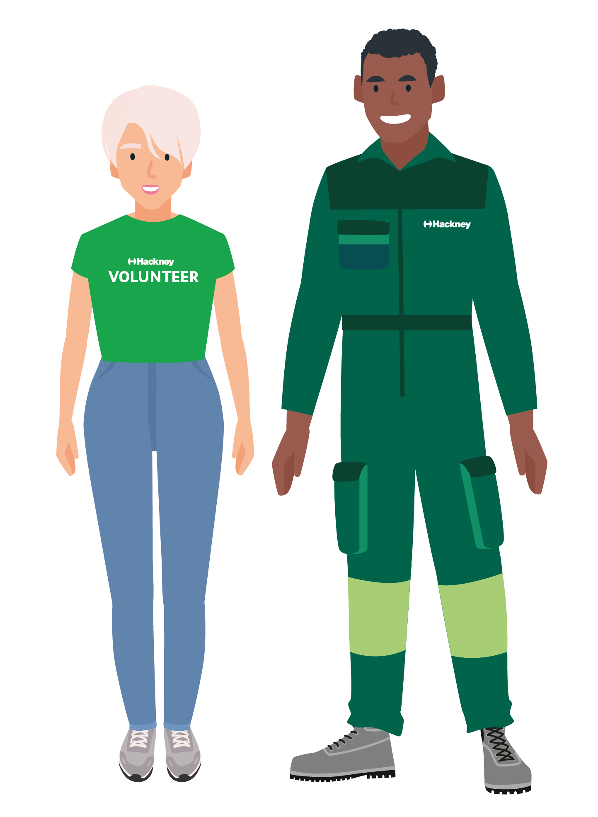

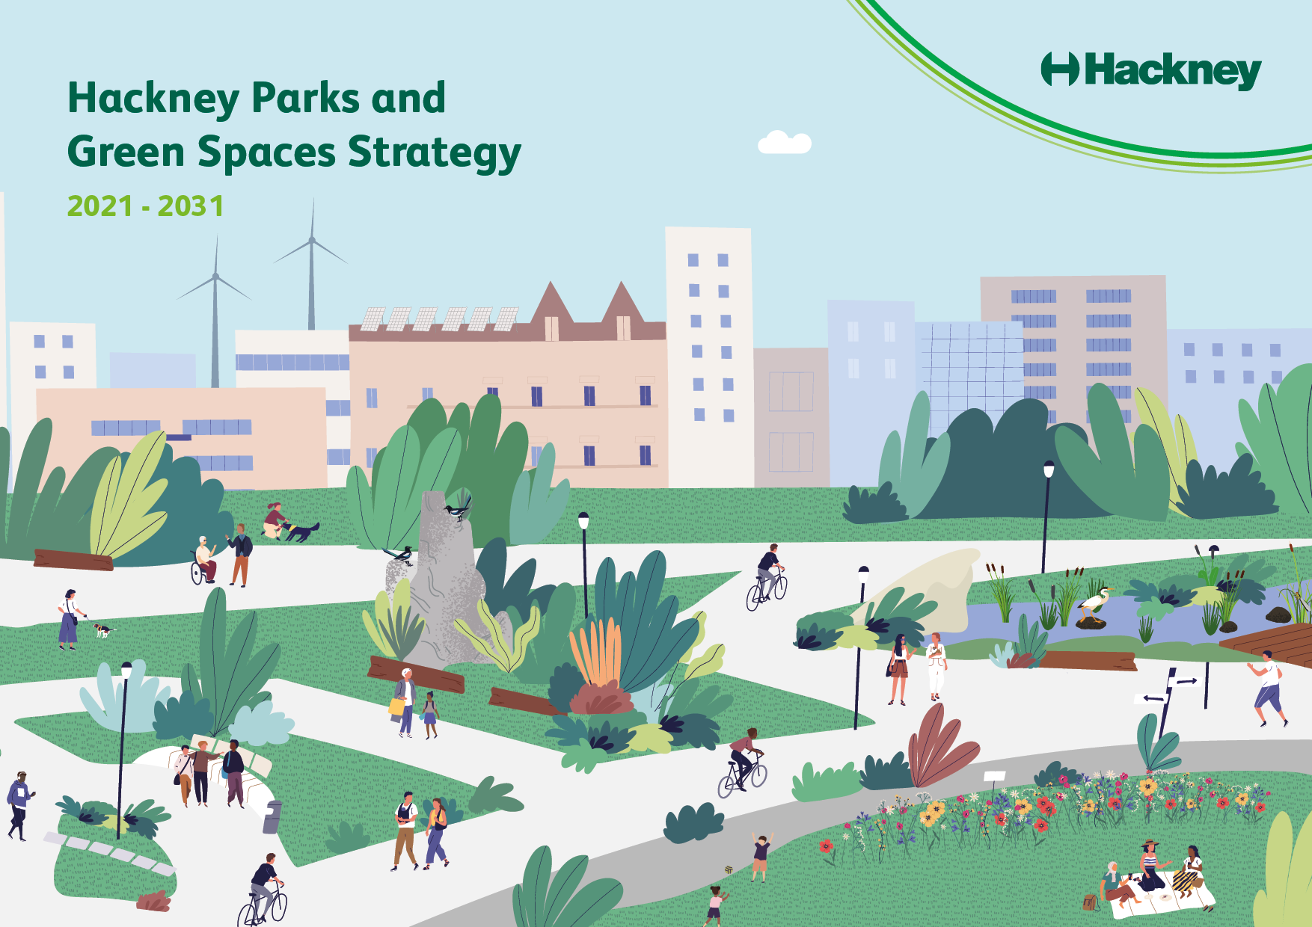

Fig: Front page of Hackney's draft Parks and Green Spaces Strategy

Key objectives for the draft strategy consultation

The vision and commitments in the draft strategy were co-developed during a period of research and engagement that lasted over 3 months and took into account the views and priorities of a wide range of residents, stakeholders and staff we engaged in the process and the insight obtained through evidence based studies conducted in Hackney over the past 3 years. During consultation we wanted to ask for feedback on the draft strategy, to check we had heard people right, to identify gaps we might need to address and to give people a blank page to tell us their own ideas, views and priorities for parks and green spaces over the next ten years.

The key themes of the draft strategy and the three areas we wanted to consult on were:

1. Community involvement

This theme covers people’s ideas about how they want to be involved and making them more appealing for a wider range of people.
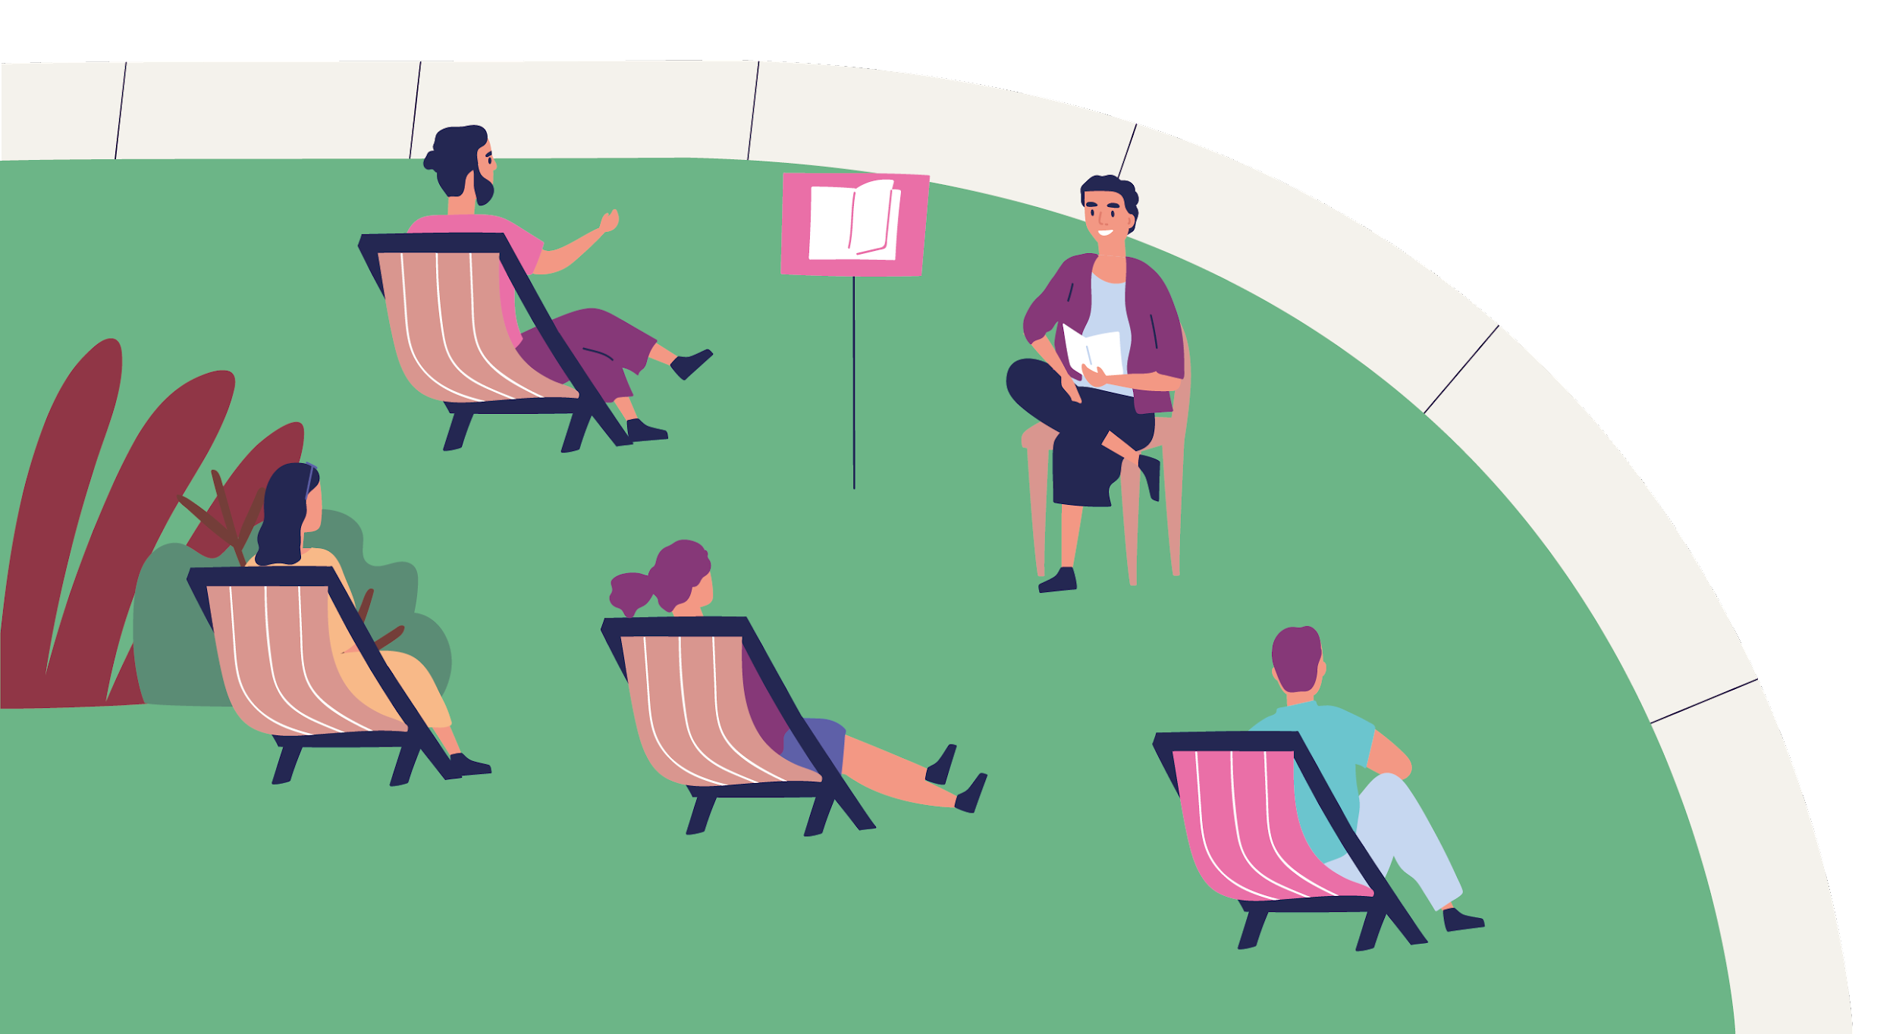 | 2. Activating parks and green spaces  This theme covers people’s ideas about what should happen in parks and green spaces - from activities and events to park design.
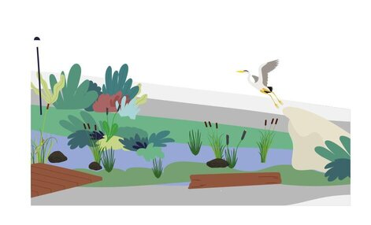 | 3. Environmental sustainability  This theme covers people’s views about nature, biodiversity, trees and planting, environmental initiatives and learning about nature.

Section 1: Consultation and Engagement

Consultation and COVID-19

Work to develop the strategy and the timescales of the project were hugely affected by COVID-19. In March 2020 we were forced to cut the engagement phase short and reorder the work. The original pre-COVID plans, which included filming, park events, stalls, creative outdoor engagement and a conference all had to be stopped.

Under normal circumstances a park consultation of this scale would have been launched in summer when people are using the parks, but two major lockdowns meant that public consultation had to take place during winter and Christmas holidays.

Risk management

COVID-19 meant that there was a risk that the consultation couldn’t go ahead. To mitigate against that we took the following measures:

- Where we could, we moved all face to face engagement we had planned online
- Where we could, we supported partners and stakeholders to run consultation sessions and conducted telephone surveys and quick polls on our behalf.
- We extended the engagement period to draft the strategy during the first lockdown
- We extended the consultation period to six weeks
- No paper surveys were sent out to ensure we weren’t making people leave their homes unnecessarily - we responded to 2 requests for printed and large print copies by sending them in the post
- Banners and posters signposted people online with the key info and quick-scan QR codes to ensure we weren’t causing people to gather around banners or posters
- We wrote an EIA statement and revised consultation plan to ensure the process would still be accessible to all.

Issues and challenges

Despite the measures put in place to mitigate against these risks, midway through the consultation the UK went into a third full lockdown. This led to a number of new challenges and, as a result:

- Online sessions with many schools and partners were cancelled due to a second lockdown and school closures in January. This meant that, even with our revised online consultation plan, we couldn’t hear from children and young people on the scale we had planned to.
- The social media campaign we were able to run was limited because of the risk of conflicting with important public health messages during lockdown.
- During the consultation there were frequent mentions of lockdown (52), COVID (41) and the pandemic (27). Even when people didn’t specifically mention the pandemic, the issues people raised often linked to the unprecedented pressures put on parks and green spaces during the summer and the issues exacerbated by lockdown such as - overcrowding, increased antisocial behaviour, litter, increase in exercisers. A full summary of what people told us about parks and the pandemic is in Section 4: Key themes.

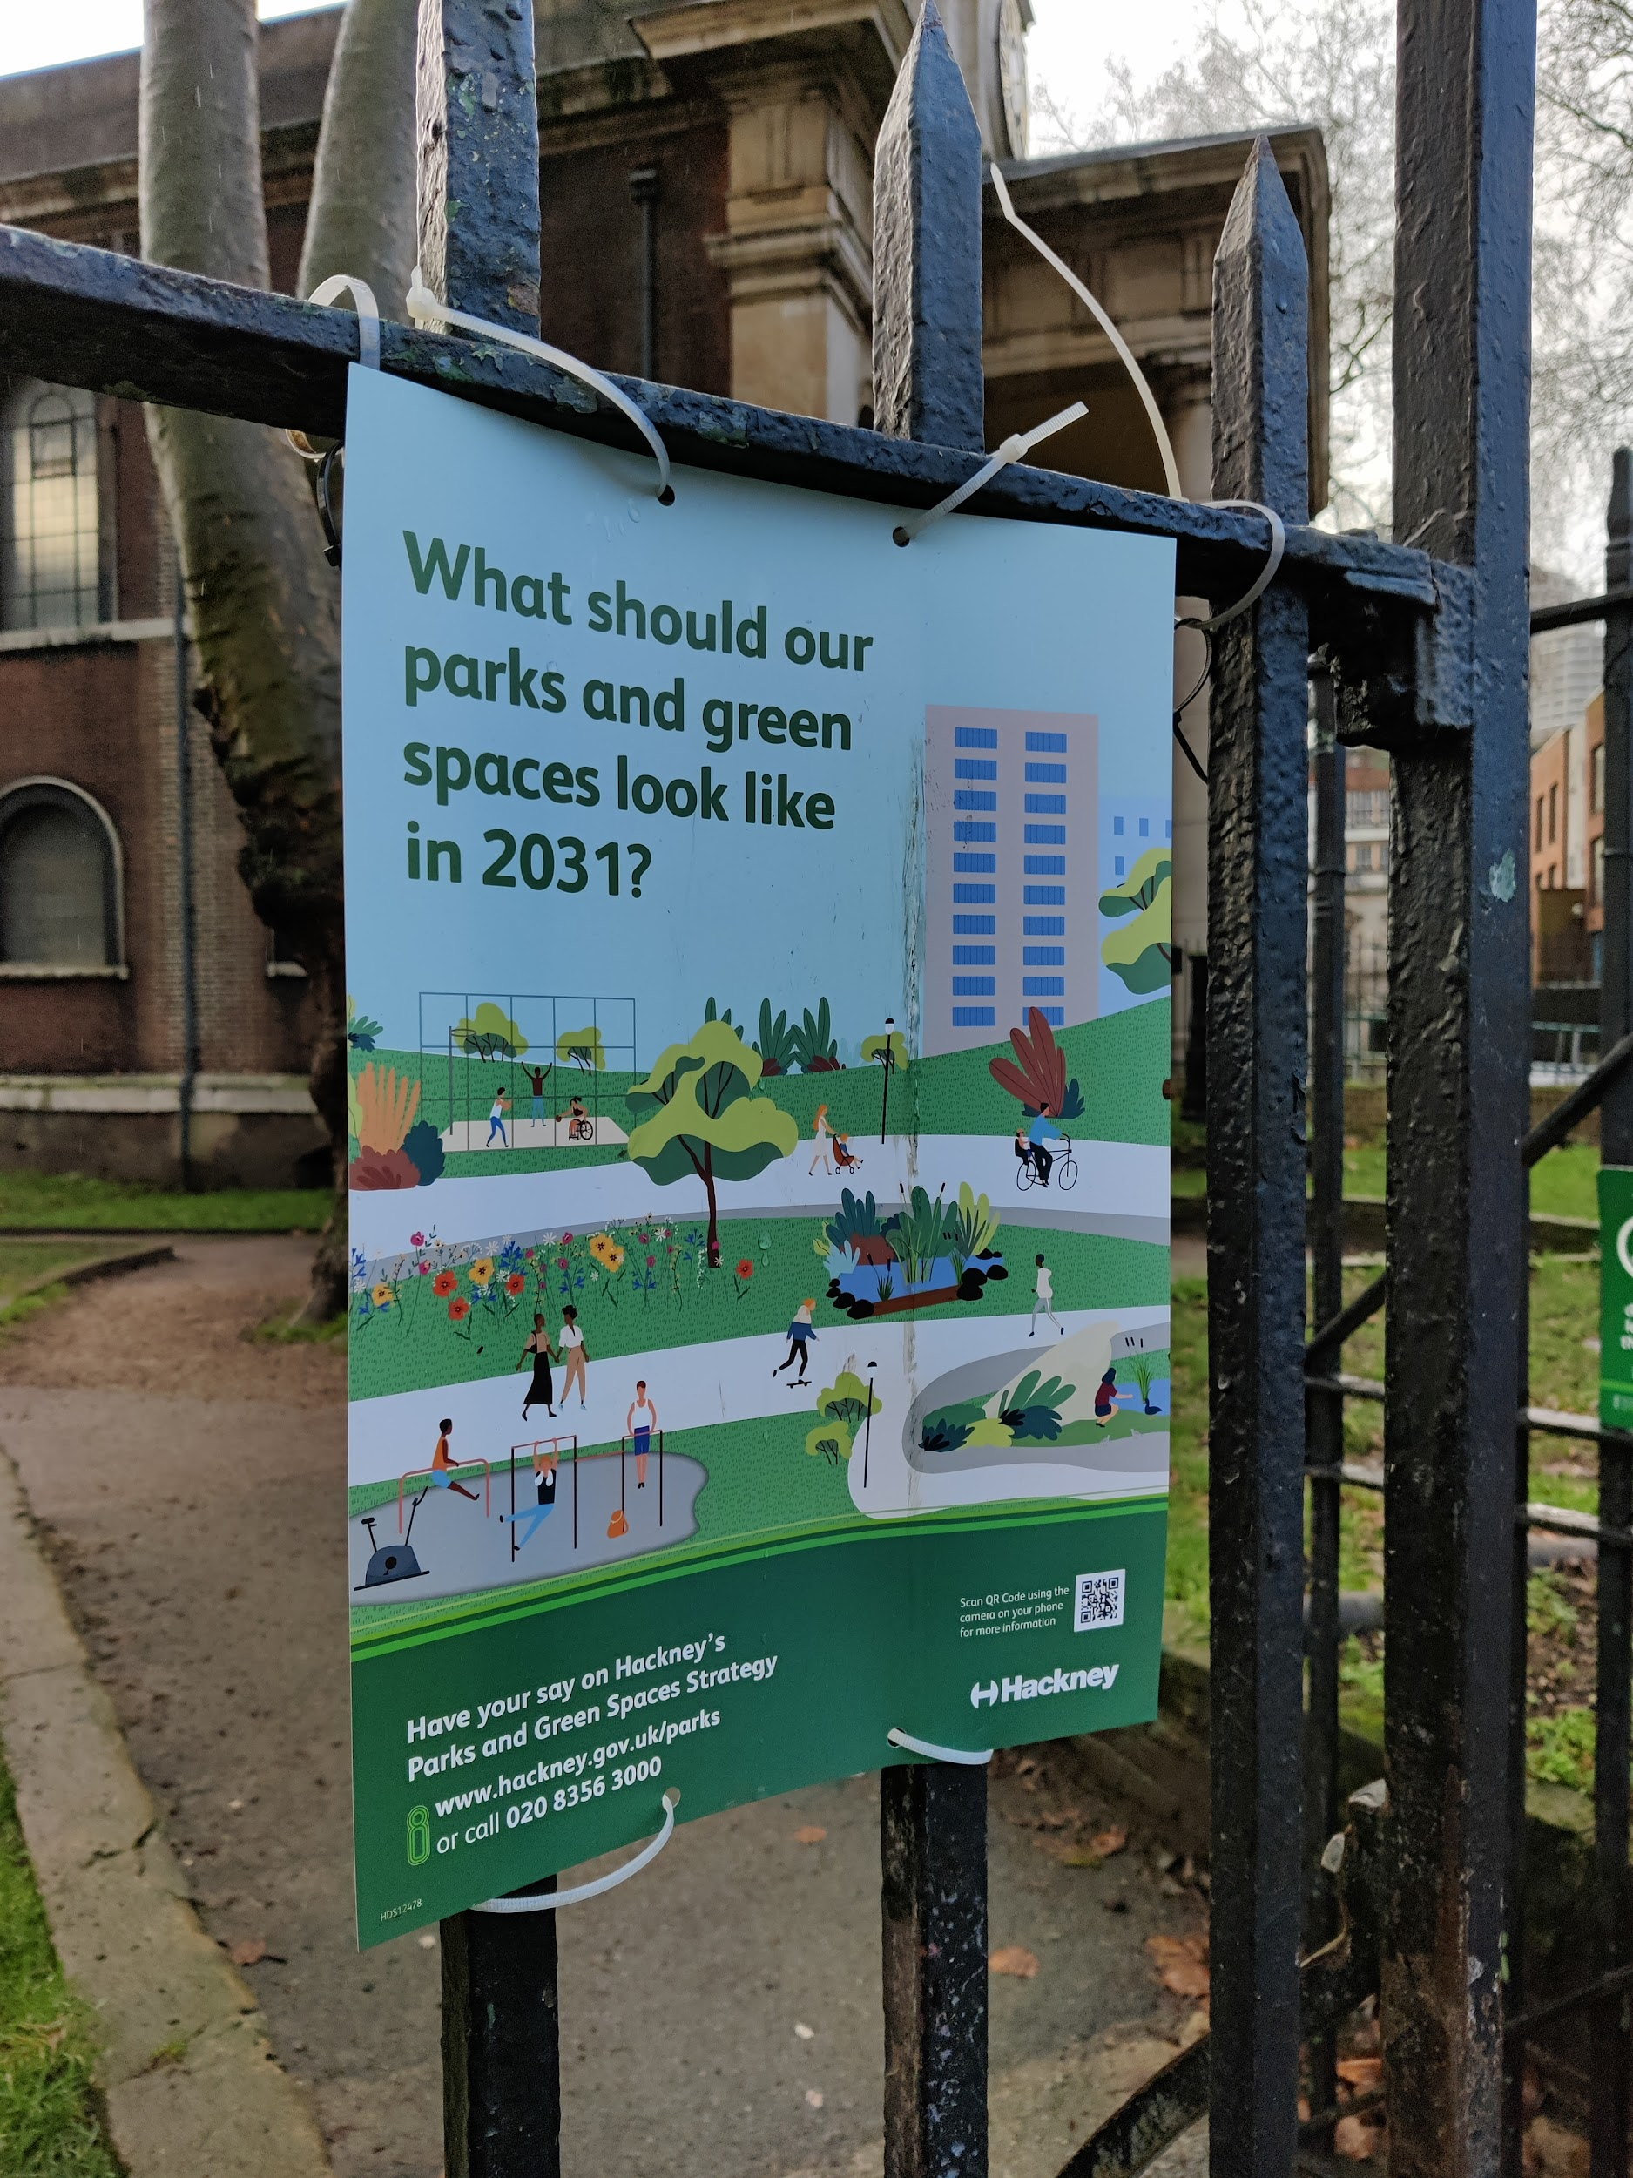
Consultation overview

The borough wide public consultation was launched on 16/11/2020 and closed on 18/01/2021, running for a period of six weeks.

Despite the challenges presented to us by COVID-19 and the time of year, the consultation was a huge success.

967 people participated in total.

645 participants completed the online questionnaire, 307 took part in focus groups, polls or via other online methods and 15 responded by email or in phone surveys. 361 signed up to the Parks and Green Spaces Newsletter.

The comments, data and insight they shared with us are analysed in the report.
Fig: Posters advertising the consultation went on park
railings and housing estate noticeboards

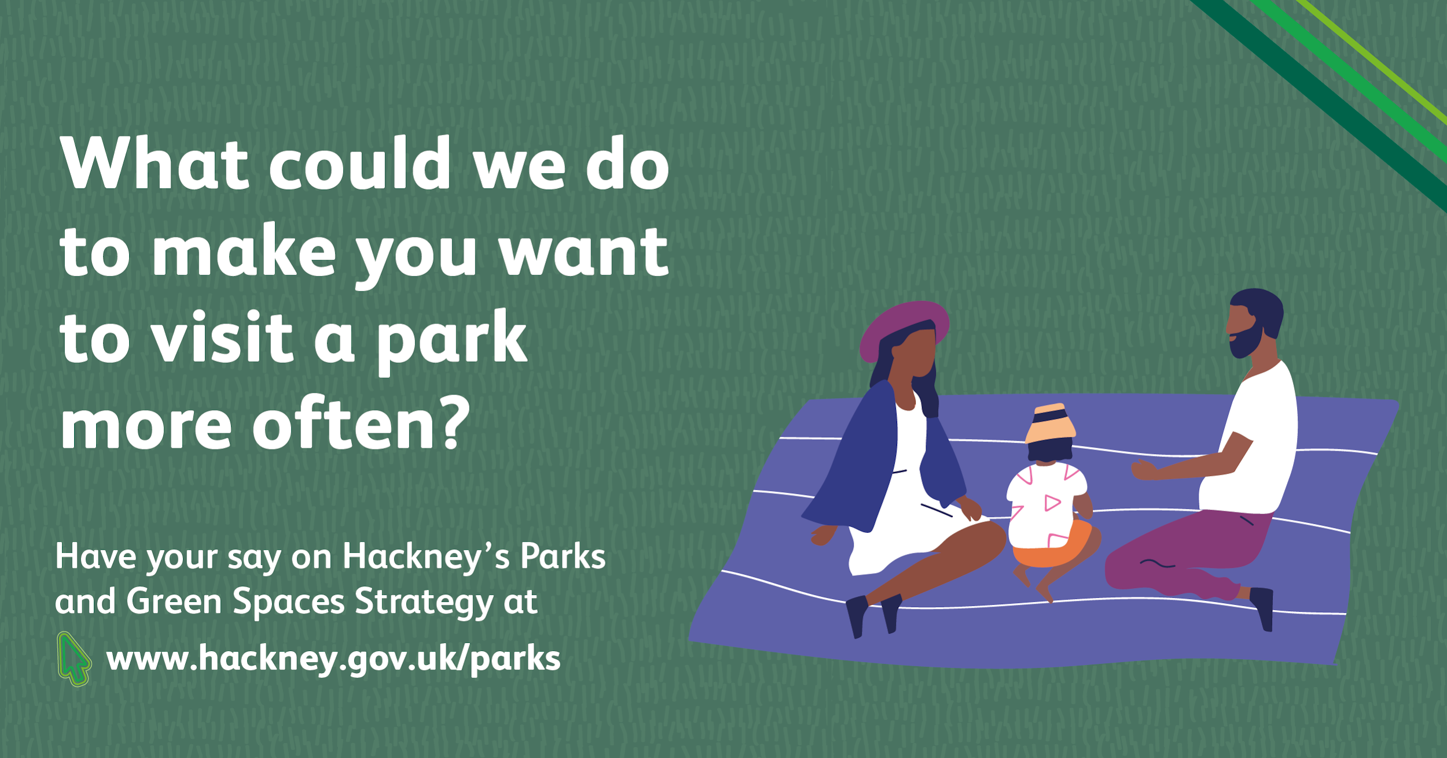

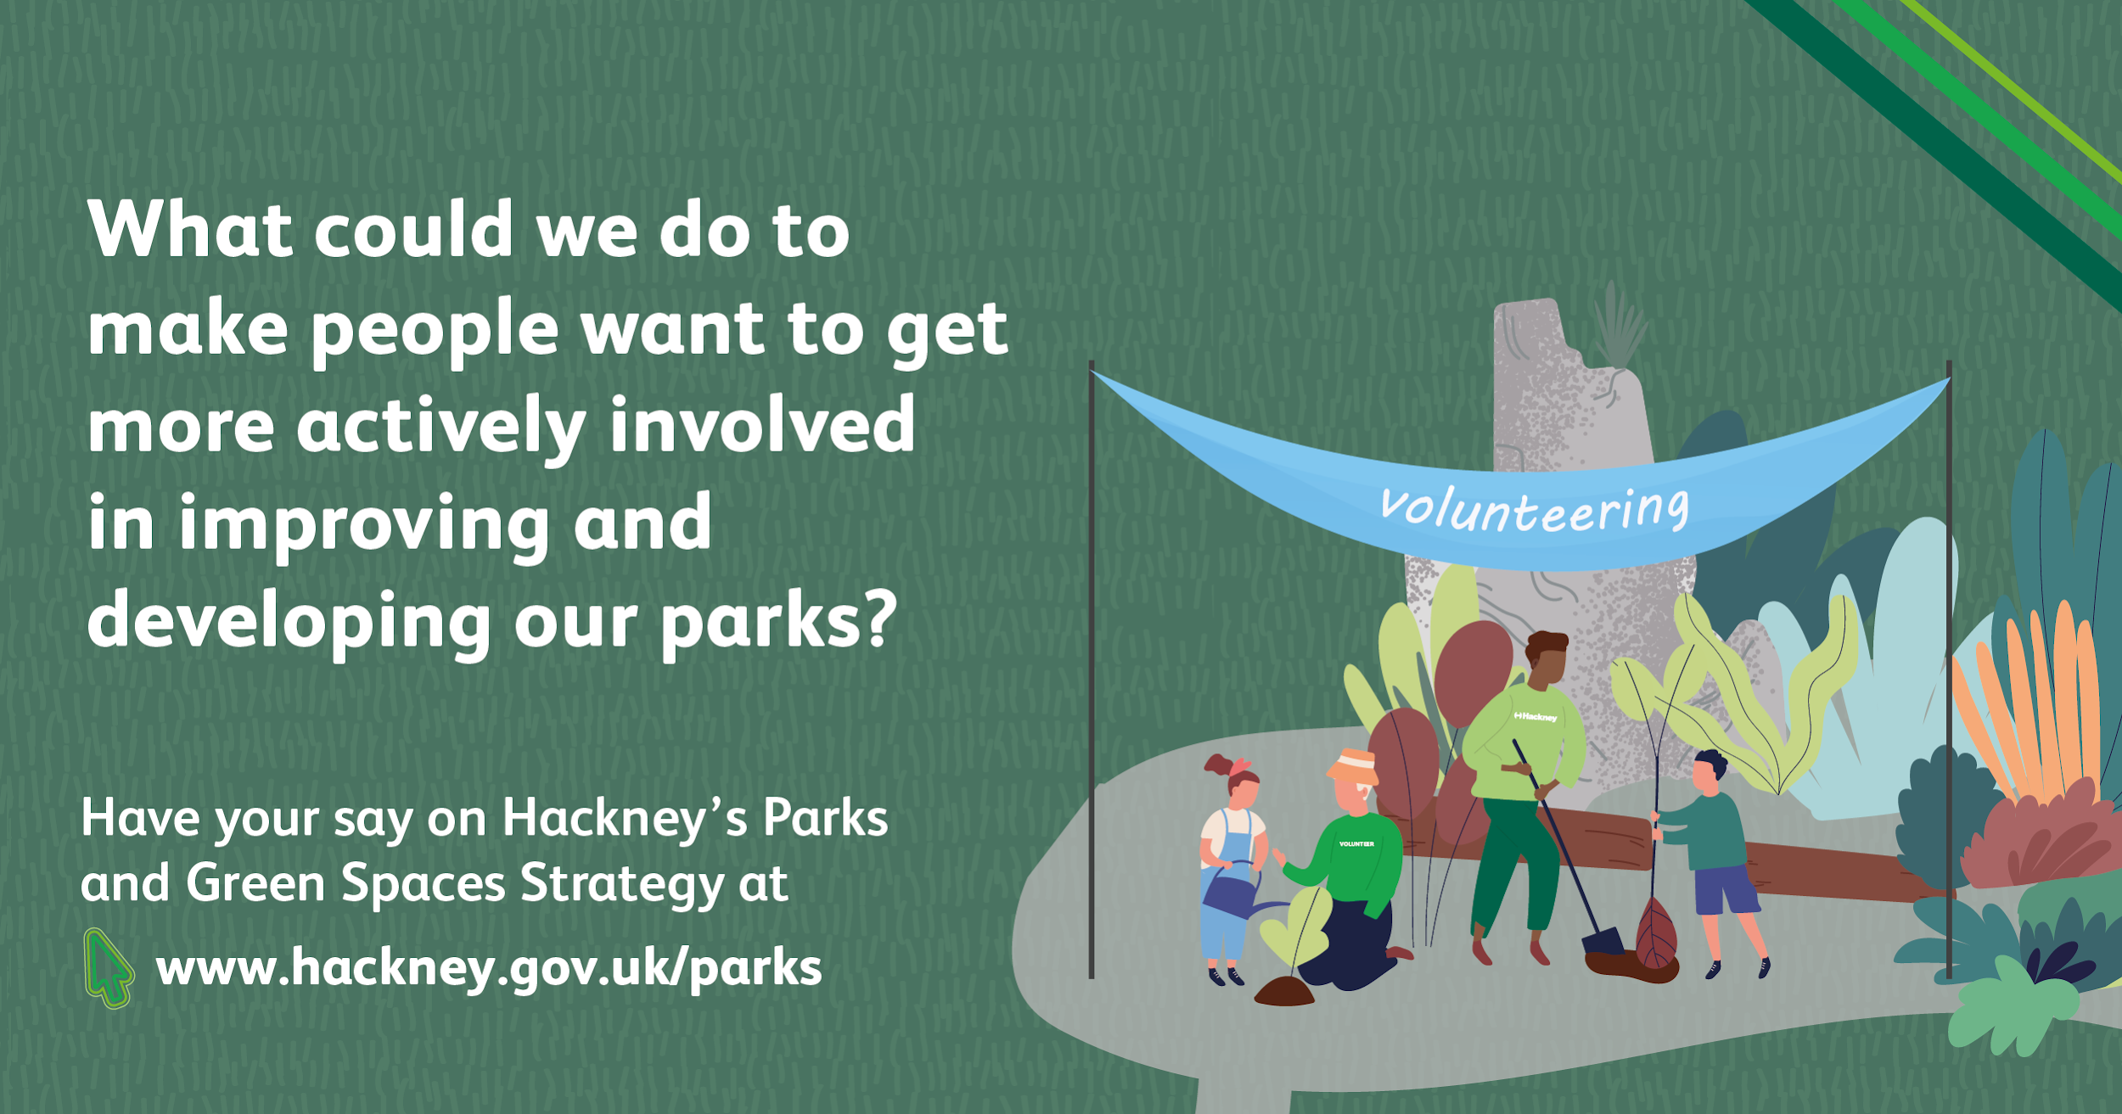
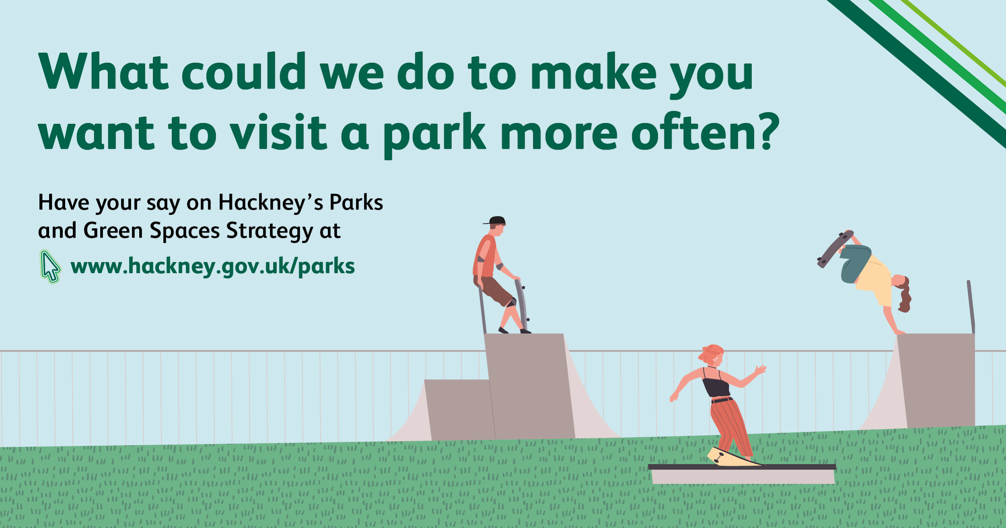

Fig: Digital advertisements for the consultation were posted on social media

Consultation methods
The consultation methods we used are set out below:

- Citizen Space: The draft strategy document and questionnaire were available digitally on the Citizen Space website, the Council’s primary consultation platform. People could read the strategy and answer a number of questions about it.
- Printed: 8ft x 4ft banners and A3 and A4 posters were erected in parks and housing estate noticeboards signposting people to the online consultation.
- Social media: Hackney Council tweets were shared by ward Cllrs, the Cabinet Member, Mayor, park user groups, friends groups and campaign groups. Paid advertisements were taken out on Facebook and Instagram and targeted at residents, businesses or those who had logged onto local wifi networks or had tagged themselves in the locality.
- Internal comms: The draft strategy consultation was advertised on the intranet page, staff headlines and in the parks and leisure staff newsletter urging staff to have their say and to share the consultation info with their networks
- Email: A launch email was sent to participants of focus groups, meetings and 994 people on the Parks and Green Spaces Mailing list. We also sent newsletter items out through: Hackney Business Network, Connect Hackney, Hackney Circle, Greener Hackney and Hackney Matters.
- Website: Information about the draft strategy and links to the survey were published on the Parks and Green spaces page of the Council’s website.
- Press: An article was published in the Council's free Hackney Life newspaper, which was distributed to properties across the Borough. The piece included information about how the residents could participate in the consultation. The launch of the consultation also appeared in the Hackney Gazette and there were two articles in Hackney Citizen.
- Cabinet members: In the initial stages of producing the draft strategy, officers attended meetings with the lead Cabinet Members and the Mayor of Hackney.
- Focus groups: Where we could, and where we had the support of partners, focus groups and sessions with residents and target groups were moved online. A partnership with Growing Up in Hackney led to the co-facilitation of a number of successful online sessions. Focus groups were a combination of questions and discussions, quick polls, and map based engagement.

Section 2: Data Collection Methodology

Online survey
The primary method we used to collect data was Hackney’s online consultation platform, Citizen Space.

Designing the consultation survey

The online survey was designed to check that we had got the focus of the strategy right and participants agreed with the draft vision and commitments. We asked specific questions to identify gaps and missing priorities, but also included lots of open text questions to give participants an opportunity to tell us their own views, ideas and priorities.

Hackney’s online strategy consultations have traditionally had a really low response rate (an average of 35 participants per consultation). With this in mind, and with the engagement restrictions placed upon us by COVID-19, we anticipated having to rely heavily on low numbers of online responses providing the detailed feedback we needed. For this reason we allowed for a much higher proportion of open text responses than you normally would for a strategy consultation.

Strategy | Online participants | Date Closed
Parks and Green Spaces Strategy | 645 | 2021
Ageing Well Strategy | 34 | 2020
Inclusive Economy Strategy | 6 | 2019
Single Equalities Strategy | 35 | 2018
Community Strategy | 28 | 2018
Hate Crime Strategy | 69 | 2018

Fig: Most recent strategy online consultation figures for comparison

What we asked participants

Participants answered 9 blank page questions and 2 multiple choice questions.

Open text / visioning questions

- What is the name of your local park or green space?
- Have we got the focus right? If, no why?
- Have we got the vision right? If no, why?
- What could we do to make people want to get more actively involved in improving and developing our parks and green spaces?
- What could we do to make you want to visit parks and green spaces more often?
- How could parks and green spaces be more environmentally sustainable?
- What commitments should we prioritise and are there missing commitments?
- What ‘other issues’ are you concerned about?
- What ‘other comments’ do you have?

Multiple choice questions

- How do you feel about parks and green spaces in Hackney overall?
- What are the three top issues affecting your local park or green space?

Focus groups, sessions and other data collection methods
A diverse range of people live in Hackney and during consultation we needed to use a range of data collection methods to capture and understand the complexity of experiences, opinions and views. Our pre-COVID consultation plan included workshops, sessions,outdoor events and focus groups in schools, community centres and parks. We did our best to move these online where we could, but this was not always possible for the reasons outlined in Section One: Consultation and Engagement (Consultation and COVID-19).

We delivered sessions ourselves, supported partners to conduct surveys and sessions with their groups, and worked with internal and external partners to organise co-facilitated workshops. In total 307 local people participated in focus group sessions, meetings and provided feedback via other methods, which included:

Online focus group sessions

- Apprentices, trainees and new starter apprentices (48)
- East London Advanced Technology & Training (ELATT) College students (25)
- Xenia migrant women group (20)
- Hackney Matters Citizen Panel (9)
- Shoreditch Park Primary School Council (4)
- Project Indigo LGBTQI+ Young People (10)
- Hackney Parks Forum / Park User Groups (29)
- Hackney Biodiversity Partnership (33)

Online focus group and feedback sessions delivered with partners

- Connect Hackney & Age Concern (10) with Growing Up In Hackney
- Connect Hackney & Hackney Youth Parliament (8) with Growing Up In Hackney
- Resident Liaison Group (20) with Resident Participation Team
- Stroke Survivors Group (2) with Shoreditch Trust
- Hackney Marsh Adventure Playground (12) with Young Hackney
- Healthy Weight Partnership Meeting (16) with Public Health
- Health and Wellbeing Board Meeting (24) with Public Health
- Kings Park Moving Together project participants (11) with KPMT Project Team
Remote engagement

- Online polls were held with Xenia and Hackney Matters (37)
- Emailed feedback (13)

What we asked people

In focus group sessions we focused on the same areas as the online survey - issues in parks and green spaces, have we got the vision and focus right, how would you like to be involved, what would make you want to visit more often and how could we be more environmentally sustainable. We also gave room for participants to talk about priorities and the commitments they support or are missing.

Focus group sessions were planned differently for each focus group and included a mixture of presentations and feedback/discussion, Q&A, visioning and ideas activities, activities using maps and images, and quick polls.

Throughout the report, quotes, feedback and comments from these events have been added to give further insights and provide more detailed context to the data. Summaries of focus group conversations are in Section 5: Focus groups.

Comments received and analysed

Across the consultation 967 participants provided 3398 responses / comments.

Consultation method | Total comments
Citizen Space Surveys | 2871
Focus Groups | 512
Emails and phone surveys | 15

Key highlights from the consultation
967 | participants
3398 | comments recorded in Citizen Space, focus groups and emails
96% | like or love Hackney parks and green spaces
95% | are local, living near a Hackney park or green space

Key messages identified in the data
28% | would like us to make parks and green spaces wilder and more natural
18% | would like us to plant more trees
17% | would like us to increase biodiversity
13% | would like to attend more community and cultural events and activities walks and talks
13% | would like us to make parks feel safer
13% | told us parks are great / our communities need parks / parks are the best thing about Hackney / parks kept me sane during lockdown
13% | would like us to connect green spaces together
12% | would like us to find better solutions to the litter problem
12% | would like to take part in food growing, gardening and nature activities
11% | told us we could improve the way we engage with the communities

Section 3: Citizen Space survey responses

The online survey questions were designed to check that we had got the focus of the strategy right and that people supported the draft vision and commitments.

We also included lots of open text questions to give participants an opportunity to tell us their views, ideas and priorities.

645 participants responded. A summary of the responses received follows.

Questions about local parks and green spaces

The following questions asked participants how they felt about Hackney’s parks and green spaces overall and the issues they experienced in their local park or green space. These questions were designed to create a database of hyper local insight about individual parks and green spaces.

How do you feel about parks and green spaces overall in Hackney?

645 responses
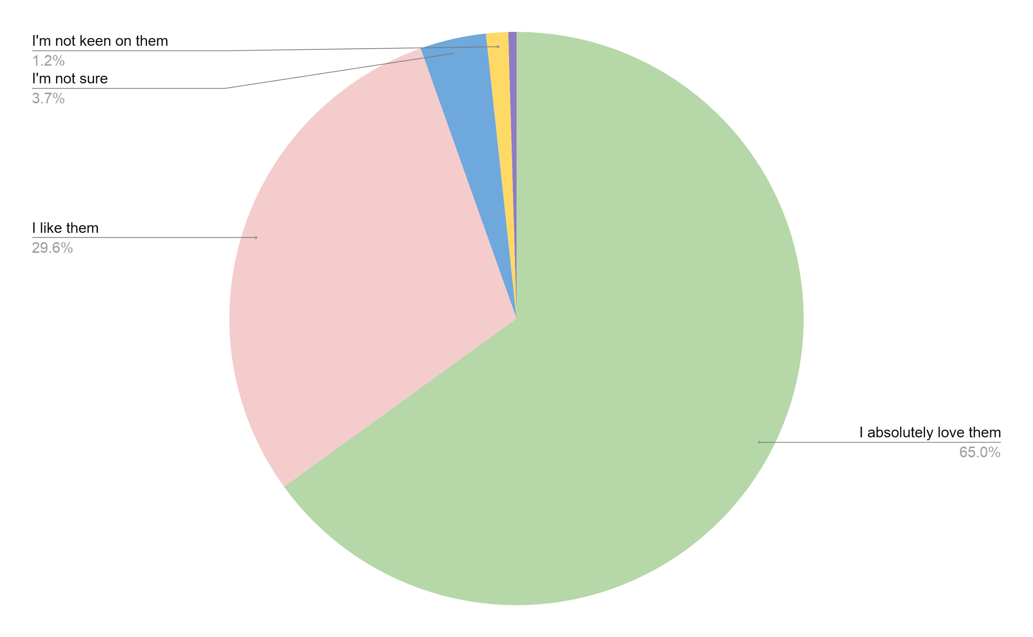
Fig: How do you feel about parks and green spaces overall in Hackney?

What is the name or location of your local park or green space?

644 responses
What is your local park or green space? | Total | Percent
Local Hackney park or green space - top 5 parks participants provided feedback on were: Clissold Park (131), London Fields (89), Hackney Downs (78), Millfields (48) and Springfield Park (43) | 610 | 95%
Victoria Park (25), Finsbury Park (6), Other response - n/a, too many to mention (3) | 34 | 5%

What are the top three issues or concerns in your local park or green space?

645 responses

Participants were asked to choose their top three issues from a multiple choice list of options. 100% (645) of participants chose their 3 top issues. The most common issues are shown in the graph below:

Fig: Issues in local parks and green spaces
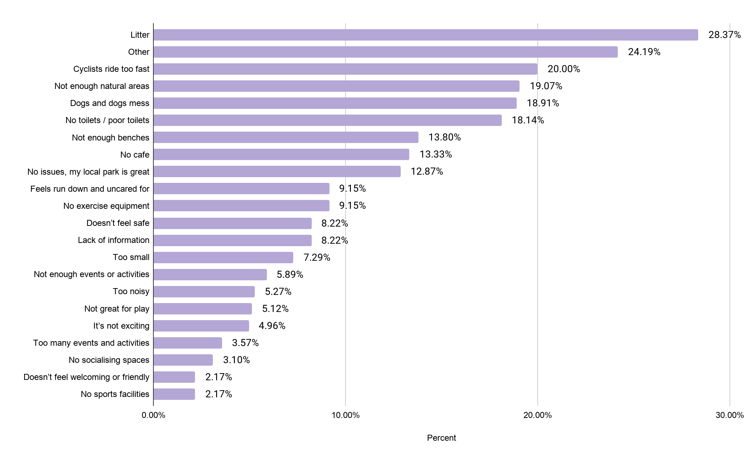
If other, please tell us:

272 responses

In addition to the issues selected in the multiple choice section, the top ‘other issues’ highlighted were antisocial behaviour (34 - 13%), the protection of trees (20 - 7%), overcrowding (17 - 6%) and too much traffic in and around green areas (14 - 5%).

Questions about the vision

The following questions were designed to test whether the strategy vision focused on the right things. Participants were given an open text box to tell us what they would like to see included in the vision.

Is there anything missing that you would like to see in a future vision for parks and green spaces in Hackney?

644 responses
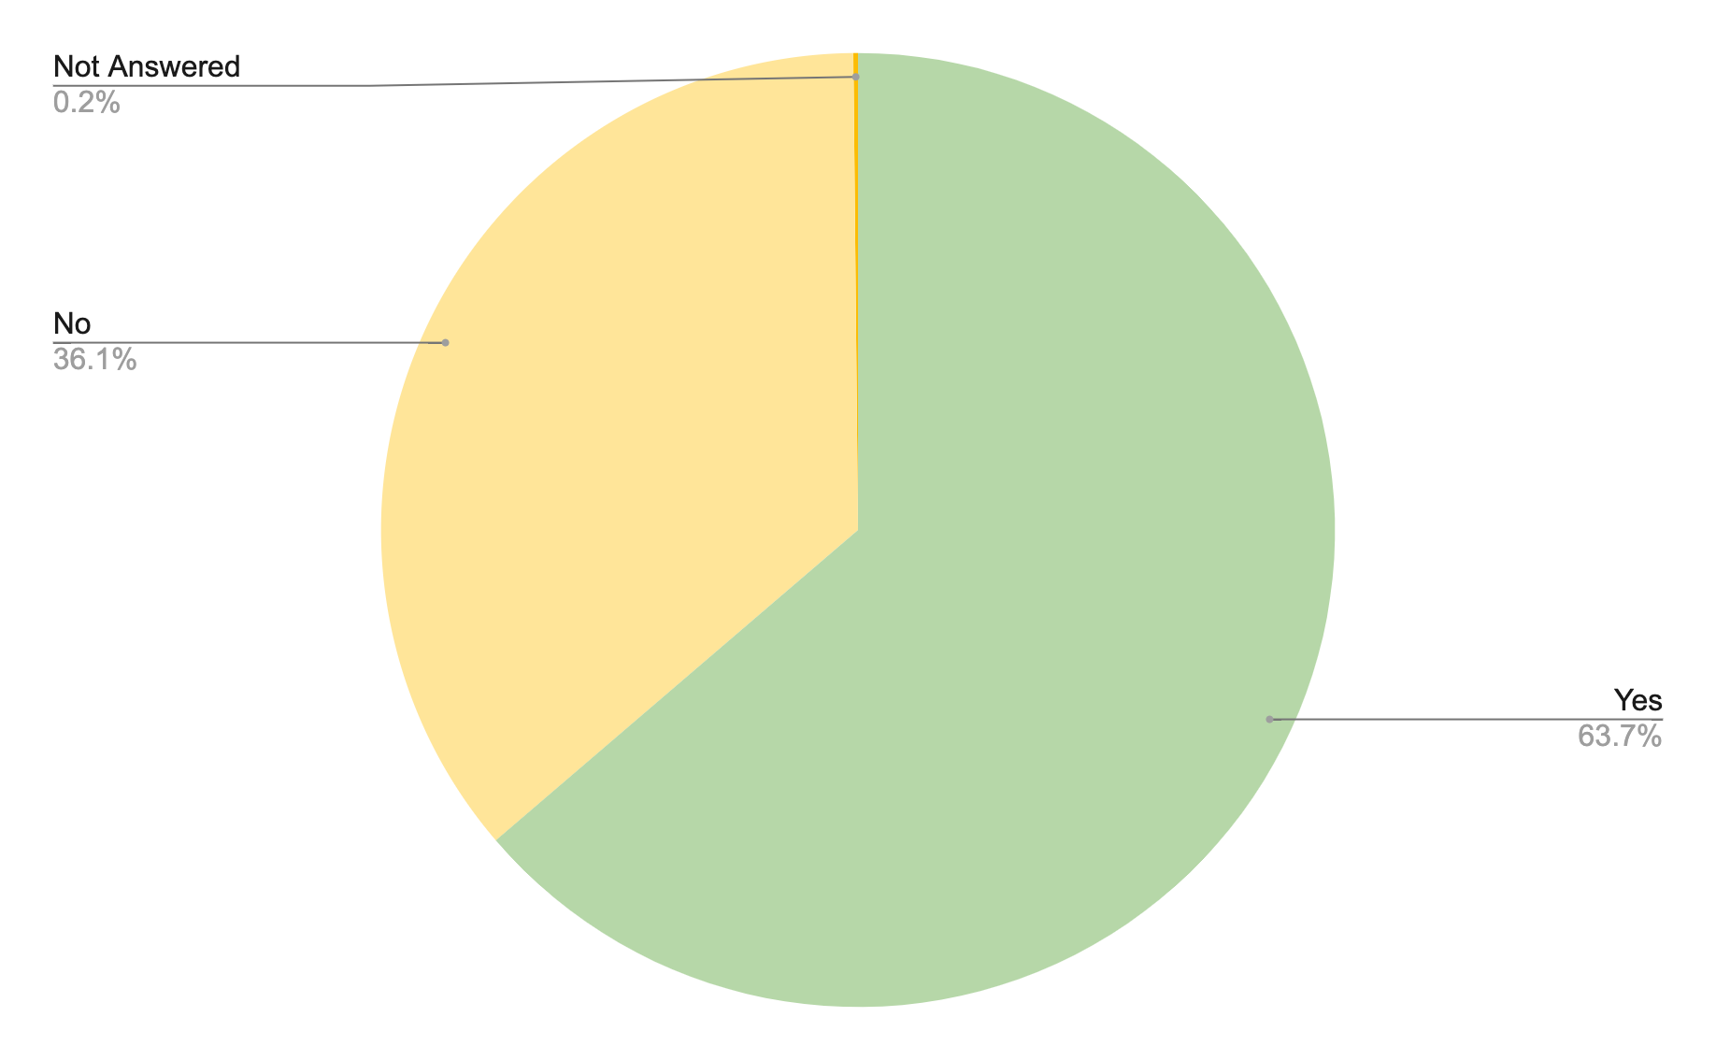
Fig: Is there anything missing that you would like to see in a
future vision for parks and green spaces in Hackney?

If yes, tell us what’s missing?
413 responses
If yes, tell us what’s missing from the vision? | Total | Percent
Wilder - more relaxed grass, dead wood, wildflowers | 39 | 9.4
Trees - more trees planted | 31 | 7.5
More of a specific sport / More sports | 31 | 7.5
Support for more community food growing/gardening | 24 | 5.8
Opportunities to engage with nature - nature education events, info signs about wildlife and natural features of parks | 22 | 5.3
Connecting green spaces together, more green space, green streets and pavements, parklets | 20 | 4.8
Improving play - better, more diverse play, more natural play | 20 | 4.8
Dogs in parks are a problem and an issue that needs solving | 20 | 4.8

Responses to this question were a combination of:

- Things that participants wanted to endorse as important.
- Issues and concerns that may have been addressed in the commitments, but participants felt deserved acknowledgement at a higher level in the overall strategy vision (e.g. solutions to the issue of dogs, connecting green spaces together, improving or investing in play).
- Things participants felt we should make a stronger or more ambitious commitment to (e.g. environmental measures around trees, biodiversity and wilding, growing initiatives).
- Things people felt were missing entirely (e.g. specific sports or a focus on sport).

Questions about the focus of the strategy

The following questions were designed to test whether we focused on the right things in the strategy. Participants were given an open text box to tell us what they would focus on.

Have we focused on the right things?

644 responses
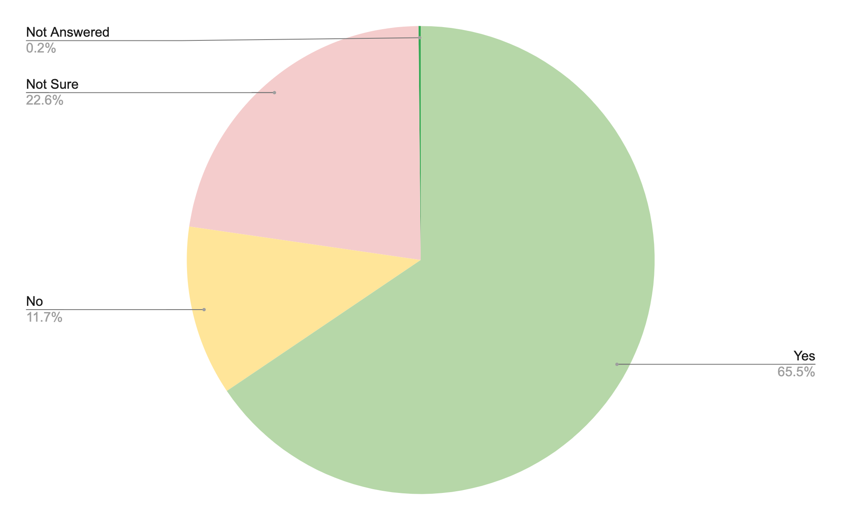
Fig: Have we focused on the right things?

If no, explain why:

159 responses

If we haven’t focused on the right things, what should we be focusing on? | Total | Percent
Don't activate parks and green spaces | 19 | 11.9
Unclutter parks. peace and quiet, relaxation, escape | 16 | 10.1
Connect green spaces together, more green space, green streets and pavements, parklets | 15 | 9.4
Prioritise safety, make parks safer | 12 | 7.5
Improve the way you engage and involve people and prioritise engagement | 11 | 6.9
Health and wellbeing in nature, peace and quiet, don't need activities | 11 | 6.9
Reduce events and activities and school use | 11 | 6.9
Protect green spaces from development, protect funding for parks and green spaces, more green space | 10 | 6.3

Responses to this question were a combination of:
- Issues and concerns that may have been addressed in the commitments, but participants felt deserved acknowledgement at a higher level in the overall focus of the strategy (making parks feel safer, improving engagement).
- Things participants felt we should make a stronger emphasis on (calm and quiet parks, health and wellbeing, creating more green space).
- Things they felt we had got wrong (not everyone wants their parks ‘activated’, not everyone wants to attend events and activities).
- Things that were missing entirely (a focus on protecting green space from developers, from funding cuts).

Question about strategy commitments

This question was designed to test that we have covered everything in the commitments we were making. Participants were given an open text box to tell us their ideas and views about the 30 strategy commitments.

Are there any commitments you would like us to prioritise in the final strategy or is there anything missing you'd like to see included?
366 responses

Commitments we should prioritise? | Total | Percent
Connect green spaces together, more green space, green streets and pavements, parklets | 29 | 7.9
Improve the way you engage and involve people and prioritise engagement | 28 | 7.7
Increase biodiversity | 24 | 6.6
Stronger measures / ban Glyphosate and weed killers | 24 | 6.6
Solutions for ASB - drugs, muggings and crime, parties and noise | 19 | 5.2
More drought tolerant and native planting | 19 | 5.2
Prioritise safety, make parks safer | 18 | 4.9
Prioritise environment over everything else | 18 | 4.9

Participants tended to respond to the question about strategy commitments by either:
- Strongly endorsing the commitments we had already made and they felt we should prioritise (support for connecting green spaces, increasing engagement, increasing biodiversity), or
- Highlighting where commitments we had made needed to be stronger (stronger commitment to finding solutions to safety and crime, banning rather than reducing Glyphosate, improving communication and engagement for example).
Participants also used the space to tell us that the commitments were good, seemed achievable (15) and that there was nothing missing (14).

Questions about the strategy themes - community involvement, activation and environmental sustainability

The following questions were designed to test that we had covered everything in the commitments we had made around each key theme in the strategy. Participants were given an open text box to tell us their ideas and views about each theme.

Online survey: What could we do to make people want to get more actively involved in improving and developing our parks and green spaces?

487 responses

What could we do to make people want to get more actively involved? | Total | Percent
Better publicity and promotion of volunteering, activities and events | 89 | 18.3
More volunteering opportunities | 62 | 12.7
Health and wellbeing activities linked to nature and the environment | 49 | 10.1
More free community / cultural events and activities / walks and talks | 45 | 9.2
Work with schools - children and green education, green initiatives and partnerships | 42 | 8.6
Engaging with nature - nature education events, info signs about wildlife and natural features of parks | 36 | 7.4
Empower / support / fund communities to take ownership | 36 | 7.4
Community growing and gardening opportunities | 34 | 7.0

Participants responded to the question about involvement with suggestions about volunteering, events and activities, partnerships and publicity.
For a more detailed breakdown of the responses, views and ideas participants had around community involvement, which also takes into account responses received in focus groups, see Section 5: Focus groups.
Online survey: What could we do to make you want to visit parks and green spaces more often?

487 responses
What could we do to make you want to visit more often? | Total | Percent
Increase biodiversity and wildness | 69 | 14.2
Parks are great as they are! | 61 | 12.5
Better solutions to the litter problem, including recycling bins | 37 | 7.6
More toilets / better toilets | 35 | 7.2
Dogs in parks are a problem and an issue that needs solving | 33 | 6.8
Increase free community/cultural events and activities /walks and talks | 27 | 5.5
More cycle lanes, restrictions, controls | 28 | 5.7
Connect green spaces together, more green space, green streets and pavements, parklets | 28 | 5.7
More Cafes | 25 | 5.1
Prioritise safety, make parks safer | 21 | 4.3

Participants responded to the question about activating parks and green spaces with suggestions about making parks and green spaces cleaner, safer and more appealing to visit. They highlighted the issues and barriers they face accessing parks and green spaces, their solutions for overcoming them and suggestions for making them more appealing for people to visit including improved facilities, more community events and cafes.
For a more detailed breakdown of the responses, views and ideas participants had around activation of parks and green spaces, which also takes into account responses received in focus groups, see Section 5.

Online survey: How could parks and green spaces be more environmentally sustainable?

451 responses

How could parks and green spaces be more environmentally sustainable? | Total | Percent
Make them wilder and more natural | 164 | 36.4
More recycling and composting | 92 | 20.4
More trees planted | 69 | 15.3
Increase Biodiversity | 63 | 14.0
Reduce / ban Glyphosate and weed killers | 46 | 10.2
Make them better for birds, insects and wildlife | 44 | 9.8
Education, skills, events around food growing, gardening, nature | 44 | 9.8
More opportunities to learn about nature | 36 | 8.0

Participants responded to the question about environmental sustainability by telling us their priorities for the next ten years, which included making parks and green spaces wilder, planting more trees and improving them for birds, insects and wildlife. Many also stressed the importance of providing events and opportunities to learn about nature and develop skills in growing and gardening.
For a more detailed breakdown of the responses, views and ideas participants had around environmental sustainability and parks and green spaces, which also takes into account responses received in focus groups, see Section 5: Focus groups.

Any other comments?
This question was designed to ensure participants had room to tell us anything they felt we needed to know that they hadn’t covered in the preceding questions.

Any other comments? Please use this space to tell us anything else you’d like us to know.

236 responses

Other Comments? | Total | Percent
Parks are great - thank you, best thing about Hackney, kept me sane during lockdown | 37 | 15.7
Strategy is great - achievable, good practice, accessible | 28 | 11.9
Improve the way you engage and involve people and prioritise engagement | 21 | 8.9
Make parks more inclusive / accessible to all / greater range of residents | 15 | 6.4
Wilding - relaxed grass, dead wood, wildflowers | 14 | 5.9
Prioritise maintenance, parks need to be well maintained | 14 | 5.9
Trees - more trees planted | 13 | 5.5

Participants used this space to tell us how much they appreciated Hackney parks and green spaces, to make generic comments and suggestions about the strategy (either to endorse it or to make suggestions about improving it) and to emphasise the commitments they felt we should be prioritising.

Common themes came up here again; increasing biodiversity (11), antisocial behaviour (11) and litter (10) as issues needing solving as well as further suggestions to empower, support and fund communities to take ownership (12), and to work with hyper local partners to support engagement (10). But also, participants used this space to mention priorities that didn’t directly relate to involvement, activation or environmental sustainability, but they felt we should look at or that the strategy should cover such as maintenance, which quite a few participants were surprised to see missing from the strategy.

The “any other comments” space was also used by housing estate residents to reiterate and stress to us the importance of housing green space to residents, and how it needed to be protected for residents (9) and to tell us the strategy needed to differentiate more clearly between parks and housing green space (9).

Section 4: Key themes
This section explores 10 key themes emerging from the data.

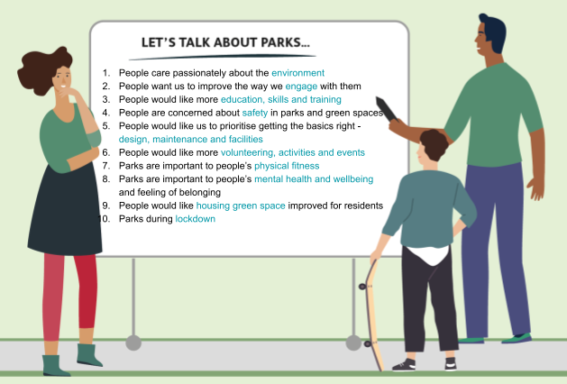

The data used in this section has been amalgamated from different sources to make it easier to read. This means the summaries for each of the 10 themes take into account the 3398 comments from 967 participants from across the whole consultation.

For each theme we provide a graph to illustrate the top five comments relating to that theme, a summary of the other, but less frequently mentioned, comments relating to the theme and a sample of quotes from participants to give context to the analysis.

1. People care passionately about the environment
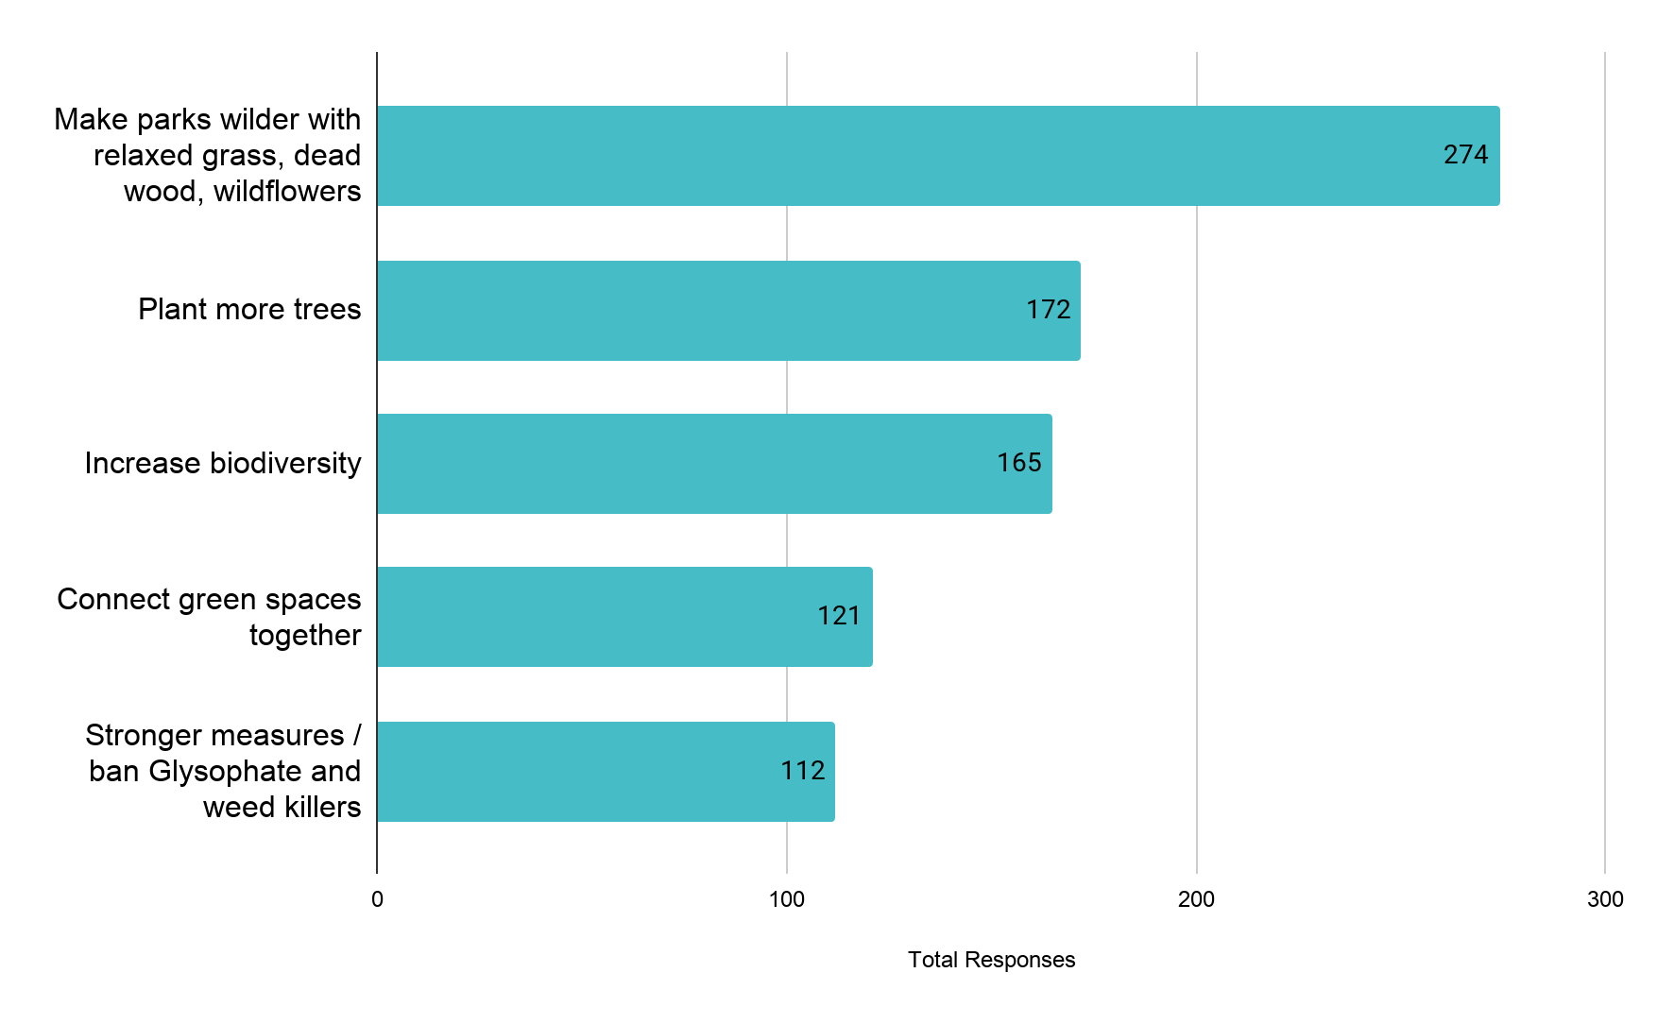
Fig: Top comments made about the environment across the consultation

Other things people told us...
Participants would also like to see a bigger commitment to recycling (108 comments), more planting, particularly drought tolerant and native planting (108). They would like parks and green spaces to be better for birds, insects and wildlife (103) and would like more opportunities to engage with and learn about the nature we have in our parks (106). Wilder, more biodiverse environments and more trees was the second highest comment made by residents regarding housing estate green spaces (70).
“We need more recycling bins because there's so much trash everywhere and people need to take responsibility”
(Shoreditch Park Primary school focus group participant)

“Can we start allowing areas to rewild naturally? ...Nature really does know better than us”
(Citizen Space participant)

2. People want us to improve the way we engage with them
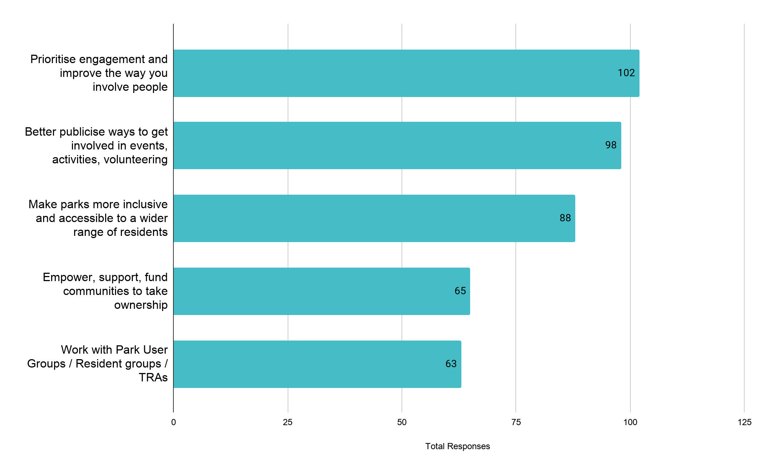
Fig: Top comments made about community engagement across the consultation

Other things people told us…
Participants also stressed the importance of reaching out to marginalised groups (60 comments), improving the way we communicate and consult with people (56), working better with the groups who already care for our parks and green spaces (56), working with hyper local partners to support engagement (49) and making park user groups more accessible (21).
“We should have more disabled friendly things and sensory zones to walk through” (Hackney Marsh Adventure Playground)
“Advertise volunteer programmes - I am interested in helping but don’t know how to get involved” (Citizen Space participant)
“Build a sense of collective responsibility and ownership throughout the community” (Kings Park Moving Together Participant)

Who do we need to engage?
102 participants told us we should prioritise engagement and improve the way we involve people. Many also made suggestions about who we needed to work harder to engage in the improvement and development of parks and green spaces over the next ten years:
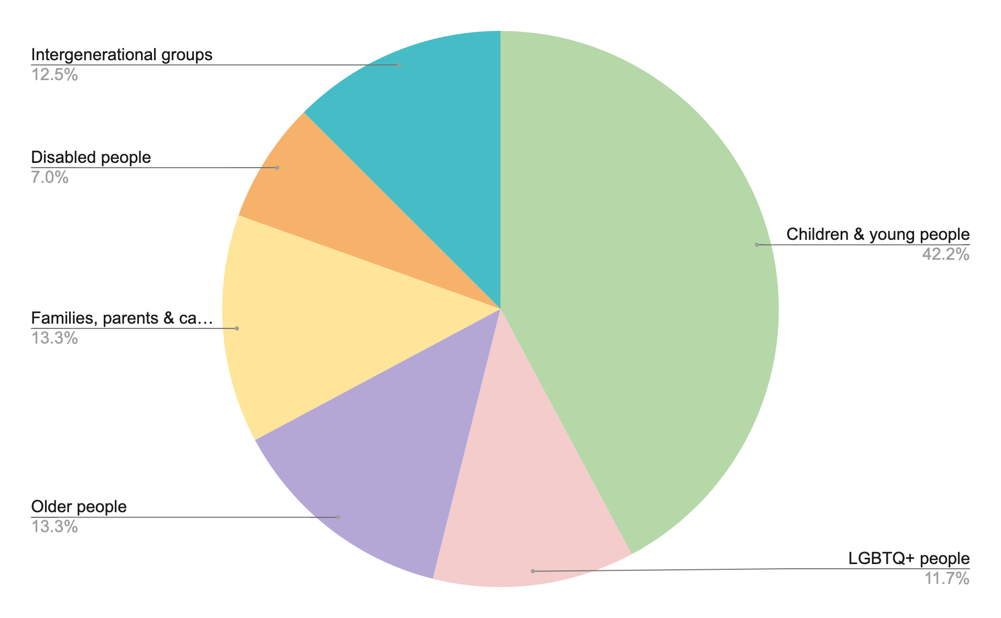
Fig: Most frequently occurring comments and suggestions about who to engage

“We all want our groups to be more representative, but we need suggestions on how to do it”
(Park User Group focus group)

“Get more family members involved. Send out more leaflets and surveys. Do pop up workshops to allow the community to speak. Hold competitions and give prizes for the best ideas. You need more recognition for the BAME community” (Kings Park Moving Together Participant)

3. People would like more education, skills and training

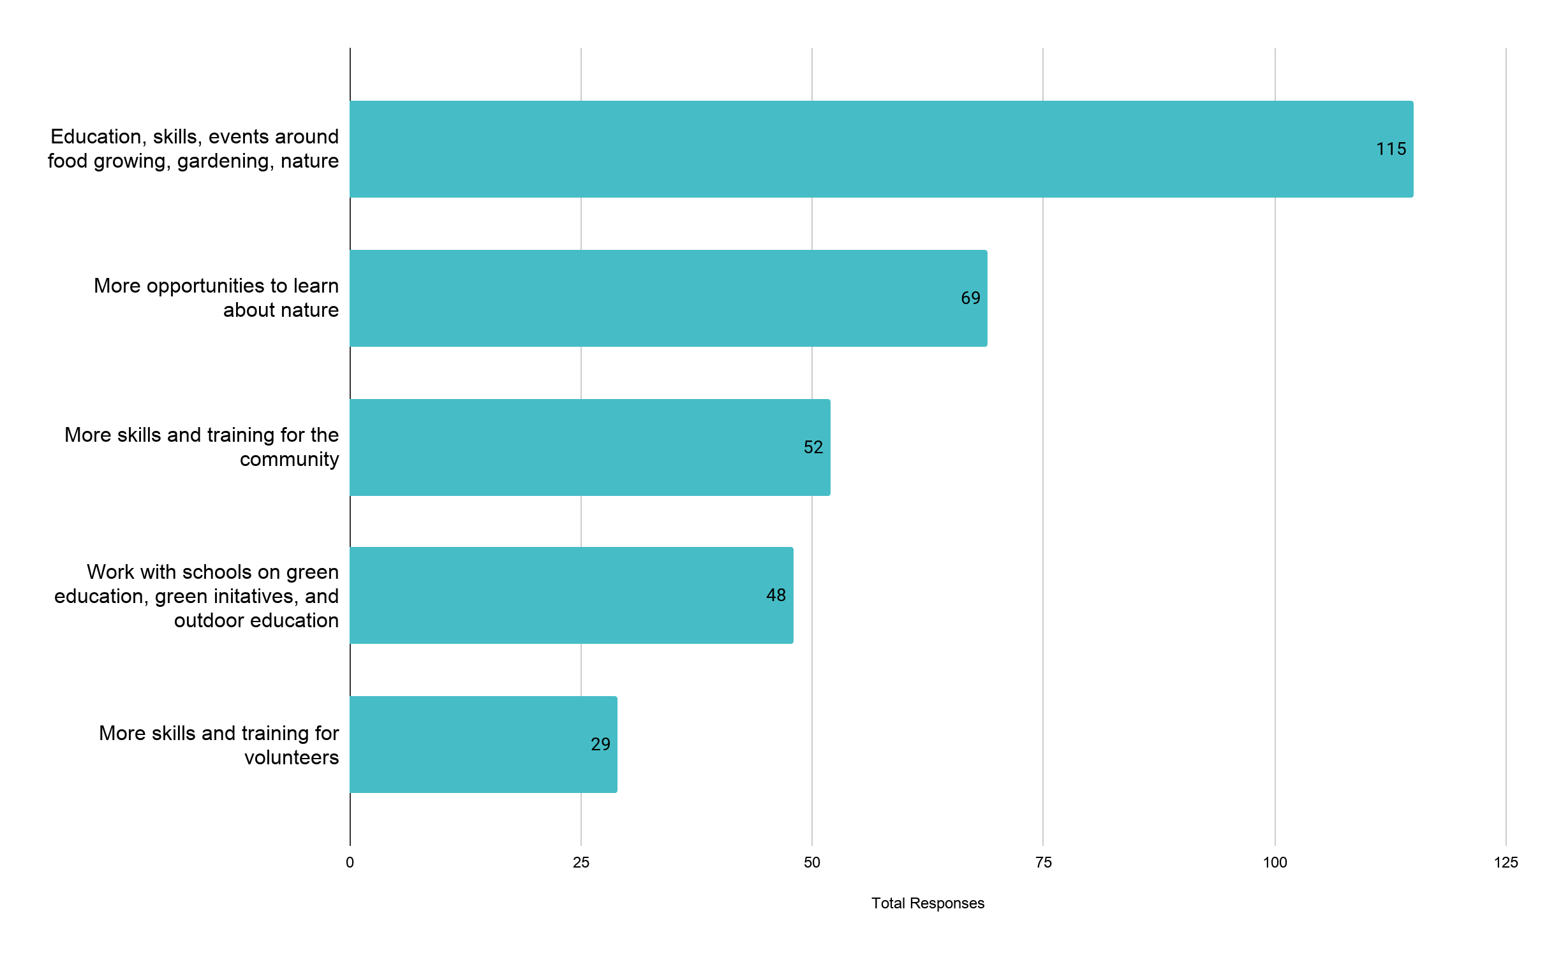
Fig: Top comments made about education, skills and training across the consultation

Other things people told us…
Participants also made suggestions about the importance of outdoor education and forest schools (24), skills and training for staff (19), and how they supported the commitment we had made around apprenticeships and supported work experience for people with disabilities (7).

“You should hold courses for people to learn about planting and caring for trees and flowers. Talk to existing projects like the Tree Musketeers (for example)” (Citizen Space participant)

“I would love to have free Gardening lessons”
(Age Concern focus group participant)

“Run beginners' gardening sessions, using community knowhow as well as expert input” (Citizen Space participant)

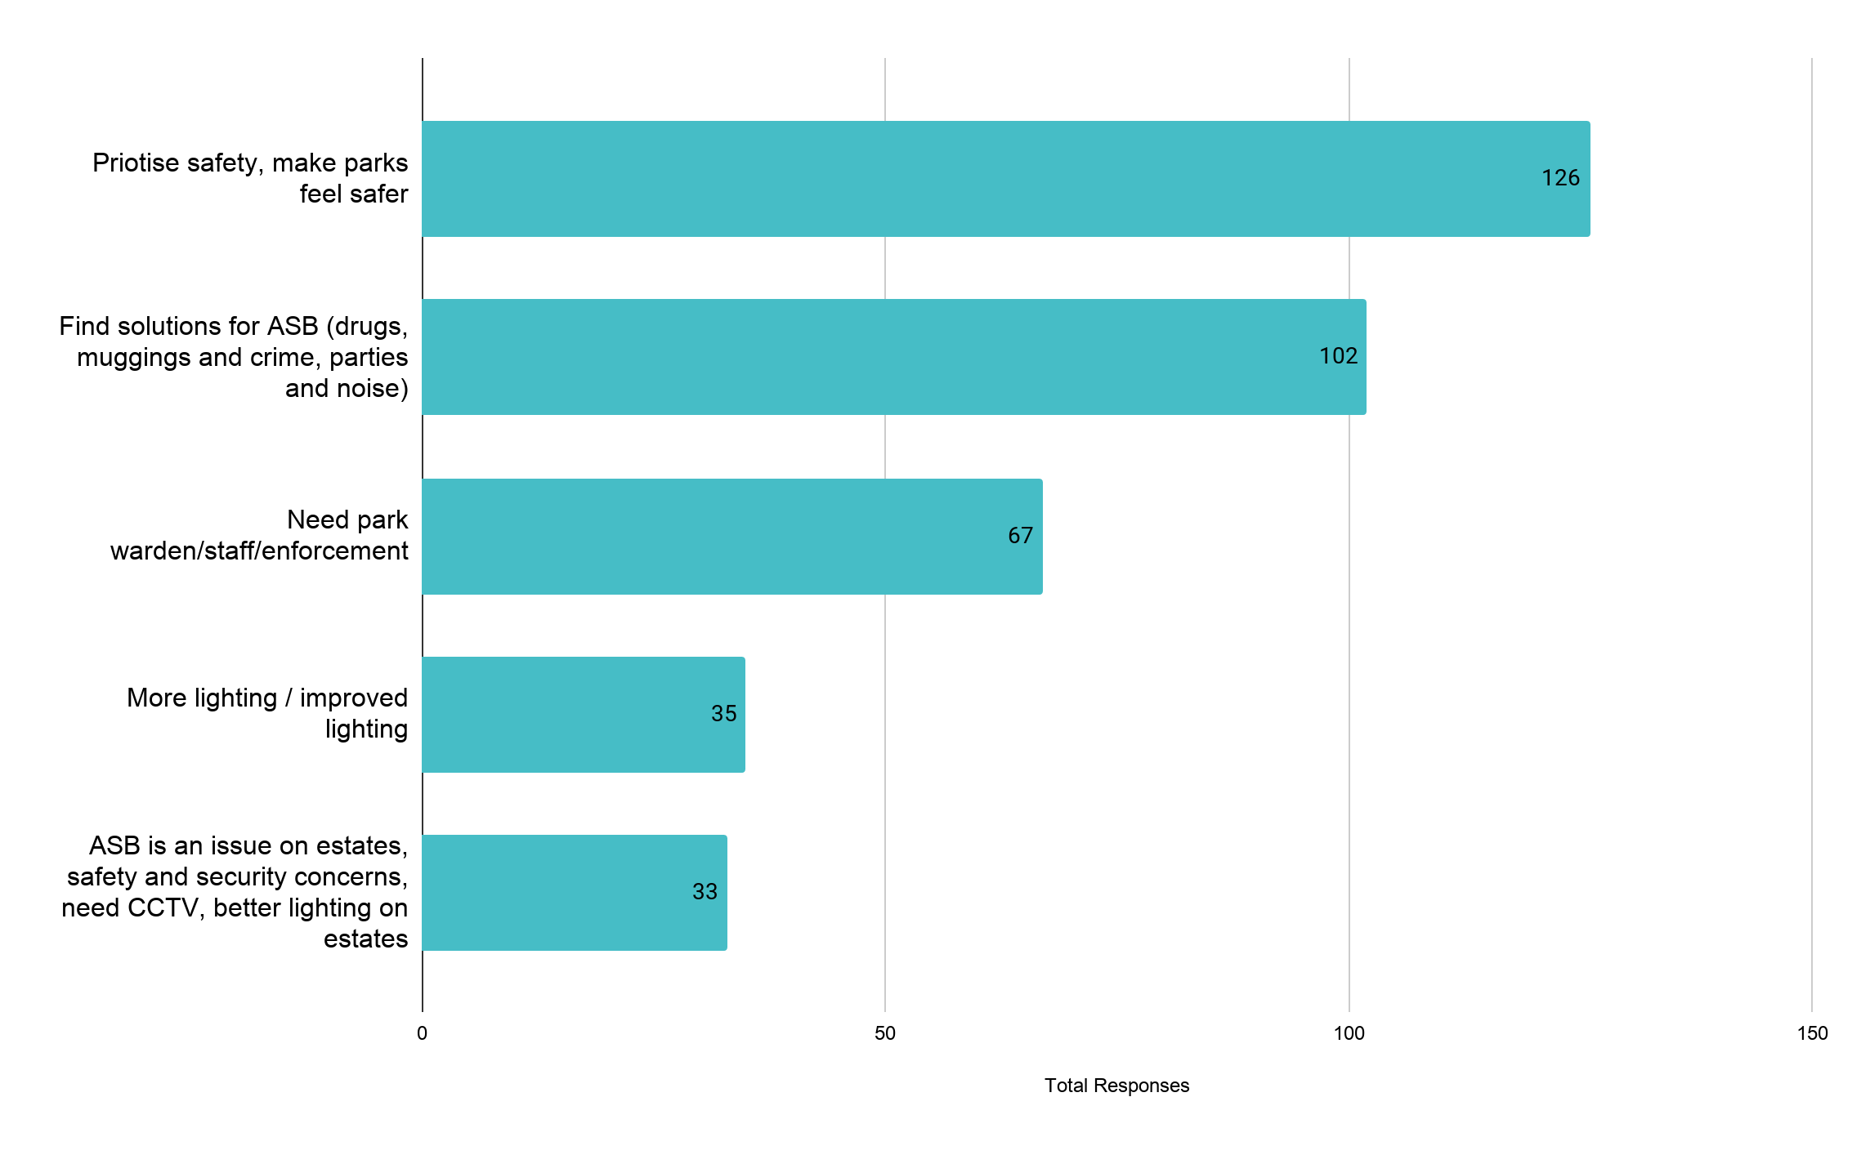
4. People are concerned about safety in parks and green spaces
Fig: Top comments made about safety across the consultation

Other things people told us…

Participants also highlighted the issue of antisocial behaviour and young people (21), the importance of prioritising the safety of women and girls (19) and made suggestions for solving the issues they were concerned about including banning/discouraging alcohol (15), banning BBQs (12) and suggestions to keep parks open later in the evenings to encourage people to use them more so they feel safer (16) and closing parks at night to discourage people from using them (6).

“Parks can be great routes for active travel or early morning exercising in the winter, but often feels/are unsafe in darkness, especially to women.” (Citizen Space participant)

“Safety and security are really important to young people. If you can't put CCTV in then we need to light parks better.”
(young person, ELATT College Group participant)

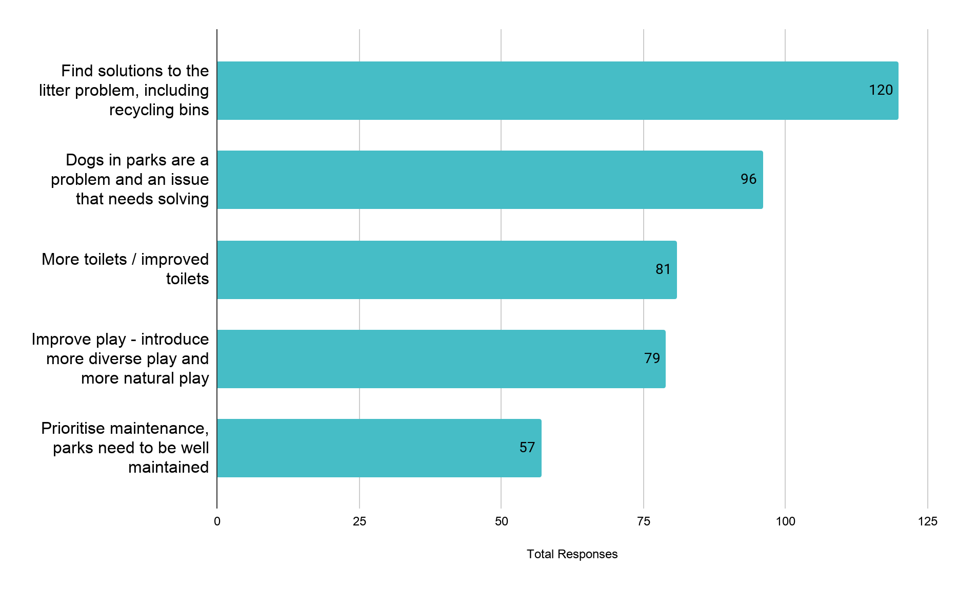
5. People would like us to prioritise getting the basics right - design, maintenance and facilities
Fig: Top comments made about design, maintenance and facilities across the consultation

Other things people told us…

Participants also highlighted that any park improvements and decisions around facilities needed to prioritise the needs of children and young people (53) and for families with young children (42). Cyclists going too fast was highlighted as the third highest issue in the quick poll (129) and participants would like to see more restrictions and controls for cyclists and cycle lanes to keep cyclists off of walking pathways (48). Keeping parks clean was something participants asked us to prioritise (46) as well as introducing more social spaces, benches and picnic tables (44).

“In parks there is space for everyone, but I would like to see more benches and chairs for disabled people” (Young Speaker, Hackney Youth Parliament)

“Dogs might only want to play, but my children are scared and so we can't go to the park” (Xenia focus group)

“We have lots of families living around our parks, we need to make sure we have enough swings for everyone” (Y6 pupil, Shoreditch Park Primary)

6. People would like more volunteering opportunities, events and activities
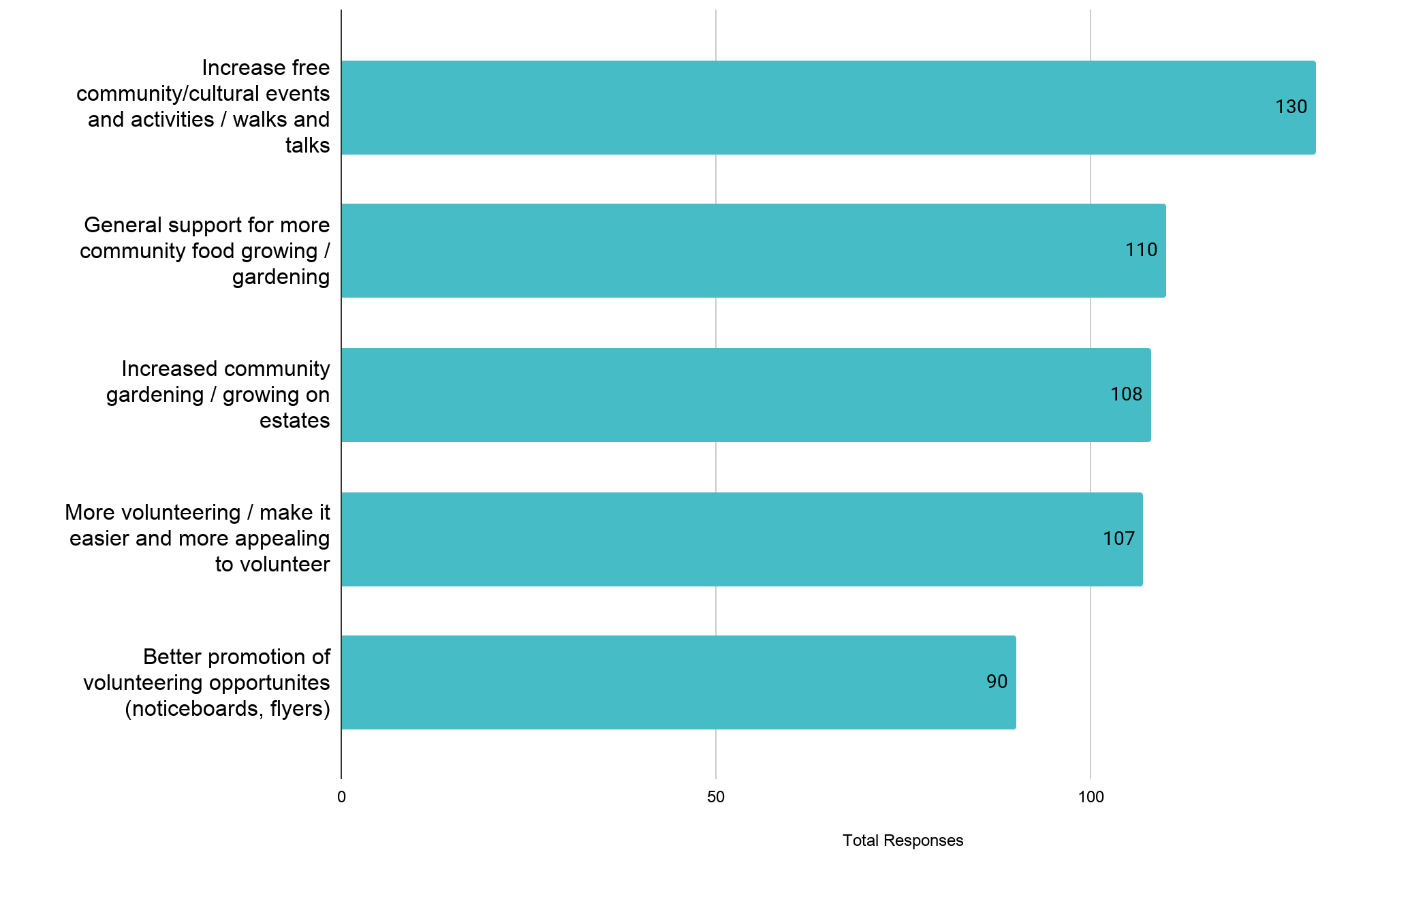
Fig: Top comments made about volunteering, events and activities across the consultation

Other things people told us…

Participants would also like to see more community growing and gardening initiatives in parks and green spaces (71), more green volunteering activities such as tree planting and litter picking (32), and more drop in / just turn up events (25). Participants also told us they would like to see a reduction in the number of events and activities in parks, including schools using them for PE (32) and that parks and green spaces shouldn’t be activated (19).

“I volunteered in a homeless kitchen at the beginning of lockdown, all the community coming together. I would like to volunteer in a park, it's something to do, I like helping out and staying busy” (Xenia Women)

“I would like to see Council-funded but community-run activities: educational walks, litter-picking, tree-planting, short-distance organised runs around parks, group outdoor exercise classes” (Citizen Space participant)

“Have ways to bring communities together. Community growing spaces” (Citizen Space participant)

7. Parks are important to people’s physical fitness
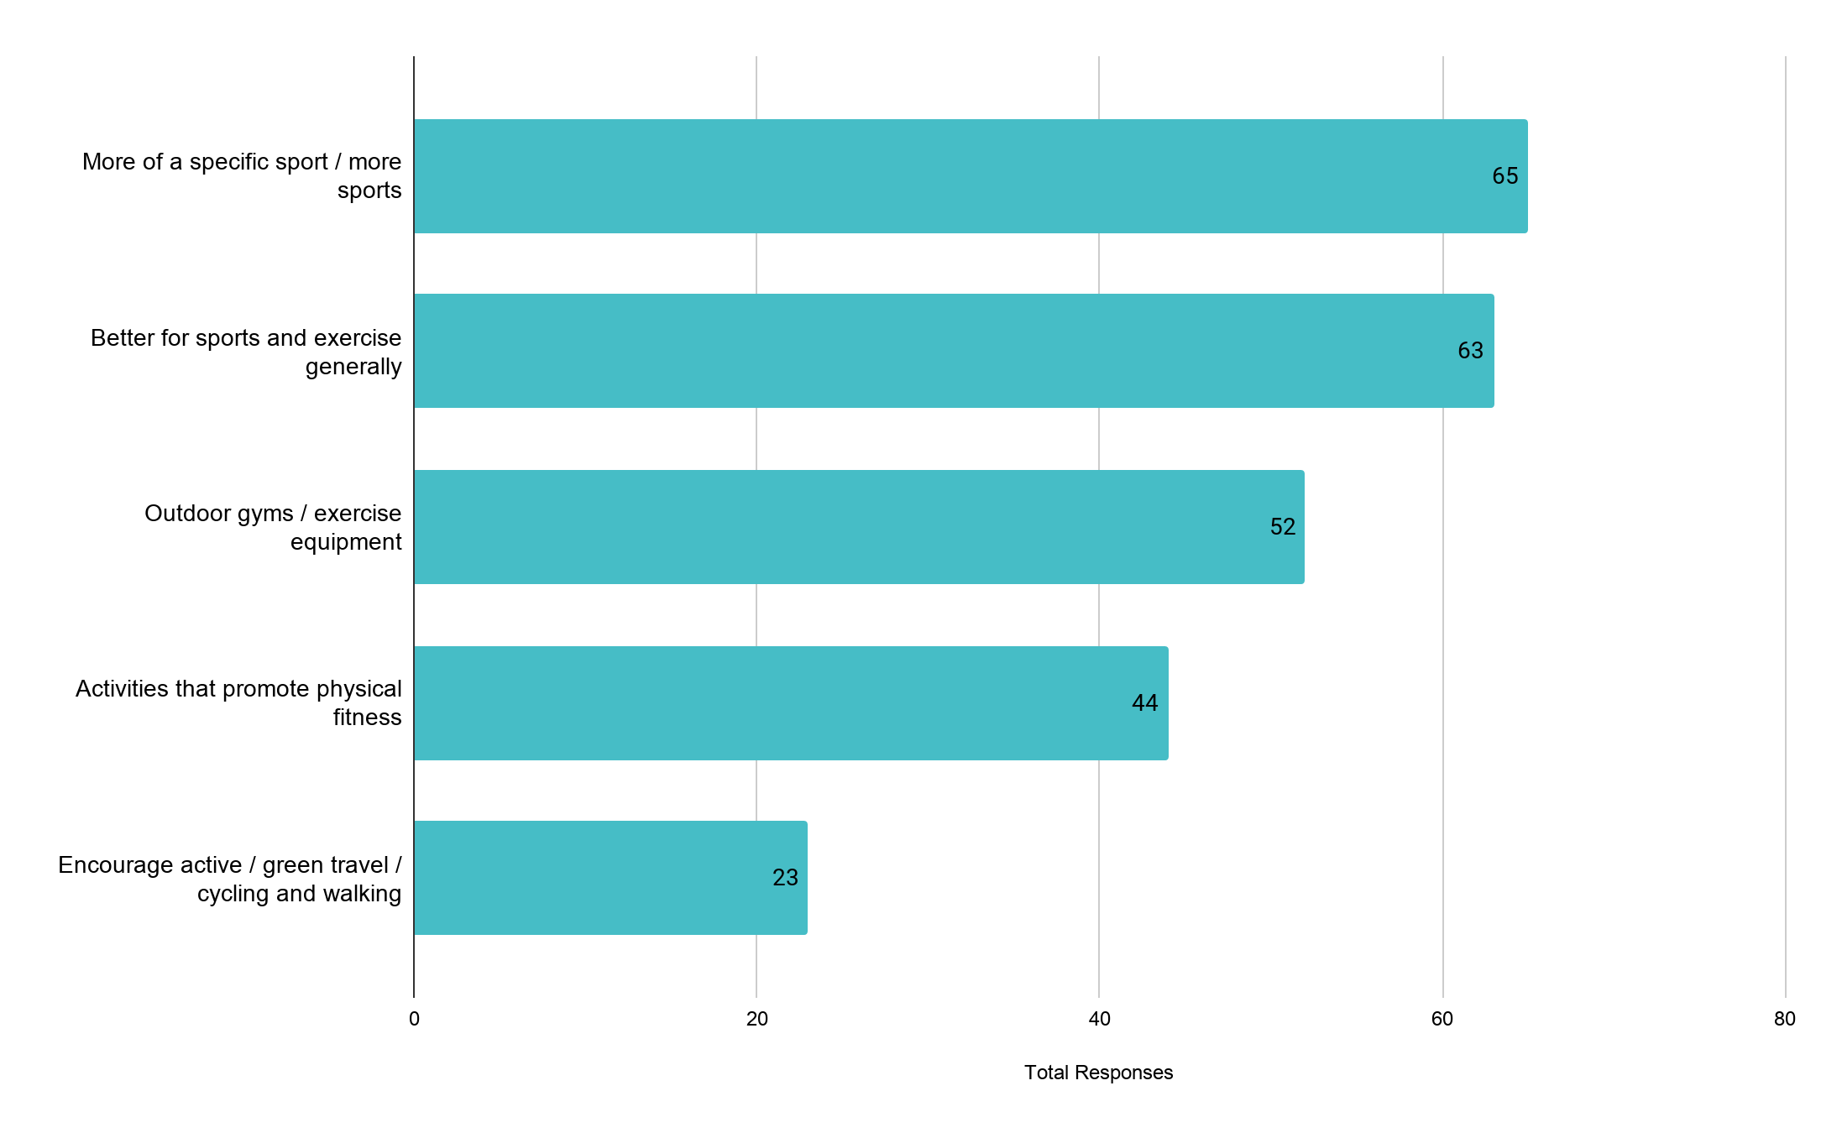
Fig: Top comments made about physical fitness across the consultation

Other things people told us…

Participants also told us about the specific sports they would like to see. Numbers for each sport were fairly low due to the blank page, but included more or improved facilities for football (28), basketball (18), tennis (12), skateboarding (10), cricket 9), rugby (5), table tennis (4), bowling (2). They stressed the importance of being introduced to outdoor exercise from an early age, being supported to be active in older age and being able to access free exercise equipment at any time of the day. When it came to outdoor gyms, some favoured calisthenic static equipment and others told us they needed moving equipment, this was particularly important for older people and people recovering from injury. Many enjoyed using Hackney’s parks and green spaces for formal sports, and others spoke about taking part in informal sports with friends and communities coming together to exercise.

“Exercise is very important. We do not have enough free exercise equipment or none at all like other countries” (Citizen Space participant)
“Exercise outdoors should be free, fun and accessible for all residents, many of whom live in flats with no outside space” (Citizen Space participant)

8. Parks are important to people’s mental health and wellbeing and feeling of belonging
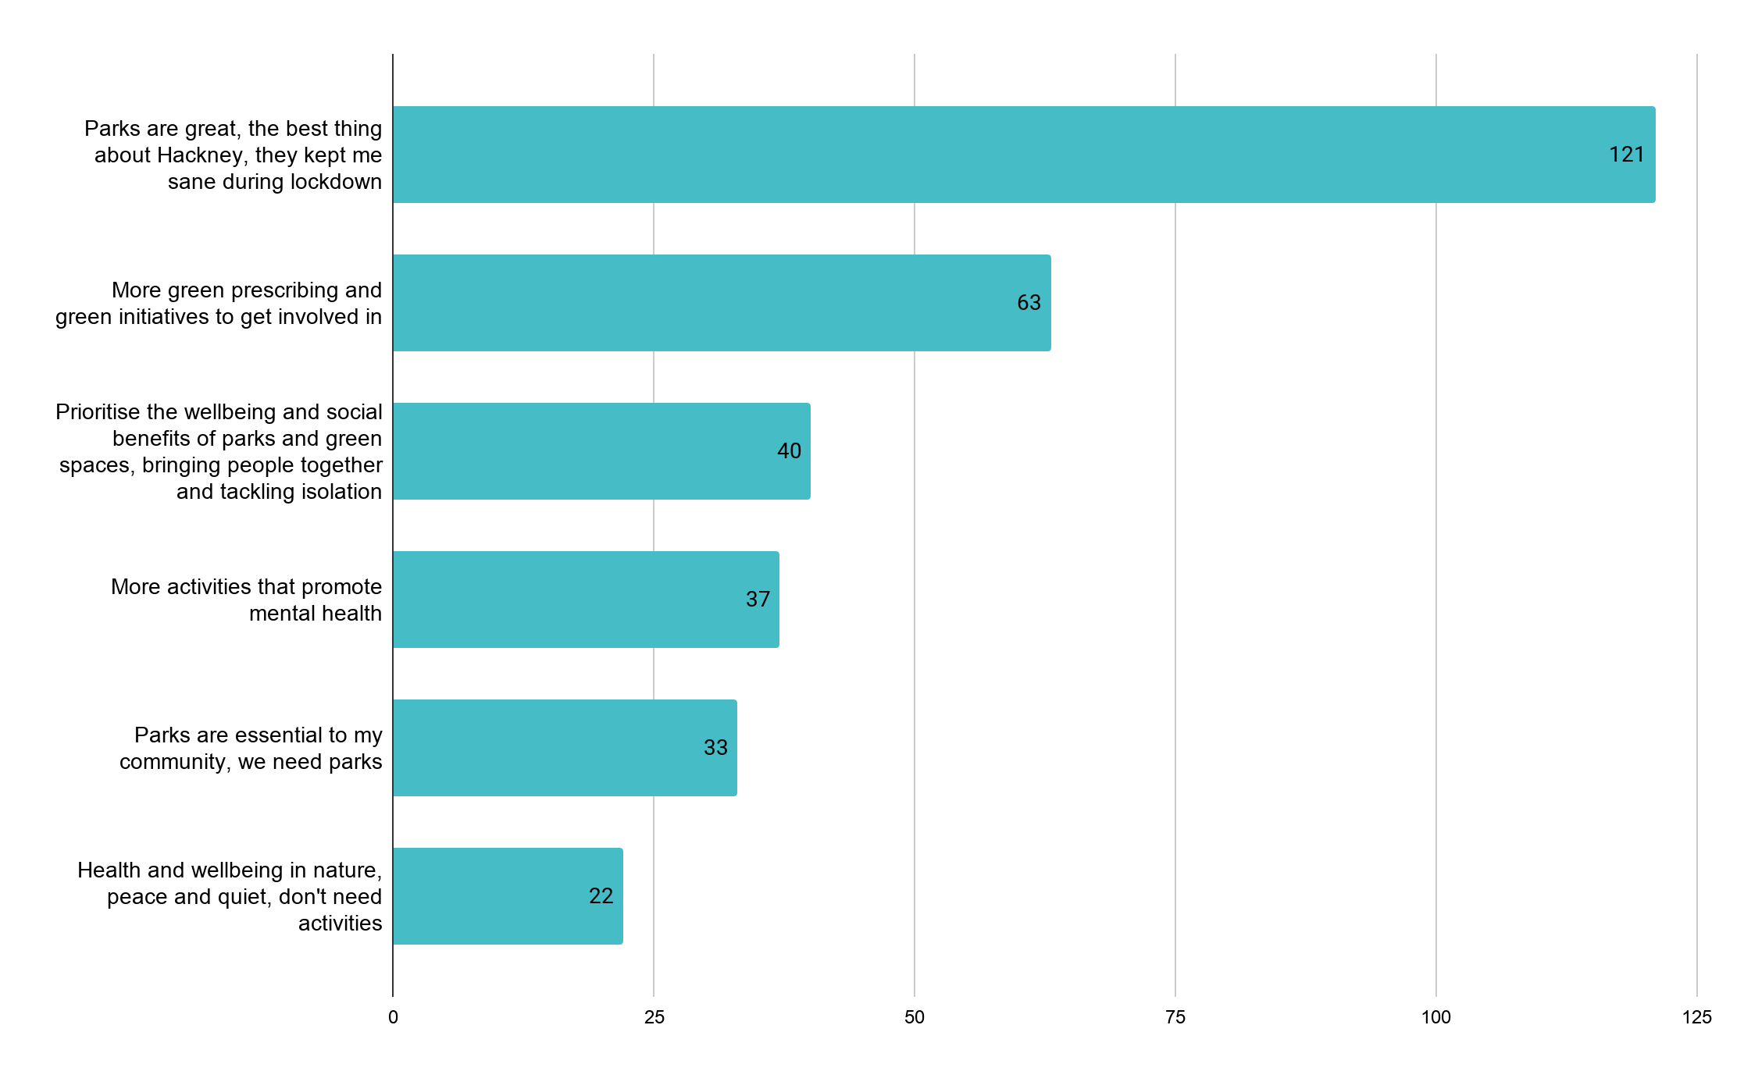
Fig: Top comments made about mental health and wellbeing across the consultation

Other things people told us…

Participants also told us that quiet and peaceful parks and green spaces were good for their mental health and wellbeing, or that they found wellbeing in nature (22). To make parks and green spaces healthier some suggested banning smoking (3) and it was recommended that we should work with Public Health and Neighbourhoods on health and wellbeing initiatives (2).

“Green spaces have always been important, but especially after COVID -19, they have provided not only a physical, but also mental refuge for many local residents” (Citizen Space participant)
“Sometimes play spaces and parks are the only places we can meet and hang out. If you or your friend are not out or accepted then you can’t go to your partner or friend’s houses.”
(Project Indigo LGBTQ+ focus group participant)

“Parks are great also because they bring diverse cultural and age groups together and people whose lives would otherwise never cross mix and mingle”
(Xenia Women focus group participant)

9. People would like housing green space improved for residents

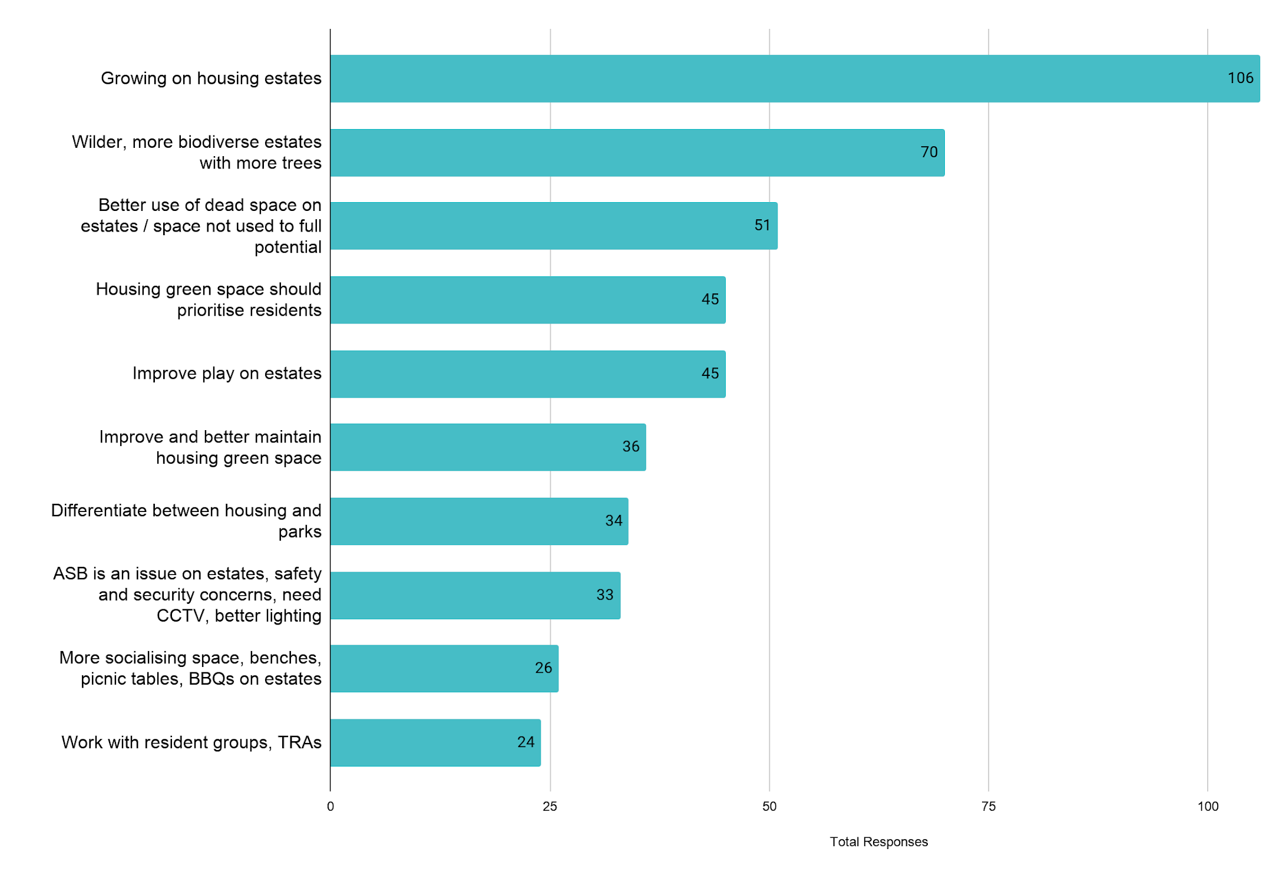
Fig: Top comments made about housing green space across the Parks and Green Spaces Strategy and REIF consultations

In total we received 201 comments and suggestions about housing green space during consultation (13 comments in focus groups and 188 in the Citizen Space survey). We also reviewed 158 comments and suggestions from the Resident Estate Improvement Fund (REIF) data. The REIF data was collected during October 2020 and housing green space was the most popular topic, providing us with a wealth of data to work with.

Other things people told us…

During a meeting with Hackney’s Resident Liaison Group (RLG) we were asked to better clarify the differences between parks and housing green space. This was reflected in the Citizen Space consultation where 34 participants also raised this as an issue. The RLG also raised questions around ‘activation’ and being clear about what this meant and how bringing to life parks and green spaces should be considered differently to bringing to life housing green space for residents. Whilst some wanted to see an increase in socialising space with more benches and BBQ space, others felt these spaces would lead to an increase in noise, antisocial gatherings and antisocial behaviour issues.

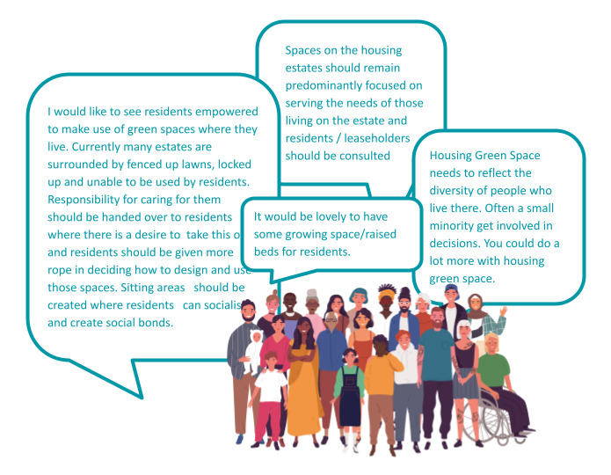
Fig: Some of the comments received about housing green space across the
Parks and Green Spaces Strategy and REIF consultations

10. Parks during lockdown

Across the consultation there were frequent mentions of lockdown (52), COVID (41) and the pandemic (27).

Many of the comments were to express concern about the issues experienced by people living near parks or using parks during the first lockdown (overcrowding, jogging, partying and antisocial). Participants also expressed fears about having to endure another lockdown. Participants also commented positively on parks during lockdown, they praised parks staff for the work they did to keep parks open and as clean as they could. They told us that parks were a lifeline during lockdown, the only place they could exercise or safely meet friends, and they also made suggestions for the community initiatives (litter picking) that they would like to see continue beyond the pandemic.

Here are some of the things participants told us about using Hackney parks and green spaces during lockdown:

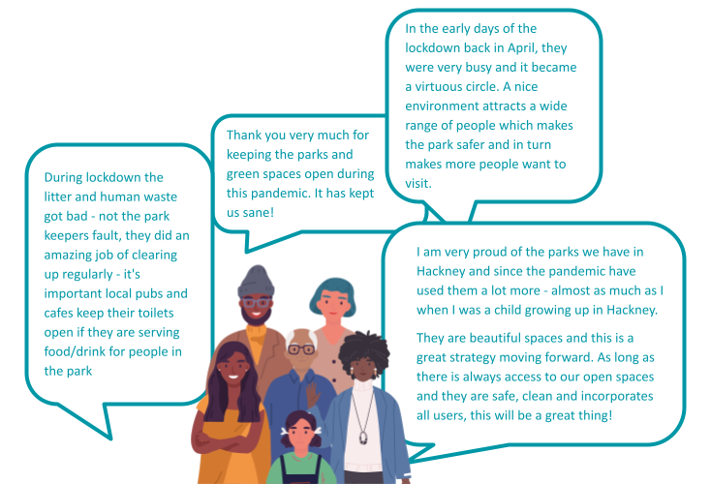
Fig: Some of the comments received on Citizen Space and in focus groups
about parks and green spaces during the pandemic

Section 5: Focus groups and other feedback
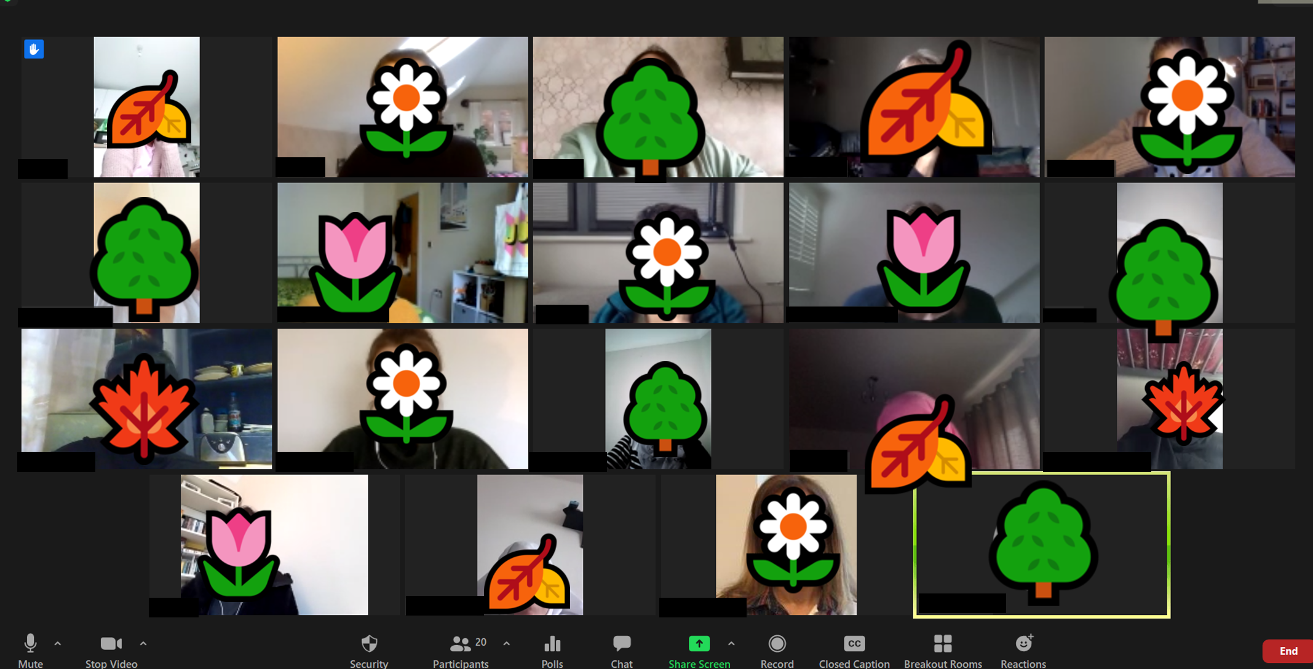
Fig: ‘Rethinking Parks and Green Spaces in Hackney’ Focus Group with Xenia Women
(photo permission granted)

Who took part?
In total 307 local people participated in focus groups, meetings and provided feedback via other methods, which included:

Online focus group sessions

- Apprentices, trainees and new starter apprentices (48)
- ELATT College students (25)
- Xenia migrant women group (20)
- Hackney Matters Citizen Panel (9)
- Shoreditch Park Primary School Council (4)
- Project Indigo LGBTQI+ Young People (10)
- Hackney Parks Forum / Park User Groups (29)
- Hackney Biodiversity Partnership (33)

Online focus group and feedback sessions delivered with partners

- Connect Hackney & Age Concern (10) with Growing Up In Hackney
- Connect Hackney & Hackney Youth Parliament (8) with Growing Up In Hackney
- Resident Liaison Group (20) with Resident Participation Team
- Stroke Survivors Group (2) with Shoreditch Trust
- Hackney Marsh Adventure Playground (12) with Young Hackney
- Healthy Weight Partnership Meeting (16) with Public Health
- Health and Wellbeing Board Meeting (24) with Public Health
- Kings Park Moving Together project participants (11) with KPMT Project Team

Remote engagement

- Online polls were held with Xenia and Hackney Matters (26)
- Emailed feedback (13)

Focus groups were arranged by the strategy team, but some were co-organised and co-facilitated with the Growing Up In Hackney project team. The team were consulting on their co-designed Child Friendly Supplementary Planning Document at the same time. Where we could, we joined forces to organise and deliver focus groups together, particularly with older people and young people. We also worked with internal partners in Young Hackney, Housing, Public Health, Parks, Employment & Skills and Consultation & Engagement to organise focus groups and sessions. We also worked with external partners in the Shoreditch Trust, OffCentre, ELATT, schools and environmental campaign groups to extend our reach.

How the insight was used
All focus groups and sessions were transcribed and all opinion polls were counted. The comments and votes were then analysed alongside Citizen Space survey data and helped to inform the redrafting of the strategy. Changes we made to chapters, areas of focus and the commitments as a result of the consultation.

What we asked people
In focus groups sessions we concentrated on the same areas as the online survey (Issues in parks and green spaces? Have we got the vision and focus right? How would you like to be involved? What would make you want to visit more often? How could we be more environmentally sustainable?). We also gave a blank page for participants to talk about the areas of focus and commitments they would prioritise.

Focus group sessions were planned differently for different groups and included a mixture of presentations and feedback/discussion, Q&A, visioning and ideas activities, activities using maps and images, and quick polls.

What focus group participants told us
Insight and data from focus groups was also used in the data analysis to produce the ‘top comments’ graphs in Section 4, but the summaries below contain more detail about the priorities, concerns and views of the groups who participated in focus groups. Quotes have been used to give context to the analysis.

Children

Creative feedback session with: 12 x 7-13 year olds from Hackney Marsh Adventure Playground and focus group with 4 x under 11s Shoreditch Park Primary School Council

At Hackney Marsh Adventure Playground and Shoreditch Primary School Council we gave a blank page to the children to tell us their priorities for parks and green spaces now and over the next ten years. They told us they would like to see more environmentally friendly initiatives and more opportunities for children to join clubs and take part in craft and nature activities. They told us how important it was to feel safe and, when it comes to play, younger children would like a wider range of fun and exciting play equipment and older children would like to see play spaces that were designed with the over 11 year olds in mind.

“We need better signage across parks about dogs mess and litter - people need to be able to see the signs better… if children designed the signs people might take more notice”?

“We need more recycling bins because there's so much trash everywhere and people need to take responsibility“

LGBTQ+ Young People

Focus group with 10 x 16-24 year olds from Project Indigo

All focus group participants said they would like to be engaged and consulted more often about improving parks for young people and for LGBTQ+ people. The key priorities they highlighted were: improving toilets, building more gender-neutral and accessible toilets and making parks feel safer for LGBTQ+ young people. Participants also discussed the parks and green spaces across the borough and London where they felt safe and welcome, how important nature was to them and how to use creative interventions in public spaces to normalise LGBTQ+ people. They discussed monuments to Queer people in public spaces, and, rainbow slides and trans inclusive signage in facilities. Rainbow slides and rainbow crossings were discussed in great detail, but concerns were also raised about the intention of creative interventions and token gestures of support for LGBTQ+ people.

“Rainbow slides for children in playground to normalise from an early age...but also rainbow slides for young adults adults - we need to cater better for older young people (13+) so they feel more welcome and have somewhere to go”

“There’s only so much you can do with design, you can paint flags, murals, but design can’t monitor people’s responses and behaviours in that space - how will you ensure the space remains safe after the intervention has been installed?”

Young people

Focus group with: 25 x 16-19 year olds from East London Advanced Technology Training (ELATT)

A focus group of college students told us that parks and green spaces needed to be better for young people generally. They suggested including wifi in parks and having activities specifically for young people, like the decks they have in Mile End Park, which made them feel welcome. They discussed safety as an issue affecting how young people use parks and said they would like to see better CCTV or at least lighting and more consideration for security. The college tutor told us how he frequently used Shoreditch Park and Regents Canal for outdoor teaching and suggested more activities and events in partnership with the college in the future.

Fig: Some of the comments from ELATT College Students

Kings Park Moving Together (KPMT) families

Google quick-survey with 11 x local families

Participants living in the Kings Park ward filled in an online Google Form survey distributed by Kings Park Moving Together community researchers. Participants highlighted dogs' mess, lack of toilet facilities and not having enough space to play in such a busy area as the key issues in local parks and green spaces in the area. The most popular suggested improvements were to have toilets, gym equipment, water play and general improvements to play in the area, including more inclusive and sensory play for SEND children, a water play facility and play equipment for older children.
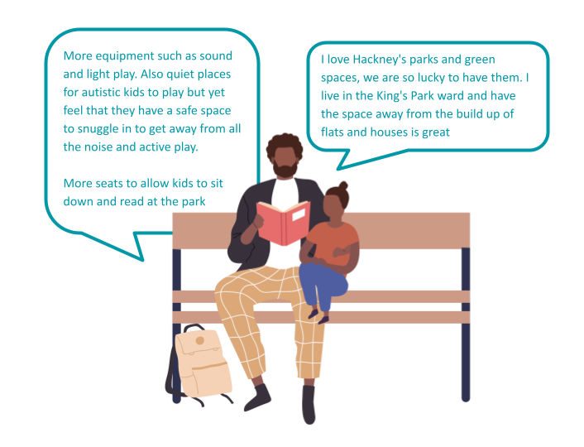

Fig: Some of the comments received by KPMT families

Apprentices and Trainees

Focus groups with 48 x young people on the Hackney Council Apprenticeship Programme

Hackney Council apprentices and management trainees took part in online focus groups and discussions facilitated by a management trainee working on the Parks and Green Spaces Strategy. Environmental sustainability was identified as the highest priority for this group, but it was felt that the strategy could go further and be more ambitious about the environmental targets and commitments we are making. Next highest was the format of the strategy, which they described as ‘modern’ and ‘accessible’ and ‘the way the rest of the council should be going with regards to writing strategies’. They liked that the strategy addressed diversity and that it felt representative. There was support for linking up green spaces and creating a network of parks across Hackney. Members of this group whose work was mainly desk based also felt that they would like to have more outdoor opportunities as part of their apprenticeships and suggested opportunities in parks parks tours, volunteering days, supporting outdoor initiatives and activities for all apprentices.

Intergenerational Workshop:

Focus group with 5 older people from Connect Hackney and 3 young people from Hackney Youth Parliament and Hackney Young Futures

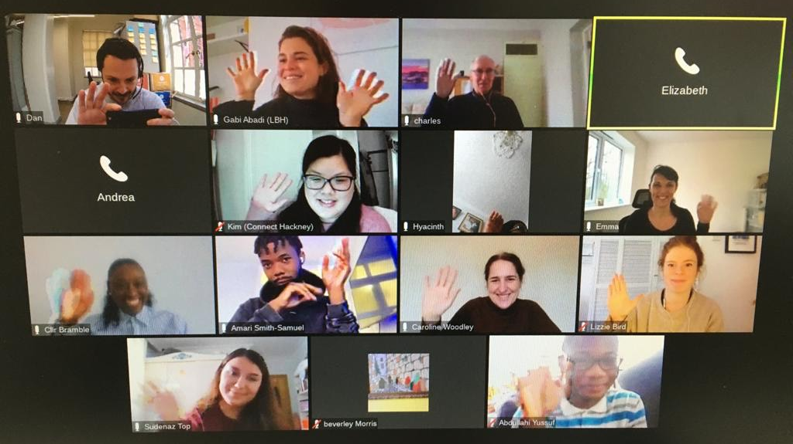
Fig: ‘Child Friendly Borough Intergenerational Workshop’ Focus Group with Growing up in Hackney (full photo permission granted)

The Intergenerational Workshop organised by Growing Up in Hackney brought together older people, young people and Councillors with the Growing Up in Hackney and Parks and Green Spaces Strategy teams. Participants in the workshop discussed ideas, views and solutions around creating inclusive and welcoming spaces and bringing different age groups together in public spaces. Suggestions included making parks accessible for older people and young people with disabilities through the design of benches and the improvement of pathways. They also asked us to consider older young people and adults when designing play in parks. They wanted us to create more spaces to relax and enjoy nature, more areas to socialise and to meet and make friends. Young people and older people need socialising space and spaces to meet and connect.

“A swing is good for the soul at any age- how old is too old to play in the park?”

“I think it would be dangerous to allow adults on their own to go into play spaces, but we could have swings outside play spaces and make the park more fun for everyone”

“Those outdoor gyms with swingy bits are good for everyone”

English Learning Women:

Focus group with 20 x English Learners from Xenia Women

Participants were a mixture of recently arrived and settled migrant women. All of the women agreed that they really needed parks and green spaces, particularly during lockdown where they had used them for exercise and taking their children to play and get fresh air. They told us that parks were important places to socialise and meet friends, but also to make friends. The main concerns they had were around safety, antisocial behaviour , litter and cycling. They agreed that lighting and enforcement of rules was the best way to solve the problems in our parks, but the main issue affecting their enjoyment of parks was dogs - only 1 out of 20 liked to see dogs in the parks. They discussed the parks and green spaces they played in as children outside the UK and the similarities and differences with the parks and green spaces we have in the UK - some liked the wildness, trees and plants, others though they should be even wilder and for some Hackney’s parks were places that reminded them of home.

“Parks need to feel safer for women to walk in”

“I pray to god there is lots of parks because people live in small rooms. We need parks for reading, exercise, running and fresh air”

Older People:

Focus groups and phone surveys with 26 older people from Connect Hackney, Shoreditch Trust Stroke Survivors Group, Age Concern

We gained a lot of insight around older people and their use of parks and green spaces from the Ageing Well Strategy, but we also organised a number of focus groups during the consultation period with Growing Up In Hackney, Age Concern and HCVS. The feedback received about parks and green spaces in these sessions was that our parks and green spaces are really needed, valued and loved by older people. It was also felt that many Hackney parks aren’t yet as good enough for older people as they could be. Suggested priorities and improvements included improving toilets, providing more benches and spaces to sit down and places to shelter from rain. Some said they would like parks to feel wilder and more natural, and there were also discussions about making parks more playful for older people and providing outdoor gyms. The main concerns participants had were around antisocial behaviour , drugs, crime and safety and some participants told us that the presence of park wardens would solve many of the problems we have in parks.
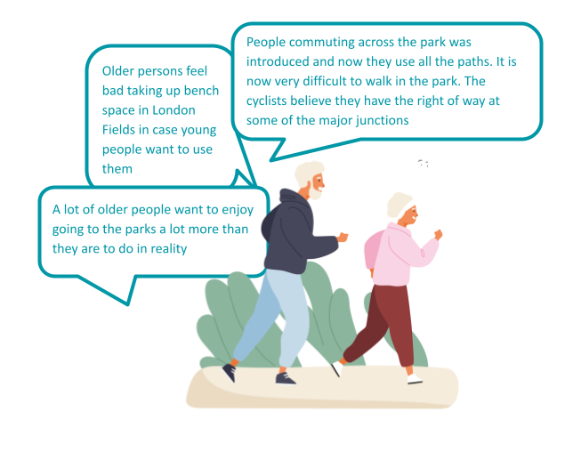
Fig: Some of the comments received in focus groups from older participants

Councillors and Officers

Focus groups and feedback from Council officers and managers working in Parks, Housing, Public Health, Living in Hackney Scrutiny Commission, Healthy Weight Partnership, KPMT, Health and Wellbeing Board.

Feedback received from officers and on behalf of teams and project boards stressed the important role parks and green spaces could play in community cohesion and tackling isolation. They supported commitments around organising more community friendly events, bringing more people together through volunteering, health and wellbeing initiatives, and they highlighted food growing on estates as a great success story of recent years, and suggested we commit to expanding this work. Improving and increasing public toilets as an equalities issue was emphasised as was the lack of a commitment to expanding exercise equipment to help encourage people to be active.

Park User Group diversity was raised as something we needed to look at and provide more support for tackling. Park user diversity was also mentioned and the need to ensure parks were more accessible, welcoming and inclusive of a wider range of local people. It was suggested that we should prioritise reaching out further into local communities when we’re developing and improving parks. They provided us with useful suggestions about working in partnership, making better use of data and asked us questions about how we will evaluate and measure success and how we will keep people informed of progress. They supported our commitment to developing apprenticeships and made suggestions and recommendations about skills and training programmes.

“There is little in the strategy about how it will tackle inequality, and ensuring all parks are accessible to all people. Lack of toilets is a key barrier to residents using parks so it is unfortunate this has not been mentioned.“

“I really like the strategy - it feels very accessible, clear and it's obviously based on lots of listening. There are quite a few touch points with Housing Services - not least around the community grow spaces that we have developed on estates, all of which can play a role in tackling food poverty / social isolation, and encouraging community cohesion / development.”

Quick polls
Hackney Matters Citizens Panel
26 local residents on the Hackney Matters Residents Panel from across the borough

Hackney Matters ran an opinion poll asking: What are the top three issues or concerns in your local park or green space?

26 participants took part and the top 3 responses were no toilets / poor toilets 11 (14%), Doesn't feel safe 8 (10%) and Litter 7 (9%).

Emailed feedback
We received 15 responses to the consultation by email. These were from residents, community groups, external partners and internal officers and teams. All emailed and collective responses were read, reviewed and considered when redrafting the strategy and some of the responses received are summarised here:

- London Beekeepers told us they supported the themes of the strategy, particularly the commitments around sustainability and the climate emergency, but urged Hackney to “go further and faster” with increasing sustainability, becoming zero carbon, banning Glyphosate, connecting green spaces and training staff in biodiversity. They stressed the importance of prioritising flowers to helping increase the wild bee population.

- Resident Liaison Group wrote a letter outlining the importance of housing green space to residents and how the strategy needed to be clearer about the differences between housing green space and parks so it didn’t exacerbate the antisocial behaviour issues some residents had experienced over the past year. There were also concerns about the idea of connecting green space and the impact this might have on housing green space.

- Kings Park Moving Together Project Team wrote a collective response telling us how much they liked the document and the approach, but how they would like to see a greater commitment to reaching out to marginalised groups and responding to equalities issues, such the lack of toilets and free outdoor exercise equipment.

- London Sport told us they broadly supported the strategy and it’s themes, but asked us to place greater emphasis on our parks and green spaces as public health assets, strategically important sites for increasing physical and mental wellbeing and inclusive and accessible sites for all. Specific areas we could go further on were commitments to active travel and health, being clearer in the language used around inclusivity and accessibility and they wanted to see a playing pitch strategy. They also drew our attention to the work of KPMG in the Kings Park ward, which highlighted a need for toilets and free outdoor exercise equipment.

- Public Health Council officers in Public Health were interested to know if active travel, smoking bans and evaluation had come up and generally how we were going to measure the impact of the interventions we were going to put in place to improve people’s mental health, wellbeing and fitness. They suggested partnering with public health, primary care partners and neighbourhoods on volunteer schemes, community event programming and skills development programmes. They suggested making use of inequalities and deprivation data and prioritising toilets in improvement programmes.

- Union of Hackney Gardeners gathered responses from members of the Union who told us to prioritise working with local primary and secondary schools, creating areas suitable for outdoor classrooms, community performances, forest schools they also recommended including the Union of Hackney Gardens alongside the Tree Musketeers as a bridge to the community growing spaces and volunteering on Hackney Council owned land. They would also like to see a Council officer with specific duties around food growing implementation and supporting community growing sites and composting and they told us they were keen for the biodiversity officer to start soon.

- Cordwainers Garden shared with us a report about the impact of their Easy Grow Green programme on housing estates during COVID-19, highlighting the social impact of the intergenerational programmes they ran and they would like more Hackney support for.

- Hackney Marshes Users Group told us the strategy had lots of good things in it and had the right priorities, particularly the commitment around simplifying the process of putting on events. They would like to see stronger commitments to control commercial dog walkers, promote active and sustainable travel, and reduce all pesticides at sports grounds where bees feed on clover.

- Shoreditch Trust Stoke Survivors Group told us they enjoyed Hackney’s parks and felt they were mainly kept in good condition. They felt that parks should provide shelter from rain and there weren’t enough toilets and the few we did have were cold and in poor condition. They told us that they (and a lot of other older people they knew with disabilities and mobility impairments) would like to be able to use parks, but many can’t because they don’t have family members, carers or friends to support them or the transport to get there.

- 4 x local residents the residents who emailed feedback highlighted how important parks and housing green space had been to local families during lockdown, particularly to young people, people with young children and those without gardens. Residents also wanted more wild space and growing projects for residents and told us to prioritise access for residents with disabilities and visual impairments.

- Housing Council officers representing grounds maintenance and resident participation emailed to say they supported the strategy, but would like it to emphasise the success of projects already being undertaken to improve housing green space with residents - particularly the successful food growing and gardening initiatives on estates across Hackney. It was also felt that the strategy should be clearer around the differences between housing estate green space and parks and how any projects or programme affecting housing green space will involve residents, residence groups and will prioritise the needs of the people who pay towards their upkeep.

Section 6: Drafting the final strategy

Feedback about the strategy approach
We didn’t ask participants for feedback about the approach taken to develop the draft strategy and how it is presented, but many told us what they thought and their comments have helped us to redraft and focus some of the chapters and commitments in the draft strategy.

Where participants were supportive of the draft strategy they told us they liked how easy it is to read and how accessible and inclusive it feels. Across the consultation there were mentions of the process of developing the draft strategy and the strategy itself being best practice.

“Host a conference, events to promote your positive approach”
(Citizen Space participant)

“I really like the strategy - it feels very accessible, clear and it's obviously based on lots of listening” (Council officer)

“modern... accessible….the way the rest of the council should be going with regards to writing strategies” (Apprentices and Trainees focus group)

Where participants suggested improvements they asked us to make commitments more focused and specific and to use less jargon. Some wanted us to be more ambitious with our commitments around inclusion and the environment, and others told us we should focus on keeping things simple like keeping parks clean, well maintained and safe as the best way to encourage people to use them.

“No need to be bold and ambitious, incremental change, like nature, takes time, allow maturity to happen naturally.” (Union of Hackney Gardens)

Participants also asked us how will you measure impact? ...how will it be implemented? and ...how will you keep residents informed about meeting the commitments?

“This strategy lacks specifics, as in how will we know it has worked, by when. Also who will monitor it? - will you come back to the people every so often and tell us how well its doing?” (Citizen Space participant)

“Welcome the strategy. In terms of priorities I would like to see short, medium and long terms outputs and outcomes to manage residents expectations” (Citizen Space participant)

Updating the strategy

To prepare for writing the consultation report we read every comment and every focus group transcript.

Before amalgamating and coding the data to get an understanding of what participants were saying overall, we first analysed the data separately to understand the concerns and priorities of different age groups, different types of park users and participants who faced barriers accessing parks and green spaces.

For the most part participants endorsed the draft strategy and welcomed the changes we were proposing to introduce, but the insight about aspects of the strategy that needed to be better explained, that didn’t reflect their experience and the things participants felt were missing entirely really helped us in our work to redraft the strategy.

What you told us… | How we updated the strategy…
Affordable food - Many participants told us they’d like more places to buy food and drink and were pleased to see a commitment to more cafes, but our detailed analysis showed us that 20% of these wanted ‘less expensive’, ‘affordable’ places to buy food and drink. | Updated commitment:  17/ Expand the provision of affordable and healthy food and drink in parks and green spaces
Outdoor gyms - Many participants mentioned improving parks and green spaces for sports and physical fitness - football (28) and basketball (18) were among the most popular requests - but ‘outdoor gyms’ were by far the most popular request (52) with detailed analysis showing that access to fitness that was ‘free’ was important factor | New commitment:  19/ Invest in a network of new, free, outdoor gym facilities
Toilet facilities - In our Citizen Space issues poll 18% of participants voted ‘lack of toilets/poor toilets’ in the top three issues in their local park. In the Hackney Matters poll it was the top issue with 14% of the vote. Older people, families, Council officers and politicians raised the lack of toilets and improvement of toilets as a top priority. | New commitment:  12/ Refurbish all of our park toilets, and explore opportunities for additional toilets linked to new cafe facilities
Activation - In the draft strategy, the chapter on ‘activation’ covered events, activities and facilities. It was conceived as a catch-all to account for the fact that parks and green spaces mean different things to different people. During consultation it was clear that the word was too heavily focused on populating and putting things in parks and green spaces, which was not to everyone’s liking. This word caused issues for housing estate residents, who felt the choice of word didn’t work for housing estate green space. | Deleted chapter:  We will activate our parks and green spaces
Clean, safe and well maintained - Many participants told us that events and activities were only a small factor in your reasons for choosing to visit or not to visit a park or green space. Far more important were the basics like feeling unsafe, dirty benches and not being able to use a toilet. These were barriers for participants across the consultation. This chapter replaces the original ‘activation’ chapter and still has a focus on events, activities and design, but also now has a stronger emphasis and new commitments that will ensure we get the basics right and create more ‘welcoming ‘parks and green spaces. | New chapter:  We will create welcoming spaces
Health and wellbeing - When giving feedback on the strategy vision and missing commitments participants told us they wanted to see a greater emphasis on health and wellbeing, green prescribing activities and that we should be doing more to work in partnership with public health, primary care and neighbourhoods on these programmes. | Updated commitment:  15/Work with partners to prescribe and promote activities across parks and green spaces to improve people’s physical, mental and social health and wellbeing
Older people - Some participants asked us to ensure older people’s voices were heard in shaping parks and green space improvement. The Ageing Well strategy team from Policy told us they would support this work as part of the older people’s scrutiny panel they are putting together. | Updated commitment:  5/Involve young and older people in designing and improving our parks and green spaces to reflect the recommendations of the Hackney Young Futures Commission and Ageing Well Strategy
Orthodox Jewish representation - One participant told us they liked how representative the illustrations felt, but the lack of Orthodox Jewish people depicted in the park illustrations meant that none of the park images felt like their local park in the north of the borough. | Updated imagery: Illustrations of Orthodox Jewish families have been added after guidance was sought with the community to get the representation right.
What about us? - Some local groups asked to be mentioned in the strategy. We have updated our commitment about working with local groups to reflect our ongoing commitment to supporting you to deliver the amazing work you already do to enhance, improve and care for our parks. | Updated commitment:  9/Continue to support local groups to improve their parks and green spaces, and the Tree Musketeers to plan future tree planting in parks
People with Special Educational Needs and Disabilities (SEND) - “You told us that parks and green spaces were a sanctuary and respite for young people” The point was raised that people with disabilities and their support workers also needed parks and green spaces and wanted this to be reflected in the strategy too. | Updated chapter text:  This sentence has now been changed to include people with disabilities and older people.
Heritage - Whilst mentioned in the overview text, a few participants were disappointed that a direct commitment to sharing the rich history and heritage of our parks had been missed in the draft strategy. With such a broad reach we can’t have commitments to everything, but we felt interpretation - heritage and about natural features - should be featured in the design guide. | Updated commitment:  11/Create a design guide to inform the improvement and interpretation of parks and green spaces
Litter - The highlighted top issues affecting our parks and green spaces was Litter. Litter was top of the issues poll, but the suggestion to organise community and volunteer litter picks also came up frequently in suggestions participants had about getting more actively involved. | New commitment:  10/ Set up regular volunteer ‘clean up days’ in our parks  and launch a campaign to reduce littering
Cyclists riding too fast - Voted as the second highest issue affecting parks and green spaces, the issue of cycling continues to be a problem affecting participants' enjoyment of parks. Meanwhile many participants also told us how they learned to ride a bike in parks, enjoy hiring bikes from parks, love wheels sports in parks, and enjoy family bike rides to and from parks. - which makes it very hard to create sanctions on cycling in parks. In addition the Council’s Green infrastructure strategy, to which the Parks and Green Spaces Strategy is linked - promotes cycling and active travel. | - We designed the issues poll to give us data about how cycling affects specific parks to inform future park improvement projects  - Recommendations about cycle calming measures will be suggested in the Design Guide and addressed during park improvement projects  - The speed of cyclists is governed by byelaws. Updated commitment:  13/ Continue to consult people on Hackney’s Dog Control Orders / Public Space Protection Orders and byelaws to help parks feel safer
Dogs and antisocial behaviour - The draft strategy committed to: Consult people on whether Hackney’s Dog Control Orders / PSPOs / byelaws need updating - It’s clear from the consultation that they do need updating and that we need to continue to hear from residents in park improvement projects and to inform our wider strategic work with Hackney’s Community Safety Teams and enforcement to ensure our parks feel safe | Updated commitment:  13/Continue to consult people on Hackney’s Dog Control Orders / Public Space Protection Orders and byelaws to help parks feel safer
Housing Green Space - Working through the Resident Estate Improvement Fund (REIF) data and hearing from and meeting with a wide range of housing estate residents and housing staff, it’s clear that residents and staff have hugely varying and different priorities and ideas for these spaces. Just like parks, we need to work with a good balance of residents who use these spaces and residents who don't to improve housing green space for the communities who live around it. Unlike parks we won’t be directly managing these spaces, but maintaining them and working with the people who manage them to improve and maintain them. It’s clear from the consultation that the draft strategy didn’t make it clear enough our future role in these spaces and the difference between parks and housing green spaces. | New double page:  A new illustrated double page has been added to the strategy to make clear the difference between housing green space and parks.  New wording:  We have also made it clearer in the introduction text that the parks team would be responsible for ‘maintaining’ not ‘managing’ these spaces.
Growing projects on estates - Residents, community groups and Council officers and managers working in Housing told us about the success of growing projects on estates in recent years and during COVID-19. It was felt that we should be doing more of this work, so we have made a stronger commitment to support this work. | Updated commitment:  16/ Introduce three new food growing projects on  housing estates each year
Keeping people informed - Participants asked us ‘How will the strategy will be monitored? Who is responsible for delivering each commitment? How will you report back to us about how the strategy and it’s commitments are being actioned and met?’ | Each year we will produce annual action plans to outline how we will deliver the commitments and annual reports that will update you on progress. Annual reports will be published on the Council’s website and sent to all participants who wanted to be kept informed by signing up to the newsletter.

