REPORT OF DIRECTOR OF THE PUBLIC REALM
DELEGATED AUTHORITY REPORT  PERMISSION TO IMPLEMENT THE REVISED STANDARD FEES & CHARGES FOR MARKETS,STREET TRADING & SHOP FRONTS 2020/21 FOLLOWING THE CONSULTATION BEING CARRIED OUT  7th Of February 2020 | Classification  Open | Enclosures  Appendixes x 7
 | Ward(s) affected  All Wards | Appendix 1: Breakdown of 2019/20 outturn position.  Appendix 2: Markets/Street Trading & Shop Fronts forecasts for 2020/21  Appendix 3: Proposed fees & charges for market licences for permanent and temporary traders and shop fronts.  Appendix 4: Consultation Report  Appendix 5: Miscellaneous Street Trading Bandings.  Appendix 6: Equality Impact assessment.  Appendix 7: Schedule for implementation.

- SUMMARY

- This report details findings from consultations on proposed revisions to fees and charges for the London Borough of Hackney’s Street Trading Licences/Markets and Shop Fronts and the timetable for the implementation of said fees and charges.

- The Council is obliged to operate its markets service in a financially sustainable way and as such the service must fund itself to adequately cover its costs without the need for recourse to public funds. Markets and Street trading performance is difficult to predict; trading activity is seasonal and often acutely affected by the weather as well as external factors such as the declining retail sector and disposable income available to market visitors.

- These proposals present opportunities to reinvest any and all surplus back into improving markets infrastructure, attracting increased visitor footfall and opportunities for traders to increase their sales. Delivering events to benefit & engage the wider communities. Projects to further enhance and grow the service’s portfolio further supporting the growth of local employment and economy in Hackney.

- Appendix 3 provides the full listing of all fees and charges proposed for 2020/21. All proposed fees and charges in this report have been calculated in accordance with the provisions of section 32 of the London Local Authority Act 1990 as amended (LLA1990).

- Appendix 1 provides a breakdown of the 2019/20 outturn position and a full breakdown of individual market forecasts for 2020/21 with an estimated full year effect of the proposed rises based on current occupancy is available in Appendix 2.

- The legislation referred to above allows the council to levy fees and charges for which street trading licence holders are to be responsible in order to recover “reasonable administrative or other costs”. This includes the costs of street cleansing, refuse removal, disposal and all other services rendered to them as far as they are attributed to such trading. We are not obliged to give back any surplus to traders by way of reducing fees the following year of any surplus made but are however obliged to reinvest any surplus back into the service. In addition the Markets account under the LLA 1990 is ring fenced and the council cannot remove or reallocate funds to finance other council services.

- The proposed fees and charges have been subject to consultation with all the respective market associations and consultation with all licensed street traders. They have been revised to take account of the different trading conditions and arrangements for each market, whilst continuing to reflect the requirements of the London Local Authorities Act 1990 (as amended).

- Appendix 7 provides the schedule for consultation and implementation of the proposed new terms and conditions for both Markets/Street Trading and Shop Front Trading.

- The proposals have the potential to raise net external revenue through increases to fees and charges, eradicating the subsidy from an outturn of £290k overspend in 2019/20 (based on the overspend due to the council subsidising the provision of stall hire, set up and take down in all of our markets and street trading sites). Based on the forecast of the proposed fees and charges for 2020/21 the cost of the deficit will be covered and any surplus will be reinvested back into the service as per tour legislative requirements.

- The primary aims of the fees and charges proposes outlined in the report include:

- To eliminate and reduce future risks for the need of public funds to subsidise the costs of running the markets service, with any surplus reinvested back into the markets.
- Levying fees & charges which reflect the cost to the Council of providing the markets/street trading and shop front trading sites.
- Adopting a fair and consistent commercial pricing strategy to reflect the financial viability of each site on an individual basis to ensure they are financially self financing.
- Encouraging markets/street trading and shop front trading to continue to thrive and in turn further support growing local employment and driving the local economy.
- To facilitate strategic development of specific markets – growing markets, increasing occupancy, improving layouts, seeing an uplift in the quality of goods on offer and developing specialised markets where demand exists;
- Supporting new and existing traders to grow their businesses and enterprises within the London borough of Hackney.

- The proposed fees and charges for street trading were consulted on for a total period of over six weeks from 18 November to 31 December 2019, and further extended by over two weeks to the 15th January 2020 to allow for written submissions from the Ridley Rd Market Traders Association (RRMTA). This is in-line with the Council’s Code of Good Practice and above the statutory minimum requirement of twenty-eight (28) days outlined in the London Local Authorities Act 1990.

- Subject to consideration of any representations received, a formal decision to implement any revised fees will be made.The earliest date the revised fees and charges could take effect from, is the 1st April 2020.

- RECOMMENDATION(S)

- The Director of Public Realm, is recommended to:

- Approve the introduction of the proposed amendments to the Standard Fees and Charges for Markets, Shop Fronts And Street Trading licence and Pitch Fees relating to Permanent and Temporary Traders as set out in Appendix 3.

- Approve the introduction of the proposed amendments to the Standard Fees and Charges for Administration Fees relating to Permanent and Temporary Traders as set out in Appendix 3.

- Approve the introduction of the proposed amendments to the Standard Fees and Charges for Storage & Container Fees set out in Appendix 3.

- Approve the introduction of the proposed amendments to the Standard Fees and Charges for Discounted Fees & Charges Options set out in Appendix 3.

- Authorise under delegated authority the Head of Parking, Markets & Street Trading’s final decision to make any necessary amendments to the fees and charges for Markets/Street Trading & Shop Fronts.

- Approve and authorise the decision to make an order adopting new Fees & charges relating to Markets & Street Trading to be introduced and upheld as of April 1st 2020.

- REASONS FOR DECISION

Permanent & Temporary Trader Fees & Charges

- Permanent Traders are extremely important to the ongoing sustainability of our Markets/Street Trading and Shop Front trading operations. They provide a fixed income and the more permanent traders situated in a designated area is an indicator of commercial success, therefore it is imperative we continue to grow this number across all parts of our portfolio.

- Our permanent traders receive a discounted fee as opposed to the fees set for temporary traders, as well as taking advantage of benefits such as being able to pay monthly, have upto 8 weeks to clear any outstanding fees and the ability to trade from the same fixed location every day. This enables traders to grow their enterprise with confidence and build a sustained level of trade. We currently have 148 permanent licensed traders in the London borough of Hackney at present.

- Temporary or casual traders, whilst important to the ongoing viability and sustainability to the long term commercial success to any trading location, are more of a financial risk than a permanent trader. Temporary traders trade on a ‘pay as you go’ basis and are not required to attend the trading site every day in the way that permanent traders are, which in turn has the potential to damage the financial sustainability of a trading site.

- All traders in Hackney begin trading on a temporary basis for 6 months as prescribed by the LLA 1990 before they can apply to become a permanent trader. Temporary traders have the ability to trade when they choose to, pay on the day and can ask for any vacant pitch on the day on a first come first served basis. Temporary traders are not subject to a financial penalty for booking a pitch and then not attending on the day. This report proposes that temporary traders are charged a fee for non-attendance of a pre-booked pitch. There are currently 321 temporary traders trading the London borough of Hackney.

- All increases/decreases in permanent & temporary trading fees have been subjected to benchmarking against other local authority run market services to ensure we are still offering value of money to our service users, whilst recovering costs that are attributed with delivering the service.

- All permanent fees are based on similar profile market boroughs and styles of markets such as 6 days a week, Sat/Sun only.

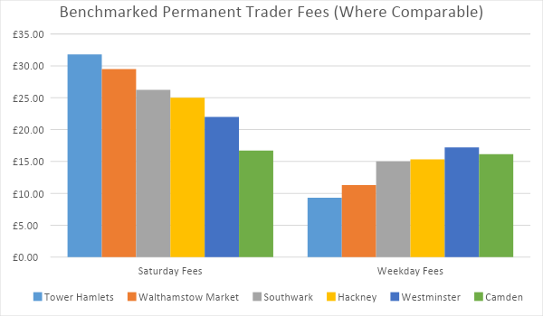
*Tower Hamlets have reduced fees across 9/10 of its markets due to a 47% decline in occupancy over the last 24 months.

- All Temporary/Casual fees are based on similar profile market boroughs and styles of markets such as 6 days a week, Sat/Sun only.
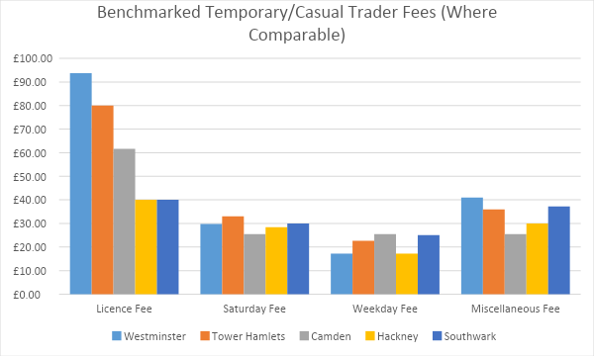
*All fees are based on the available data. Some of the fees listed above are averages where fees vary (depending on location, etc.).

- The benchmarking graphs show the proposed rises in fees and charges and highlights that Hackney council remains competitive by comparison to similar London council markets offering pitches from as little as £8 a day.

- Included in these fees are all of the additional services traders benefit from such as Trading Places training and development courses, provision of stall hire/set up and take down, events and social media marketing for all sites within the portfolio. This is above and beyond the council’s statutory licence issuing duties and what other local authorities provide for the same or similar fees. This continues to make Hackney an attractive borough for new startups and existing traders to expand their enterprises. Income for Market Street Trading forecasts for 2020/21 and full year effect of proposed rises can be found in Appendix 2.

Ridley Road Market

- Ridley Road Market currently operates at a deficit of £221k p.a. due primarily to the costs of daily waste disposal. This shortfall is currently offset by the other markets and urgent action needs to be taken to continue the successful reduction in costs within that market that has been delivered in previous years. The following actions in Ridley Road are proposed:

- The proposed increase of fees for permanent traders at Ridley Rd is 12% and rounded up to the nearest pound in zones 1 and 2. For Fruit and Vegetables and Street Food Traders trading Monday to Saturday, there is between a 14% and 15% increase rounded up to the nearest pound to accommodate for the increase in food waste generated. This enables the significant subsidy of waste charges increase and maintenance charges incurred due to trader misuse of £30k for Ridley Rd specifically to be reduced to break-even by the end of financial year 2020/21.

- The proposed increase of fees for temporary traders at Ridley Road is between 12% and 16% rounded up to the nearest pound in zones 1 and 2. For Fruit and Vegetables and Street Food Traders in zones 1 & 2 there is an increase of approximately between 16% and 17% rounded up to the nearest pound to accommodate for the increase in food waste generated.

- The service trialled a 50% reduction in fees for temporary traders in zone 3 of Ridley Road and tried to increase occupancy in the lowest footfall and commercial revenue generating zone in the market. This incentive has grown the number of pitches sold by 11% and moved the overall occupancy of the zone to 50% utilisation of pitches in the previous calendar 12 months. Therefore it is proposed that we lower the permanent trader fees by 14% and rounded to the nearest pound and temporary fees for Zones 3 are reduced by 14% and rounded up to the nearest pound.

- The graph below highlights the increase in pitch occupancy and utilisation of trading in zone 3 during the financial year 2018/19 with the current discounted fee in place.

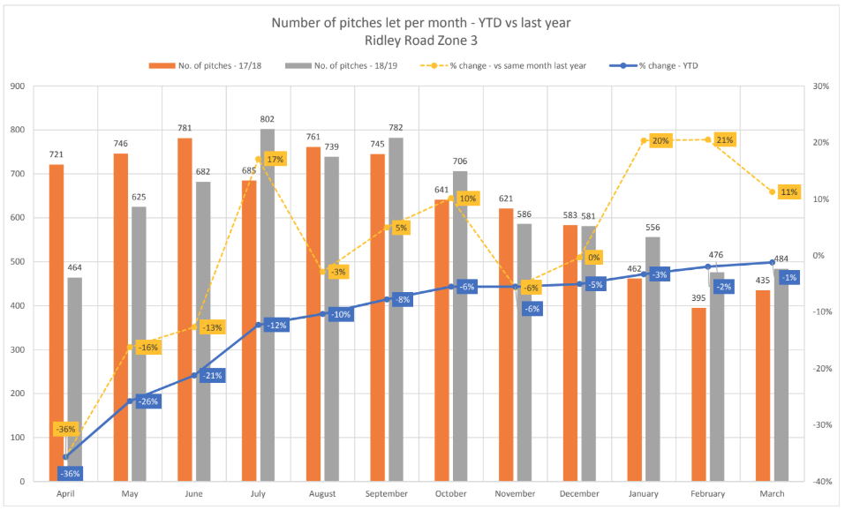
* The graph highlights an 11% increase in pitch occupancy across 2018/19 vs last year.

- The Proposed decrease of fees for permanent and temporary traders in zone 3 in Ridley Road will provide people the opportunity to trade for as little as £8 a day, making it the cheapest 6 day a week market in London to trade in.

- Ridley Road market currently has 10 permanent licence holders who hold a Fri/Sat only Licence. This licence was introduced in 2014 to the detriment of the market as it allows traders to monopolise high footfall pitches and only trade on the two busiest trading days of the week with no requirement to trade on the other 4 trading days. Thus making it difficult for the council to sell the pitches to prospective traders and therefore damaging the financial sustainability of the market.

- This report proposes to remove this type of licence from 2020/21 for new or existing licence holders who wish to apply for a variation to their licence to a Fri/Sat only. Existing traders who currently hold a Fri/Sat only licence, the proposal is to increase all Fri/Sat licence fees in Ridley Road by 20%. This will result in the fees being reflective of the monopolisation of the pitch by guaranteeing the two highest footfall trading days and maximising the commercial income generating opportunity this type of licence provides at detriment to the long term financial sustainability of the market and charged accordingly.

Hoxton Market

- Hoxton Street Market is operated as a street food trading site on Monday to Friday to meet the rising need for sought after trading space in the wards of Hoxton East, Shoreditch and Hoxton West to maximise the space available for trading by the council and then as a full designated street market on a Saturday. The fees and charges are aligned to accommodate this way of operating this site. The waste costs from Hoxton Market Mon-Sat to the service is currently £49k which breaks down to approximately £15 per trader due to the high volume of street food trading and waste produced from them.

- Permanent traders are currently charged a fee of £42 to trade Mon-Sat for non-food and £46 for fruit & veg or street food. This report proposes to raise these fees by £2 a week to accommodate the increase in waste costs. The permanent fee for a Saturday only will be £27 for a non food trader and £29 for fruit & veg / street food trader.

- Temporary traders primarily operate Monday to Friday currently pay a fee of £15 Monday-Thursday and £27 Friday and Saturday, however this is not consistent as the footfall and commercial opportunities on a Friday is the same as Monday to Thursday. This report proposes we charge £17 to trade Mon-Fri and £29 to trade on the Saturday as a non-food trader and £22 a day to trade Mon- Fri and £33 on a Saturday to address this disparity and bring charges in line with the operational costs of managing the trading site and ensure consistency across the trading portfolio.

- Temporary traders who wish to trade in the market on a Saturday only will be charged the same fee as proposed in 3.10 of £29 for a non food trader and £33 for a fruit and veg or street food trader.

- The demand for these pitches has increased by 69% in the last 12 months and to manage and service this need appropriately we need to adopt an increase to cover the cost of increased waste operations and markets management of this trading site. The graph below highlights the 69% growth in occupancy and demand in 2018/19.

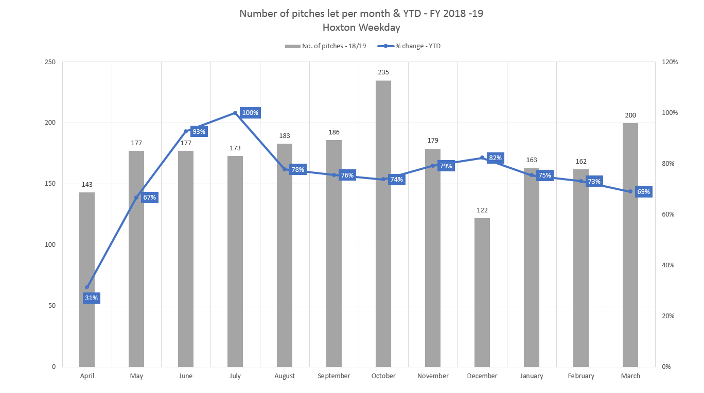

Broadway Market

- The council assumed full operational control of Broadway market in October 2018. The market operates every Saturday between the hours of 9am to 6pm. In this period we have increased the overall occupancy of the market by 47% which translates to selling 7905 more pitches than in 2017/18. The market is now at 100% capacity with no other alternatives to increase its revenue further.

- The below Graph in 3.21.1 highlights the occupancy increase in 2018/19.

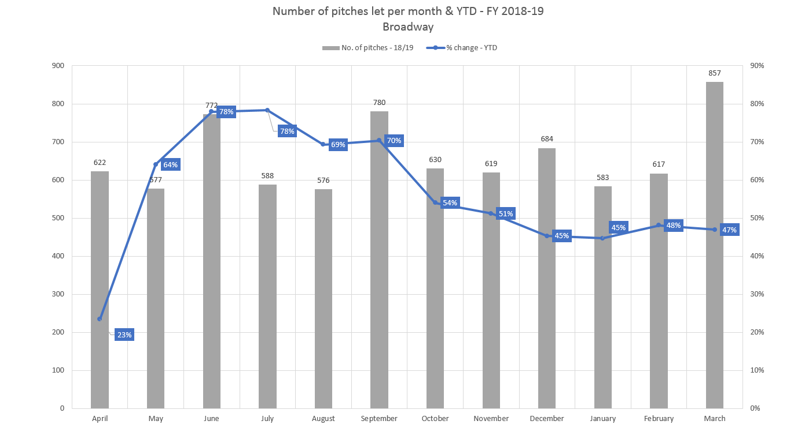
*Broadway Market occupancy 2018/19.

- Not inclusive of stall hire, permanent traders in Broadway market currently pay £14 a pitch for non-food and £15 a pitch for fruit and veg traders. Temporary traders currently pay £15 a pitch for non-food and £17 a pitch for fruit and veg. The current fees and charges make Broadway Market the cheapest market to trade in the London borough of Hackney. The market currently generates £117k per year in pitch fees to the council. All traders currently pay £30 to an external operator to set up and take down the stalls on trading days bringing the total fee for Permanent non-food traders to £50 and £55 for Fruit and Veg and £55 for temporary non-food and £60 for temporary fruit & veg traders.

- During this period we have identified a number of concerns in the financial sustainability of the market irrespective of its reputation as one of London's top 3 markets, its footfall of 2.8m visitors a year* and its commercial success for traders.
*Retail group footfall study 2018

- The market stall assembly is currently operated by the traders association who charge £30 a pitch and generate an estimated income of £187k to which the council does not receive any of this income. A new framework contract for stall assembly will be tendered in 2020 to allow for a more cost effective means of stall assembly for Council Markets as a whole with a new model to be rolled out across all markets & street trading sites.

- The current fee of £14 and £15 does not reflect the true cost of providing x2 market inspectors all day to manage the compliance and provide a high level of visibility and customer service to service users and patrons at a cost of £254 a day or £13k per annum. It also does not reflect the true cost of providing a full market development service catering for promotion,social media promotion and marketing, trader resourcing & recruitment to this fully occupied market.

- The pitch fee also does not include the full waste collection costs. Waste Services have calculated the costs of waste collection for this service to be £43k per annum, which equates to £8 per day per trader. Together with the actual costs of providing an inspection service to these sites means that it is proposed to increase the Permanent non-food trader fee to £50 and Fruit & Veg/Street food trader to £55. The proposed temporary trader fee for non food traders to £55 and £60 for fruit & veg/street food traders. This fee increase will generate an estimated £234k per annum.

- Broadway Market is currently the cheapest market to trade in the borough at present which does not provide a fairness and consistency for traders wishing to trade in Hackney. We also Benchmarked the current and proposed fees for trading against other like for like sites in london. The sites chosen for this exercise were;

- Borough market,
- Portobello rd,
- Jubilee
- Greenwich Market

- The Graph Below highlights that Broadway market was cheaper than the other like for like markets before the proposed fee increase and that Broadway continues to be cheaper despite the proposed increases. Still making it an attractive trading proposition for traders and consumers alike.

- Broadway Price Comparison Graph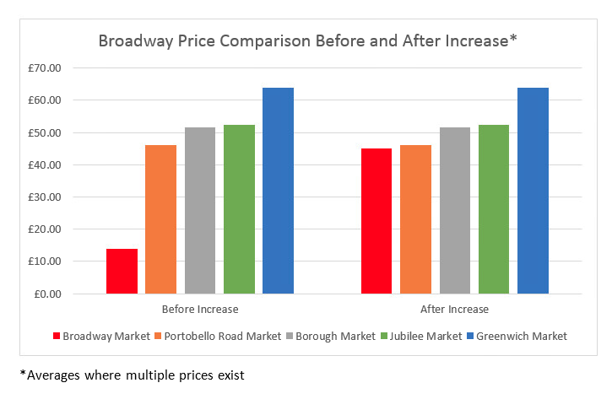

Chatsworth Road Market

- In April 2018 the council took full operational control of Chatsworth Road Market which is the council’s only Sunday market operation at present. It had declined significantly in both footfall and pitches sold to traders, so much so it traded with just 4 traders on the last Sunday before the council assumed full operational control. In negotiating the return of Chatsworth to the Council's portfolio, for continuity of the ongoing market, the council agreed to purchase the existing stalls and gazebos at a cost of £7.5k, take over the leasing of the storage area at a cost of £12k p.a. and employ the x4 stall hire crew members until the council complete the stall hire contract procurement in 2020 which currently costs the market £350 per week to set up and take down the stalls, To date none of these fees or charges have been passed back onto the traders.

- During 2018/2019 Chatsworth road market has organically grown in both footfall and trader demand for pitches. The graph below highlights that across the last financial year the overall occupancy has grown 61% with the service selling 635 more pitches than the previous year and have established Chatsworth Road market as one of London's best street food markets in London as published in Time out’s “ Best Street Food Markets of 2019”.

- Chatsworth Road Market Occupancy Graph.
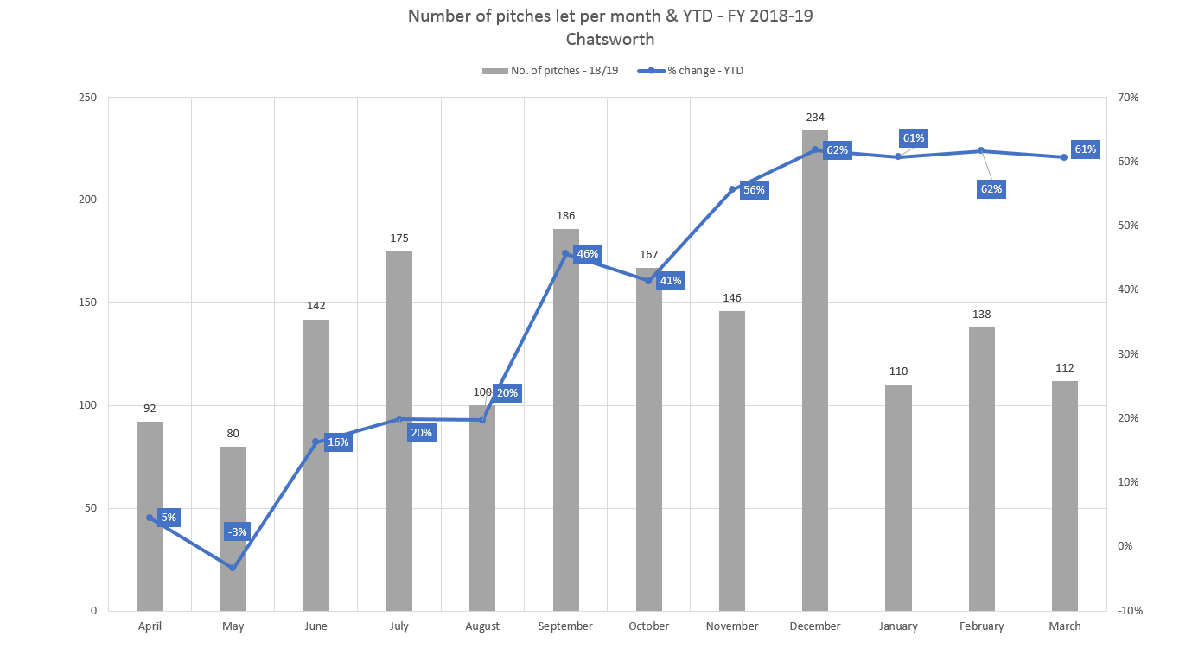

*2017/18 occupancy had declined -16% before the council assumed operation control
*2019/20 occupancy had increased +61% selling 1682 pitches in total.

- The demand from traders for the implementation of permanent licences in Chatsworth road market has been extensive. With this in mind this report proposes we offer permanent licences in Chatsworth Road, which will create a fixed income for the market and provide a platform for the council to reinvest income to continue to grow this market operation to full occupancy of 60 pitches every week. The market currently trades at 83% occupancy.

- The trader profile for this market is primarily street food trading with some artisan non food style traders to supplement this. There is currently no fee for permanent trading in this market. Pitch fees are £15 for non-food and £19 for fruit and vegetable traders and a fee of £20 for stall hire and set up bringing the fees to £35 and £39 respectively. This currently does not reflect the true cost of providing a full markets development service catering for promotion, social media promotion and marketing, trader resourcing & recruitment and a full inspector service to this growing market. It is also not inclusive of the full waste collection costs or stall hire and assembly costs. Waste services have calculated the costs of waste collection for this service to be £21k per annum, which equates to £11 per day per trader.

- Together with the actual costs of providing an inspection service to these sites means that it is proposed to introduce a permanent licence fee of £32 for non food and £38 for Fruit & veg / Street food and for temporary traders we propose to charge £38 for non-food and £43 for Fruit & veg / Street food. All charges are inclusive of stall hire costs of £20.

- These fee changes will allow the loyal trader base to have more security by becoming permanent traders and provide the service with a fixed income from this market providing further financial stability to the operation overall.

Kingsland Market

- Kingsland Market was relaunched in July 2019 and has seen a steady decline of traders from 25 in July to 6 at present who consistently trade every week. The attempts to change the trader and customer profile of this market have been unsuccessful and the service proposes to revert back to its original trader profile and target bric & brac traders for the long term financial sustainability of this trading location.

- Given the trading location does not have a natural footfall or specialised market designation like Ridley Road or Hoxton who are both within less than a mile in either direction and to encourage and support traders to consistently trade and persevere with this site to grow its reputation and footfall despite the minimal footfall this site currently exhibits. This paper proposes a reduction in fees for both permanent and temporary traders.

- This paper proposes a reduction for permanent non-food traders of 8% and permanent Fruit & Veg/Street food traders of 18%. It is proposed for Temporary traders for both non-food and fruit & Veg/Street Food that fees are reduced by 12% in line with other similar profile markets with limited footfall and income generating opportunity.

- The fee reduction in this trading location is expected to make it a more desirable trading location for potential traders of the style of commodity required to meet customer demand and will see demand for pitches steadily increase across 2020 into 2021

Miscellaneous Street Trading Sites

- The demand from traders for the implementation of miscellaneous sites across the borough has significantly increased in 2019/20 and was the services fastest growth area last year with a 70% increase on pitches sold. This equated to 3281 more pitches sold than 2018/19 especially in the wards of Hoxton East and Shoreditch, Haggerston and Hoxton West. Traders are primarily operating Monday-Friday lunchtimes and are on the whole street food traders.

- The current fee structure of £30 Monday-Sunday regardless of the trading location does not reflect the true cost of providing a satellite markets officer to manage, visit and ensure compliance to these miscellaneous sites nor does it include the full waste collection costs. Waste Services have calculated the costs of waste collection for this service to be £30k (which is not fully attributed to the account at the moment) per annum across all miscellaneous sites, which equates to £10 per day per trader. Together with the actual costs of providing an inspection service to these sites means that the current fee structure is not only outdated but not cost effective to the service despite its commercial success and revenue generating opportunity.

- To maximise on the commercial success and demand for miscellaneous street trading sites across the borough and in conjunction with providing cost effective entry points of new startups to grow and develop their enterprises in Hackney. We propose to introduce a 3 tier banding system for trading in our miscellaneous sites. These sites will be branded as:

- Miscellaneous City Sites
- Miscellaneous Primary Sites
- Miscellaneous Secondary Site

- The borough will be split into these bandings as follows:
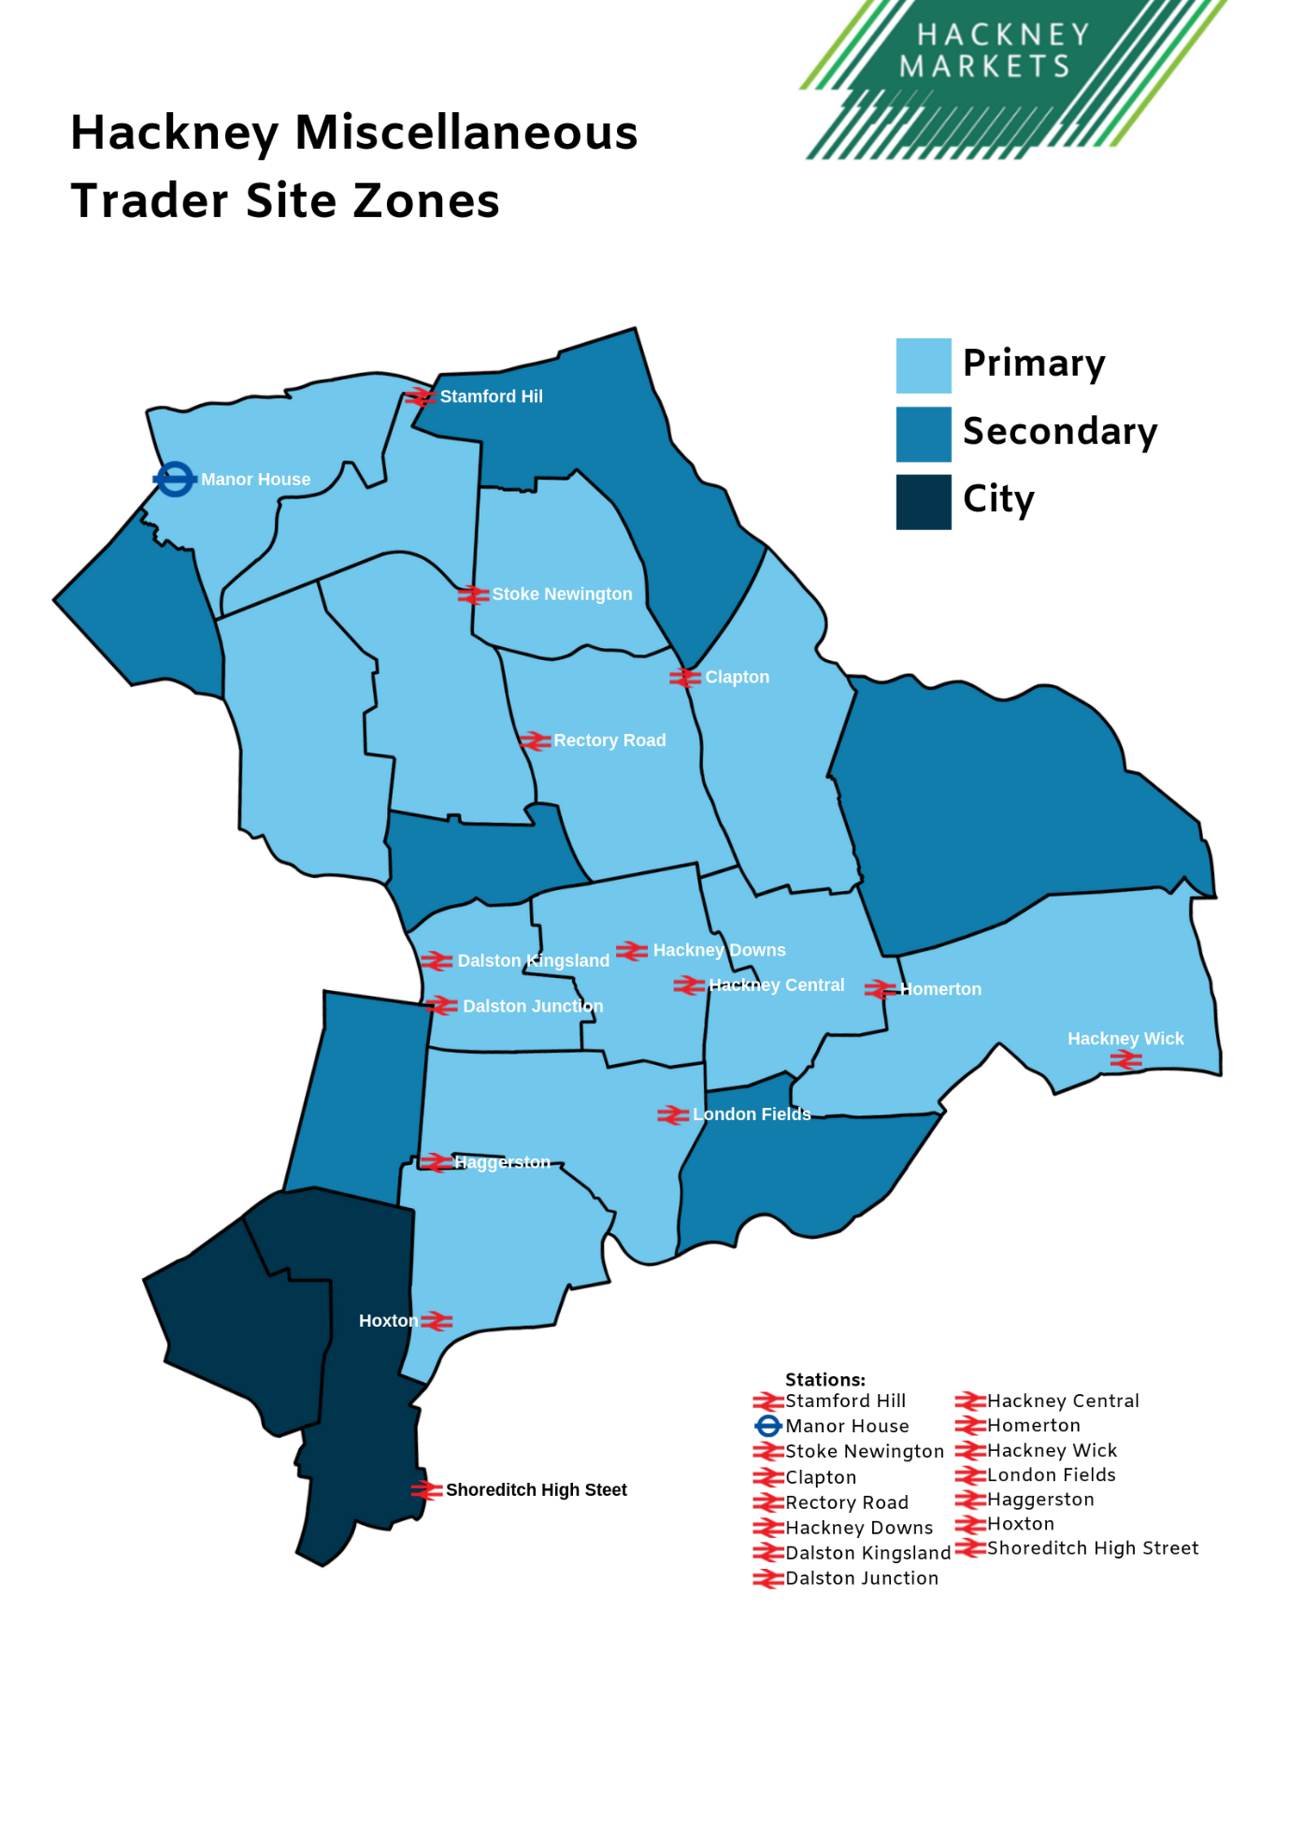

- Each Banding will have a varied tariff rate at individual locations up or down the band - within the pricing structure set out within this paper - where there is clear evidence that the existing tariff is either leading to successful commercial trading, or underutilisation of trading space.

- It is estimated that the new fees will contribute to ensuring the service becomes a self-financing service by the end of 2020/21.

- It should be noted that the increase in revenue put forward is based on the presumption that the current occupation levels of pitches in the miscellaneous sites will be maintained. There is a risk they may decline in some locations as a result of the proposed tariff increases. However, it is more likely that the proposed changes will lead to a greater increase in usage in some areas as we are able to offer a flexible pricing model to miscellaneous trading as we already do in other service areas such as parking who vary tariffs to alleviate excessive parking stress or underutilization of bays dependant on location.

- In order to realise the income levels set out above, it is important to maximise the usage of miscellaneous street trading pitches and sites across the borough. The Markets Services will monitor occupancy following the changes, and – if approved – will change an individual location’s fee up or down a band (within the proposed fee structure) where there is clear evidence that the existing fee is either leading to high footfall and commercial revenue generation or underutilisation of pitches respectively. See Appendix 5 for further information.

Events

- Hackney Council are being asked to support an increasing number of individual localised and commercial events with market stalls needing organisation, licensing and management. It is proposed to have a suite of set fees relative to the scale and type of event to be held in the borough. It is proposed that we offer the following event fees and charges:

- Miscellaneous Single Event Fee of £50
- Commercial Event - Non Food of £150
- Commercial Event - Food Trading of £250
- Hackney Carnival - Non Food Trading of £250
- Hackney Carnival - Food Trading of £400

Market and Street Trading Administration Fees

- The service has seen a significant and sustained increase from internal services, event organisers and current service users requiring the need for an application for a licence to be issued within 24-48 hours outside of our standard SLA of 7-10 working days. This requires significant resource management and we therefore prose the introduction of a fast track application fee of £100 to cover the resourcing and costing of completing this task to the required deadline.

- Other costs associated with operational management of the markets are the need to create and issue arrears, enforcement and / or revocation letters to traders. To cover the cost of administering these tasks and processes we propose to charge a fee for these as laid out in Appendix 3.

- A significant risk of financial loss to the service is the booking of Stalls/Gazebos by traders for one of the markets and then the trader fails to attend on the day. The service currently absorbs the charge of the stall/gazebo from the stall provider and this is not passed back onto the trader. This has cost the service approximately £15k over 2018/19 and 2019/20 alone. This report proposes any trader booking a stall/gazebo and then fails to attend the market will be charged for the costs of the booking the next time they trade. All fees relating to stall hire are laid out in the Street Markets Stall Hire Section of the proposed fees and charges as laid out in Appendix 3.

- The only change to the Fees for Shop Front Trading Licence administration are the introduction of a fee for 1 and 30 Day shop front licences set at the same fee of £100 in line with first time application fees. The proposed fees and charges can be found in Appendix 3.

Street Markets Storage Containers

- The markets service currently provides 20ft and 10ft container storage across a number of market sites in the borough. Historically these fees have been charged at:

- £50 for a 10ft Container
- £100 for a 20ft Container

- The fees offered for like for like storage in the borough are very expensive with an average 20 ft container costing £650 per month in other storage locations across Hackney such as the covered markets or £300 in the Indoor Market Storage area on Ridley road

- These nominal fees and charges for storage at present do not cover the Council’s costs of renting the containers, nor does it cover the costs of the business rates for the land in which they are stored which is also paid for by the markets service. This paper proposals that all container fees are increased by 50% to:

- £75 for a 10ft Container
- £150 for a 20ft Container

- This will enable the council to cover its costs for the land and the supply of containers for storage and provide the council to break even on the costs of storage by the end of the 2020/21 financial year.

Markets/Shop Fronts promotional prices

- To ensure we remain commercially competitive and accessible this paper proposes we retain all the current markets & shop fronts promotional prices we have in place at present and as listed in Appendix 3.

Shop Fronts

- Hackney council currently operates a banding system for applying fees and charges for a shop front trading licence. The system is still broken down into Permanent and Temporary licences across 3 bandings that have set fees in place:

- Less Than 6m²
- Equal to or greater than 6m² and less than 11m²
- 11m² and above

- Fees for Shop Front trading have remained unchanged since 2010 and we are currently out of date with how other London Boroughs operate their Shop Front Trading Services. The majority of London Boroughs charge a fee per m² and some additionally charge a round pound fee per item contained within the shop front licence area.

- Following a benchmarking exercise of other London boroughs fees and charges for shop front trading which can be found in Appendix 3. This report proposes that the London Borough of Hackney adopts a m² fee structure from 2020/21.

- The graph below highlights Hackney currently has some of the lowest fees and charges in London for shop front trading. However having such a rigid banding structure does mean that some sites will pay for more space than they are using or require, other sites will pay less for more space and all in the council are not maximising the income opportunity available or offering a fairer more transparent pricing structure for our service users.

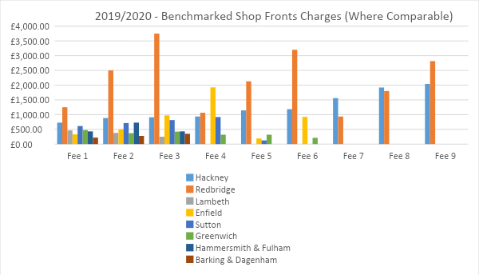
*Benchmarked vs London Boroughs with similar or larger Shop Front Trading activity

- These proposals offer the below fixed permanent and fixed temporary square metre fee from 2020/21 across 3 bandings that have set fees in place:

- Permanent m² fee of £75 per m² used
- Temporary m² fee of £81 per m² used
- 1 Day Shop Front Trading Licence fee of £50
- 30 Day Shop Front Trading Licence fee of £150

- When applied to our current live licences this would generate an estimated increase of £67k per annum, whilst reducing the cost of shop front trading for small business across the borough. It will also result in a more transparent and fairer system of fees and charges related to shop front trading by ensuring businesses are only paying for the metererage they are using which did not happen under the banding system.

- When benchmarking our m² proposals against the other London boroughs, the graph below highlights both before and after the fee changes we still offer a low cost way of expanding your business and sit within one of the cheapest places in London to shop front trade.
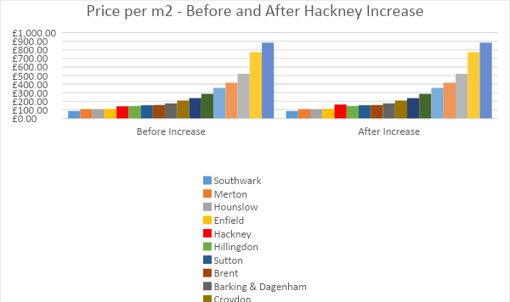

*Benchmarked vs London Boroughs with similar or larger Shop Front Trading activity

‘A’ Board Enforcement Costs

- We also propose a suite of ‘A’ board enforcement charges as set out in Appendix 3 to cover the cost of managing compliance of and enforcing on the councils zero tolerance to ‘A’ boards. These fees have been benchmarked against the other London boroughs and have been proposed to cover the operation costs of visits, enforcement action and seizures for non-compliance when officers are conducting and discharging their duties.

Stall / Gazebo Hire Costs

- A new framework contract for the provision of stall/gazebo hire, assembly and take down will be tendered in 2020 to allow for a more cost effective means of stall assembly for council markets as a whole and will be rolled out across additional markets. Until this is in place all stall/gazebo hire fees and charges remain unchanged.

Retail Price Index % Increase

- We also propose to link our fees and charges from 2021/22 to the retail price index and reserve the right to allow the fees and charges to rise and fall in line with inflation every year. This will negate the need to carry out expensive and resource intensive consultations and maintain the self-financing aspect of the service.

- DETAILS OF ALTERNATIVE OPTIONS CONSIDERED AND REJECTED

- Alternatively the Markets Service would allow trader associations to operate and manage the markets, thus reducing the costs to the council for the operational management. The consequences of this option has been evidenced with live examples of a lack of transparency, integrity and a breakdown in trust between traders and the associations managing markets, where the associations operated them outside of the legislation with evidenced financial impropriety and mismanagement in both Chatsworth Rd and Broadway markets, both of which are now both back under the full control of the council in the last 12 months. Returning to this operating model would lead to significant reputational damage as well as negative impact to the local communities,local employment and the local economy.

- Occupancy growth of 3% in 2017/18 and 15% in 2018/19 has resulted in increased income generation of over 19% so far in 2019/20 against a backdrop of declining retail numbers on the highstreet. Relying on the continued growth of the boroughs markets and street /shop front trading sites over the next 3-5 years is not sustainable in the long term to ensure the service remains financially self-sustaining without the need of a subsidy.

- Expenditure of the service has been reduced by over £400k since 2011/12 when the markets service was operating at a deficit of £1.2m right up until 2016/17 where it still made an operating loss of £250k and therefore in order to ensure street trading in the Borough is self-funding restructuring and increasing fees and charges is essential.

- Attributing increases to the current banding system in the shop fronts fees and charges was considered and thoroughly investigated. Proposals for a 30% and 60% rise were considered and taking into account the current fees are some of the lowest in London and have not been updated since 2010. It was identified that adopting the m² Fee structure was a fairer and more transparent way of attributing new fees and charges.

- Take no action by keeping fees and charges at their present tariff. The consequences of this option would result in the service no longer being a self-financing service and would revert back to requiring subsidy from public funds to operate which would also have a wider impact on the council's ability to achieve its savings plan. No further net external revenue would be raised which would not support the Council’s commitment of a long-term objective that Hackney’s street trading operations should continue to be a self-funding financially sustainable service.

- BACKGROUND

- Markets and Street Trading fees were last increased in April 2016, however this excluded all changes to permanent and temporary trading fees at all other markets/street trading and shop front trading sites other than Ridley Road Market.

- Despite significant improvements in recent years, the Markets and Street Trading Service despite breaking even in 2017/18 and again in 2018/19 have been absorbing significant costs to operating all of the council’s markets/street trading and shop front trading sites without passing on to traders and have had to rely on a subsidy to cover these costs. The council needs to ensure the service continues to be self-funding and solvent and does not fall back into operating under a deficit as it previously did between 2010-2017.

- The proposed fees and charges have been calculated in accordance with the London Local Authorities Act 1990 as amended (LLA), which provides that the Council may set fees and charges at such levels as may be sufficient to cover its reasonable costs in providing services to licence holders. Such costs may include administration costs, marketing costs, maintenance and repairs, resourcing to operate the service and the cost of cleaning streets, collection, removal and disposal of refuse.

- Policy Context

- The Markets Strategy 2017-2020 approved by Cabinet in July 2016 contained the following recommendations:

- Support enterprise & business growth
- Improve the shopping experience for customers
- Ensure our markets are managed fairly and transparently
- To be transparent and open on the current level of subsidy on the Markets Account.
- To secure the financial sustainability of our Markets.

- The proposals contained within this report, together with the approach to consultation will ensure fairness, consistency, openness and transparency in how market fees and charges have been calculated.

- For these range of targets and objectives to be delivered such as all markets becoming financially self financing, reducing waste costs and the removal of subsidy, Some of these need to be incorporated into the traders’ fees and charge and have been included in the final proposal for fees and charges.

- Equality Impact Assessment

- The Council has a legal obligation under section 149 of the Equality Act 2010 to have due regard to the need to eliminate unlawful discrimination and to promote equality of opportunity and good relations between persons of different groups. This will ensure a consistent approach is adopted.

- The Council has carried out an Equality Impact Assessment to identify if any of the recommendations made have an adverse effect on specific groups including disabled traders. Please see Appendix 6 for further information.

- Sustainability

- The on-going sustainability of markets and street trading within Hackney is dependent on the ability to resource and manage the service on a break-even or surplus basis. The fees and charges proposed in this report are a stepping stone to enable this.

- Consultations

- Please see Appendix 4 for the consultation report which details the following:

- Aim of consultation
- Methodology
- Analysis of response data
- Summary of key findings

- Following consultation and due consideration, the proposed revised fees and charges have now been finalised as set out in Appendix 3. This is following consideration of any representations made during the consultation period, any amendments deemed necessary have been incorporated as part of the proposed revisions.

- Once approved, all traders will be informed and notification of the revised conditions will be advertised in line with the LLA which is a minimum of 28 days before 1st April 2020 in the local newspaper.

- Further, in accordance with the LLA, the council shall give all traders at least 21 days’ notice prior to varying their licence and give them the opportunity to appear before the relevant officer determining the matter.

- The council is committed to an ongoing review of operational performance and financial accountability and is permitted to set its fees and charges for shop fronts and street trading. Approval for any revisions will be sought through the council’s annual fees and charges review process, or through a separate review of the fees and charges.

- These proposals and associated consultation process comply with the council’s best practice principle guidelines for setting revised fees and charges, set out by the Governance and Resources Scrutiny Commission in December 2011.

- As a result of the seven-week (7) consultation period any changes to the traders’ standard fees and charges can only be implemented at two points in the year, according to the LLA:

9.7.1 On the 1st of January, or at the point of renewal of licences in Hackney.
9.7.2 On the 1st April each year for all permanent licence holders in Hackney.
9.7.3 It is planned to introduce the revised conditions on 1st April 2020.

- Risk Assessment

- The key risk associated with increasing fees and charges is that traders could be unable to afford the new higher fees and this could lead to a reduction in market occupancy.

- To mitigate this risk, following the commercial pricing strategy for each market will result in fairer and consistent fees and charges based on the opportunity and platform each individual trading site provides for the trader to generate an income which is comparative to absorb an increase in fees & charges.

- COMMENTS OF THE CORPORATE DIRECTOR OF FINANCE AND RESOURCES
11.1 This report provides details of the consultation taken (Appendix 4) on the revised fees and charges for Hackney markets for permanent and casual traders and shop front trading as set out in Appendix 3. It also proposes increases in market and street trading administration fees for temporary license applications and renewal of market licenses.
11.2 The proposals were consulted on for a period of six weeks. A formal decision to implement any schedule of fees will be made and it is anticipated that those proposals, if agreed, will take effect from 1st April 2020.
11.3 The additional Full Year Equivalent (FYE) income forecast to be generated from proposed fees and charges is set out in the table below. This will contribute towards the reduction in subsidy of the markets account from an estimated outturn position of £290k in 2019/20 to a forecast of £13k surplus in 2020/21.
Indicative Income: Proposed Fees and Charges
Market | Projected Gross Expenditure 2019/20  £000 | Projected Income 2019/20 £000 | Projected Net Cost / (Surplus) 2019/20 £000 | Projected Gross Expenditure 2020/21  £000 | Additional Income FYE 2020/21  £000 | Projected Net Cost / (Surplus) FYE post implementation 2020/21  £000
Ridley Road | 932 | (711) | 221 | 959 | (824) | 135
Hoxton | 252 | (108) | 144 | 213 | (134) | 79
Broadway | 255 | (317) | (62) | 243 | (461) | (218)
Chatsworth | 60 | (51) | 9 | 65 | (69) | (4)
Kingsland Waste | 46 | (9) | 37 | 58 | (10) | 48
Misc Sites | 107 | (166) | (59) | 96 | (149) | (53)
Total | 1,652 | (1,362) | 290 | 1,634 | (1,647) | (13)

11.4 The proposed fees and charges incorporate a higher fee/charge for trading in fruit and vegetables to reflect the additional costs associated with managing and disposing of fruit and vegetable waste, (waste charges alone are 60% of the entire running cost of Hackney’s markets and fruit & vegetable waste is more costly to dispose of than general waste).
11.5 The demand for miscellaneous market sites has increased in Hackney which has resulted in additional waste and inspector costs to regulate these sites. The proposal is to increase fees and charges to recover the additional cost of providing the service.
11.6 Additional cost relating to the set up and putting down of stalls has been included as part of the new fees and charges. Procurement is underway to establish a new contractor which will provide a uniform service to the markets and reduce unit cost.
11.7 The proposal for Shop Front Trading is to move to a three banding system as indicated in section 3.50 to bring it in line with neighbouring boroughs. The change will increase income by £67k.
11.8 It is anticipated that there will be minimal adverse risk to stall income from implementing the new fees and charges as proposed. It has been five years since fees and changes were last reviewed.

- COMMENTS OF THE CORPORATE DIRECTOR OF LEGAL AND GOVERNANCE SERVICES

- The setting of fees and charges for street trading is governed by section 32 of the London Local Authorities Act 1990 under which the Council may recover the whole or part of its reasonable costs in connection with the administration of street trading licences and the cost of cleaning streets and the collection, removal and disposal of refuse.

Consultation

Before determining the amount of fees and charges, the Council must give notice of the proposed fees and charges to traders/bodies representing them and publish a notice in a local newspaper specifying that traders/bodies representing them may make written representations to the Council regarding the proposed fees and charges within a reasonable period, not being less than 28 days from the date of publication of the newspaper, specified in the notice.

- In addition, case law provides that :

- a consultation must be at a time when proposals are still at a formative stage;

- sufficient reasons must be given for any proposal to enable intelligent consideration and response;

- adequate time must be given for such consideration and response; and

12.2.4 the product of the consultation must be conscientiously taken into account in finalising any proposals.

- The Council’s Code of Good Practice on Consultation provides that where views will be taken into consideration when making a decision the appropriate time period is 4 to 12 weeks.

- From the information within this report the Council has complied with the requirements to give notice of the proposed fees and charges and provide traders/bodies representing them with the opportunity to make written representations as set-out in Section 9 and appendix 4.

- Given the steps taken during the consultation period the legal requirement regarding the provision of detailed information to enable an informed decision to be taken has been satisfied.

- Approving the proposed fees and charges following the completion of the consultation and consideration of any representations received satisfies the test of the proposed revised fees and charges being carried out at a formative stage.

- The Council has opted to consult on the proposed fees and charges for over 8 weeks in total, which is in accordance with the Council’s Code of Good Practice on Consultation.

- Increasing the 28 days minimum statutory consultation period by over 3 weeks, which is adequate time to consider and respond regarding the proposed fees and charges and as such this legal requirement has been satisfied.

- Representations were received in response to the consultation and were considered before finalising the proposed fees and charges. Therefore, the legal requirement regarding the product of the consultation being conscientiously taken into account when finalising the proposed fees and charges is satisfied.

Extending consultation period

- Any trader/body representing them may request that the Council supply further information or explanation regarding the proposed fees and charges to enable them to ascertain whether the proposed charges are reasonable and have been calculated in accordance with section 32 of the London Local Authorities Act 1990.

- Where such a request is made during the consultation period, that period is to be treated as being extended by the number of days that are taken by the Council to provide the information requested.

Setting fees and charges

- Section 32 of the London Local Authorities Act 1990 expressly states that a Council must consider any written representations received regarding the proposed fees and charges within the period specified in the notice before determining the amount of fees and charges.

- Where the report seeking authority to make the fees and charges includes an analysis of the representations received during the consultation and any resulting changes to the proposed fees and charges it is likely that this requirement will be satisfied.

Notice of fees and charges

- Once the fees and charges have been set, the Council must give notice to traders/bodies representing them and publish a notice in a newspaper of the fees and charges specifying the date on which the charges are to be brought into effect.

- Section 32 of the London Local Authorities Act 1990 does not specify any minimum period before which the fees and charges shall take effect, however, such period must be reasonable.

- The period of 28 days is the reasonable period specified in section 32 of the London Local Authorities Act 1990 in respect of the period within which traders/bodies representing them may make written representations to the Council regarding the proposed fees and charges.

- The same 28 day period should, where possible, be given in respect of the period that the fees and charges take effect from the date of publication of the newspaper notice.

Power to authorise the consultation on the proposed fees and charges

- Consulting on the proposed fees and charges will facilitate the discharge of the Council’s functions under section 32 of the London Local Authorities Act 1990, and so is authorised under section 111 of the Local Government Act 1972.

- The exercise of the power contained in section 32 of the London Local Authorities Act 1990 to set fees and charges for street trading licences and the consultation on the same under section 111 of the Local Government Act 1972 are Council functions which have not been reserved to Full Council and so can be exercised by the Director of Public Realm in accordance with the Council’s constitution.

APPENDICES

Appendix 1. Breakdown of 2019/20 outturn position.

Appendix 2. Markets/Street Trading & Shop Fronts forecasts for 2020/21.

Appendix 3. Markets/Street & Shop Front Fees and Charges 2020/21.

Appendix 4. Consultation Report.

Appendix 5. Miscellaneous Street Trading Bandings.

Appendix 6. Equality Impact Assessment.

Appendix 7. Schedule for Implementation.

BACKGROUND PAPERS

In accordance with The Local Authorities (Executive Arrangements) (Meetings and Access to Information) England Regulations 2012 publication of Background Papers used in the preparation of reports is required

There are no background papers that are not publicly available that have been relied on when preparing this report.

Report Authors | Daniel O’Sullivan – Service Area Manager Markets  Daniel.O’Sullivan@Hackney.gov.uk  0208 356 5981
Comments of the Corporate Director of Finance and Resources | Nurur Rahman – Group Accountant  Nurur.Rahman@hackney.gov.uk  0208 356 2018
Comments of the Corporate Director of Legal, HR and Regulatory Services | Butta Singh – Senior Solicitor for Licensing & Corporate  butta.singh@hackney.gov.uk  020 8356 6295

AUTHORISATION
Director of Public Realm

Name: Aled Richards

Signature:

Date: 20/02/2020

Authorisation of Head of Service Parking, Markets and Street-trading

Name: Kevin Keady

Signature:
Date: 20.02.2020

