Appendix 4 : Knowledge Base used to help prepare the site-specific Equality Impact Assessment.

Introduction

This Appendix sets out a knowledge base used to prepare a site specific Equality Impact Assessment. Preparation of this has allowed the gathering together of informative data in a single repository which can be kept up to date and referred to for any scheme.

It is important to stress that this is not intended to be a generic EqIA.

A full consideration of equality impacts can only be said to have been done when the following checks have been completed:

Determination of the extent to which this knowledge base is applicable. It has been prepared for schemes that are likely to reduce car use on the majority of roads but may increase on others. If the scheme does not do this then this knowledge base must not be used or must be adapted.

It is essential to establish the extent to which the composition of this area in terms of protected group membership statistics is known to differ from the Hackney norm. Where there are statistically significant differences then this knowledge base should not be used or be adapted.

For a full EqIA then there must be an assessment of the particular needs of protected groups in this area by examining which locations might be expected to be of special importance to them. This might include, but is not limited to, places of worship, healthcare etc.

The EqIA is not to be seen as a static document for completion but as an evolving process that continues to monitor and improve conditions for all.

Consultation, Listening and Qualitative Evidence:

It is important to note that this document includes the statistical evidence that has the best availability to represent the needs of people with protected characteristics. This must be supplemented with actual qualitative information on their wants and needs. Where possible this has been done at the very local level, but where this is not possible then reference has been made to feedback from representatives or from responses to similar schemes or to the overarching Hackney Transport Strategy which received widespread feedback from groups including Age UK and Disability Backup. This is a priority, whilst recognising that many people with disabilities feel that other people are speaking for them as discussed in Transport for All (https://www.transportforall.org.uk/).

Feedback used also includes policy positions by organisations such as the RNIB and research such as the ‘Pave the Way’ report by Transport for All. These experiences and insights have been useful for project officers not only to adapt the designs, but also improve the planned communication activities that are part of the proposals.

It is difficult to get feedback on multiple individual schemes from all representative groups, especially those who are charities or rely on volunteers. AgeUK for example have not been able to give detailed feedback on every scheme but their feedback on previous engagements, including the Hackney Transport Strategy was used to inform project officers on individual schemes. This feedback includes removing potential conflicts between pedestrians and other road users, including cars, bicycles and micro mobility vehicles such as e-scooters.

The ‘Pave the Way’ report outlines several experiences of disabled people with the introduction of LTNs, the communication surrounding these interventions and the impacts on a spectrum of disabled people. The report provides valuable insights such as ensuring that interventions are communicated in a proper way and that changes are announced well in advance so that road users, such as taxi services, can adapt to the new routes.

The report also highlights that LTNs can have both positive and negative impacts for disabled people, and that sometimes disabled people cannot benefit from the positives because of other pre-existing infrastructure features (i.e., poor pavement quality).

Hackney has introduced a number of LTNs since May 2020 on an experimental basis while encouraging residents to have their say online or by sending written comments to the Council during a full eighteen-month period. Comments are invited online, by phone or by Freepost address. Although this has a slight negative consequence for those who are not literate, the benefit is that feedback can be based on their knowledge and experience of how the scheme has actually worked in real-world conditions rather than having to interpret plans. It is acknowledged that this is a variation on the methods used pre-Covid in which extensive consultation preceded a permanent decision using a design based on predicted traffic impacts.

Feedback to the scheme along with a Hackney response to issues including those related to age is described in evaluation reports.

Data and Evidence on Protected Groups

Disability: Statistics and Travel Patterns

Hackney has lower than average rates of residents who identify as having a disability. In August 2019, 4,157 were in receipt of Disability Living Allowance and 3,273 were in receipt of Attendance Allowance. In October 2019 9,760 people were entitled to Personal Independence Payments. It should be noted that there might be some duplication in the numbers as people transition from receiving Disability Living Allowance to Personal Independence Payments. However, it is also the case that many people do not qualify for benefits as the thresholds are so high.

Another measure of disability is the percentage of residents who are economically inactive because of being long term sick or disabled is which is 5.2% in Hackney as a whole compared to 3.7% in London. In the 2011 census 14.6% of Hackney respondents said they had a long-term illness that limited their daily activities in some way, compared with 13% for London and 17.9% for England and Wales.

Hackney’s own research indicates that just over 35,000 identify themselves as disabled or with a long-term limiting illness. People from an Asian, Black or other ethnic background and older people are more likely to identify themselves as disabled.

With regards to disability travel, it is important to review the travel statistics released by TfL in their “Understanding our Diverse Communities (2019)”. The following Table 1 taken from page 206 of that document is especially relevant:
 | Disabled | Disabled  16-64 | Disabled  64+ | Non-  Disabled (All) | Non-  Disabled 65+
Base | (1,729) | (789) | (863) | (15,831) | (1,828)
Walking | 81 | 88 | 70 | 96 | 95
Bus | 58 | 64 | 48 | 60 | 70
Car (as a passenger) | 42 | 40 | 41 | 45 | 41
Car (as a driver) | 24 | 26 | 25 | 39 | 52
Tube | 21 | 30 | 13 | 43 | 35
National Rail | 9 | 12 | 5 | 17 | 15
Overground | 7 | 10 | 3 | 12 | 8
PHY (minicab) | 10 | 12 | 3 | 12 | 8
Taxi (black cab) | 3 | 3 | 3 | 2 | 2
DLR | 3 | 5 | 2 | 5 | 1
Tram | 2 | 3 | 1 | 2 | 2
Motorbike | - | 1 | - | 1 | 1
All public transport /bus. Tube, National Rail, DLR, London underground, Tram | 61 | 69 | 52 | 74 | 76

Table 1 Proportion of Londoners using types of transport at least once a week (2016/17 [11]%LTDS - data excluded children aged under five

The TfL data shows that walking (which includes travelling on the pavement with a mobility aid or wheelchair), is the mode of transport disabled people use the most, with 81% indicating that they walk at least once a week. After that, bus travel (58%) is the most frequently used mode of transport, and after that car travel as a passenger (42%) and driver (24%). Multiple answers were possible. It is interesting to note that disabled people in all age groups use cars either as driver or passengers less than non-disabled people. Non-disabled people over 65 have the highest proportion of regular car trips as drivers.

There are 5,664 individuals in Hackney with Blue Badges, which is around 3.5% of the total residential population and 14% of disabled people. The latter figure is lower than the approximately 18.5% in London as a whole and around 20% for England. The figure for England is also around 20%. Some 86% of disabled residents in Hackney do not have a Blue Badge Parking permit.

Other mobility impaired people in Hackney do not have their own car but rely on subsidised car-based Community Transport Services. One of the main schemes by which this happens is Taxicard which is a London-wide service providing subsidised London taxis, jointly funded by TfL and London boroughs, and administered by London Councils. There are currently 2,529 active Taxicard users in Hackney.

There is an overlap between Blue Badge holders and Taxicard users. But even if we assume that there is not it would mean that there are just over 8,000 disabled people who make use of free parking or subsidised taxi travel. This is about 20% of the total number of disabled people. While this is not conclusive it suggests that most disabled people in Hackney are less likely to rely on car travel than the general population of the borough.

Focusing solely on cyclists who have a disability, the Wheels for Wellbeing annual survey shows that 72% of disabled cyclists use their bike as a mobility aid, and 75% found cycling easier than walking. Survey results also show that 24% of disabled cyclists bike for work or to commute to work and many found that cycling improves their mental and physical health. Inaccessible cycle infrastructure was found to be the biggest barrier to cycling. The infrastructure introduced by schemes which reduce traffic within the LTN will benefit disabled cyclists and could potentially encourage people with disabilities to try cycling, if their disability allows.

Analysis based on the London Travel Demand Survey for 2019/20 shows that 7% of trips originating in Hackney are made by someone who has a mental or physical disability affecting daily travel (including old age). Mode split for these trips is shown in Figure 1 below.

Figure 1: Mode share of trips (%) made by Londoners with a destination in Hackney (2017/18-2019/20) by disability which limits travel

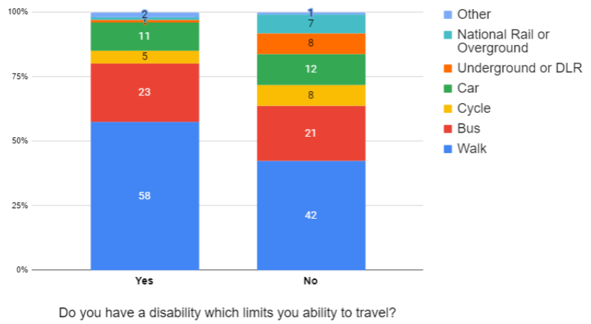

When comparing to the LTDS mode split of trips made by those with a disability in Hackney with non-disabled mode split, it is perhaps counterintuitive that those with a disability are much more likely to walk compared to those without disabilities (58% of trips by disabled people compared to 42% of those without a disability which affects daily travel).

It is also interesting to note that car use by disabled people is slightly lower than by non-disabled people (making up 11% and 12% respectively of trips taken by the two groups). Disabled people are relatively more dependent on buses (23% versus 21%) and slightly less likely to cycle (5% of trips compared to 8% for non-disabled people in Hackney

Disability. types in Hackney stated by those who have a disability affecting daily travel (including old age) is shown below in Figure 2

Figure 2: Disability Types in Hackney stated by those who have a disability affecting daily travel (%)

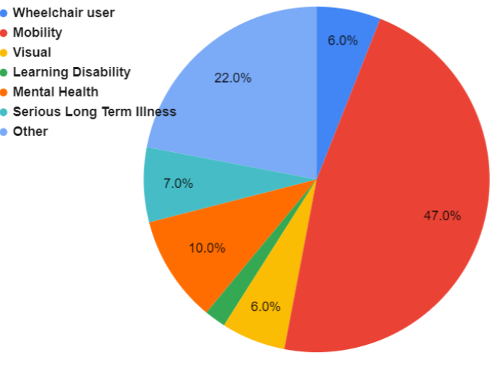

Various physical and mental disabilities can lead to travel limitations. It can be seen that mobility impairment (47%) represents the highest proportion followed by impairment due to Mental Health and ‘Other’ causes - (though this data is based on a small sample).

Disability Protected Group: Impacts of Traffic Changes

The aims of the LTNs of reducing pollution, reducing traffic, and reducing road danger are of critical importance to disabled people, who are among the worst impacted by increased pollution levels and the effects of climate change. The local bus service routes upon which many disabled people depend have not been diverted as a result of the road closures introduced by the scheme.

As the LTNs are specifically designed to achieve reduced traffic levels on residential roads, it has likely become easier to (informally) cross the road for people, including people with disabilities or using mobility aids like wheelchairs (noting that this should not be encouraged, but is something that people frequently choose to do).

As part of the proposals, all addresses and properties remain fully accessible by foot, cycle or vehicle. This is important to support community workers including midwives. Certain journeys will have had to be rerouted as part of the scheme. Hackney’s enforcement policy allows for emergency journeys to be undertaken through the LTN filters/traffic filter. Thus, in case of an emergency, a midwife would be able to traverse the restrictions and successfully appeal a PCN through the Council’s system.

Overall, it is acknowledged that all people with disabilities living within the LTNs may experience more positive impacts than those living on boundary or other roads. Some people with disabilities who must use cars may suffer disproportionately from any increases in journey times.

There are risks of a negative effect on disabled people if displaced traffic and/or less direct journey has any of the following effects

Longer journey times for residents with disabilities, lead to travel becoming more exhausting, expensive, complicated or difficult

Longer journey times necessitate earlier starts for medical appointments, resulting in carers needing to get clients up earlier and overall longer days and more stress

Longer journey times increase the pain suffered by disabled people when sitting in vehicles such as arthritis sufferers.

Longer journey times effect visitors who provide care and support to disabled people

Longer journey times increase costs (whether for petrol or cab fares) for people with disabilities who are more likely to have lower incomes with these costs, therefore, representing a greater proportion of their available money

Furthermore, it is recognised that residents with a disability may rely on motor vehicle journeys made by others, such as carers, NHS, and social services and others and these journeys may become more indirect due to restrictions on through traffic.

Disability Protected Group: Mitigation

A core part of the scheme design is the legal requirement to design for all users. Dropped kerbs and ample space for wheelchair manoeuvre is a standard part of design. Design also takes into account the needs of visually impaired people.

All designated blue badge parking spaces are retained in all schemes and no street in the scheme area which previously had motor vehicle access has lost this access. Emergency vehicles will still be able to access the kerbside. Taxi/PHV will also be able to access the kerbside, loading bays, Blue Badge Holder bays or other locations, to pick-up and drop off passengers with disabilities.

Buses provide a fully accessible form of public transport which are used by 58% of disabled people across London and make up 23% of disabled people’s trips in Hackney. No bus routes have been diverted as a result of our schemes and the potential impact on bus journey times by displaced traffic is always monitored and has, so far, found to be minimal.

Pregnancy/maternity:

There were 4,384 live births to women in Hackney in 2018 corresponding to a birth rate of 58.8 births per 1000 women of childbearing age. This compares to the London birth rate of 60.1 and the birth rate of 59.0 for England and Wales.

Impacts on Pregnancy/ Maternity Groups

The positive benefits of reducing the dominance of motor vehicles would benefit the most vulnerable road users, including parents and children who disproportionately suffer the harmful effects of air pollution. Prams and pushchairs put children at the level of exhaust fumes when navigating the streets. Air pollution has been linked to low birth weight and underdeveloped lung capacity in children, as well as higher incidences of lung conditions such as asthma. Encouraging walking and cycling and working on the school run and more generally through reducing motor traffic is an important tool in combating childhood obesity.

Traffic changes are likely to negatively affect a small portion of those who are pregnant and parents with infants and/or young children who may find it more difficult to walk and may therefore prefer the use of door-to-door transport services. However, whilst a few local vehicle journeys may become more indirect due to restrictions on through traffic, necessary access will be retained to all streets in the LTN area.

Pregnancy/Maternity : Mitigation

The positive benefits of reducing the dominance of motor vehicles would benefit the most vulnerable road users, including mothers and children who disproportionately suffer the harmful effects of air pollution. Prams and pushchairs put children at the level of exhaust fumes when navigating the streets. Air pollution has been linked to low birth weight and underdeveloped lung capacity in children, as well as higher incidences of lung conditions such as asthma. Traffic management schemes produce an overall reduction in vehicle use and air pollution in the area.

The majority of journeys in the LTN area involve walking, either because they are completely walked or through a walking leg to access a public transport stop. The scheme has improved walking conditions by reducing traffic and improving air quality in residential areas.

The scheme has ensured that taxi and private hire drivers are aware that they can access closed streets for the purposes of dropping-off and picking up passengers with mobility impairments, including pregnant passengers. Whilst acknowledging the considerable routing skill of Black Cab drivers, direct instructions have been given to mapping providers such as Google Maps and TomTom about restrictions in Hackney.

Protected Group: Age

Consideration has been given to the impact of these proposals in terms of age. The scheme is very relevant to all age groups, but in particular attention has been paid to older people and young children.

Hackney’s population is growing rapidly; at the present rate of growth the population will reach 317,000, a growth of 43,000, by 2033. Hackney is a young borough. Some 50% of Hackney’s population is aged between 20 and 44 which is one of the highest such proportions in the country and compares to just 34% in this age group nationally and 43% in London.

An analysis for trips made for all purposes ending in Hackney shows the following mode share per age category. in Figure 3

Figure 3 - Mode share of trip (%) made by Londoners with a destination in Hackney (2017/18-2019/20) by age group

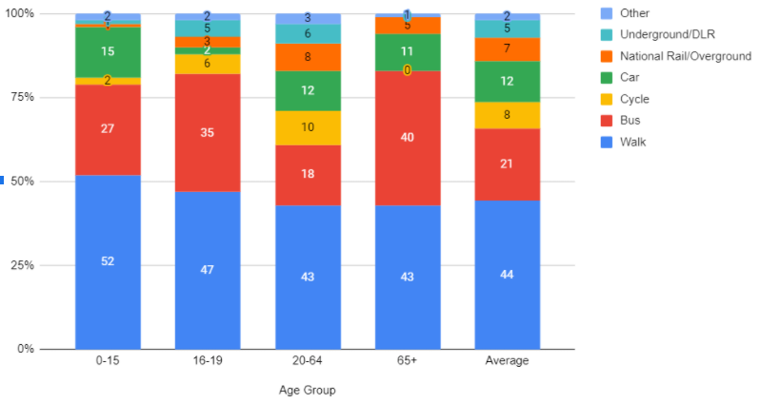

Those aged 65+ have a higher mode split of bus use compared to the average with about average walking and car use mode shares. There is very little cycling amongst this age group. Those aged 0 to 15 have much higher walking and bus use than the average and also slightly higher car use but lower cycling rates. Those aged 16 to 19 also have much higher usage of buses and walking than average and the lowest car use of any age group. Cycling is most popular among the working age adult population (10% of trips) but is lower in both younger and older age groups. Car use is relatively low amongst all age groups but is highest among the under 15s. see Table 2

Table 2 -Mode share of trips made by Londoners with a destination in Hackney (2017/18- 2019/20) by age group
Main mode | 0-15 | 16-19 | 20-64 | 65+ | Average
Walk | 52 | 47 | 43 | 43 | 44
Cycle | 2 | 6 | 10 | 0 | 8
Car | 15 | 2 | 12 | 11 | 12
Bus | 27 | 35 | 18 | 40 | 21
Underground/DLR | 1 | 5 | 6 | 0 | 5
National Rail/Overground | 1 | 3 | 8 | 5 | 7
Other | 2 | 2 | 3 | 1 | 2

Protected Groups: Age - Impacts

The LTN may make certain private vehicle journeys more indirect, due to road closures, point closures and one-way restrictions. This may disproportionately affect those in the 0-15 age category who rely on cars more than other age groups with 15% of this age group’s trips ending in Hackney being by car.

The potential impact on buses is important to monitor with respect to young and old age groups. Both 0-15s; 16-19s and over 65s are far more dependent on bus use than the 21% of trips registered among all residents. The highest dependency on bus use is among the over 65s 40% of whose trips are by bus, but the 0-15 and 16-19 age groups also show higher than average bus use with trips by this mode accounting for 27% and 35% of all the trips in these age groups respectively.

But even among the over 65s walking mode share exceeds bus use 43% versus 40% so the substantial potential benefits relating to an improvement in walking conditions and reduced conflicts with motorised vehicles should not be underestimated.

People of young and old age are more vulnerable to poor air quality. For young children negative air quality can lead to reduced lung development and for the elderly this can lead to a range of long-term health problems, therefore a reduction in emissions from private vehicle use and increases in active modes of travel is benefitting these age groups disproportionately through improved air quality.

Protected Group: Age - Mitigation

Older people are more likely to suffer from slight mobility impairments due to aging, which do not fall under the disability PCG. This can include slower movement and reaction time, and some may use mobility aids for walking. Additional space for walking is likely to be particularly beneficial for those who find it difficult to negotiate narrow and crowded footways. As such, improvements for pedestrians will disproportionately benefit this age group.

The 0-15 age group also stands to benefit substantially from the LTN with some 54% of this age group’s trips being by either walking or cycling. Improvements for pedestrians will also benefit both older and younger people who use public transport, as they are likely to walk to/from the nearest public transport stop.

All schemes ensure that local ambulance, doctor’s and Blue Badge Holder parking bays are not removed or changed. This is especially important for older people, who might need more frequent medical attention.

Bus services are of particular importance to older people and bus services. The speed of bus services is always carefully monitored, and changes implemented where necessary.

Protected Group: Religion or belief, and Race:

The 2011 Census estimates that about 45% of Hackney’s population are Black, Asian and Minority Ethnic groups, with the largest group (around 23%) being black or black British. At ward level, BAME groups form approximately 52%, 60% and 56% of Hackney Wick, King’s Park and Homerton respectively. (Note that the expression BAME is used in this report instead of more inclusive terms such as ‘people with culturally and ethnically diverse communities’ only when it is used in reference sources)

Around 71% of Hackney’s residential population hold a United Kingdom (UK) passport and 11% hold non-European passports. 55% of the residential population in Hackney are of a ‘White’ ethnic group. The ‘Asian/Asian British’ ethnic group population in Hackney (10.5%) is low compared to Greater London (18.4%) but higher than that across England, at 7.8%.

Hackney’s communities represent a diversity of religions and beliefs. Nearly 40% say that they are Christian, 28% say they have no religious belief, 14% say they are Muslim and 6% say they are Jewish. Research has shown that in inner London people with an ethnic minority background are minimally more likely to live on a main road or high street. The report found the following proportions for people living on main roads or high streets versus residential streets see Table 3:

Table 3: Inner London spatial distribution of ethnic groups by main road/residential street
Ethnic background: | Main road/high street | Residential street
White | 8.1% | 90.8%
Black | 8.4% | 90.5%
Asian | 8.7% | 90.1%
Mixed, Other & Arab | 10.5% | 87.7%

Whilst these figures are comparable, it is important to consider these numbers in terms of social equity when implementing schemes that can potentially displace traffic from residential roads to main roads/high streets.

Note that data is not available at household level for these and other protected groups. As such there could be some statistical areas that include both the main road and those on quiet side streets up to 100m away. We are constantly looking for improved data sources and will continue to do this in association with TfL, other Boroughs and third-party agencies.

The argument that LTNs areas benefit primarily the affluent white population living on the residential roads inside LTNs leaving poorer populations on boundary roads and outside the traffic filtered areas has been systematically explored. The results of the study, shown in Figure 4 below, show that a higher percentage of people from ethnic and culturally diverse communities live in LTNs compared to white people. The chart also shows that people in LTNs in Hackney are many times more likely to be in the more deprived half of the national population than in the more affluent half.

Figure 4: Relative differences (ratios) by ethnicity and area deprivation in which residents live inside LTNs by district.

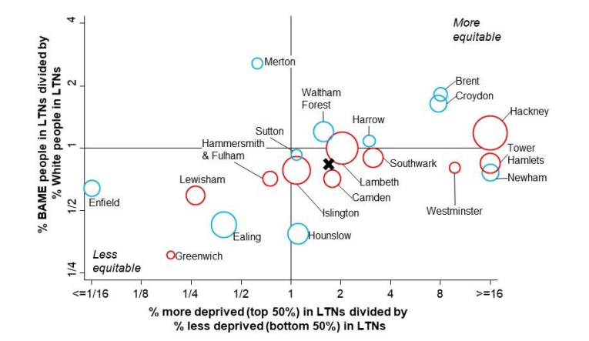

TfL data for Greater London, reported in TfL’s ‘Travel in London: Understanding our diverse communities 2019’ summary of research, shows that walking is the most commonly used type of transport by Black, Asian or Ethnic Minorities (BAME) Londoners (96% of BAME Londoners walk at least once a week, compared to 95% of white Londoners), followed by bus (65% BAME compared to 56% white). The data also indicates that both Mixed or Multiple Ethnic groups, and Other Ethnic Groups, are much more likely to walk (48% and 45%, respectively), whilst mixed and multiple ethnic groups are more likely to cycle (7%), and Asian or Asian British are more likely to drive (6%).

Hackney mode choice by ethnicity. An analysis for trips made for all purposes ending in Hackney shows the following modes shared by ethnic background. see Figure 5 Figure 5: Mode share of trips (%) made by Londoner with a destination in Hackney 2017/08-2019/20 by Ethnicity

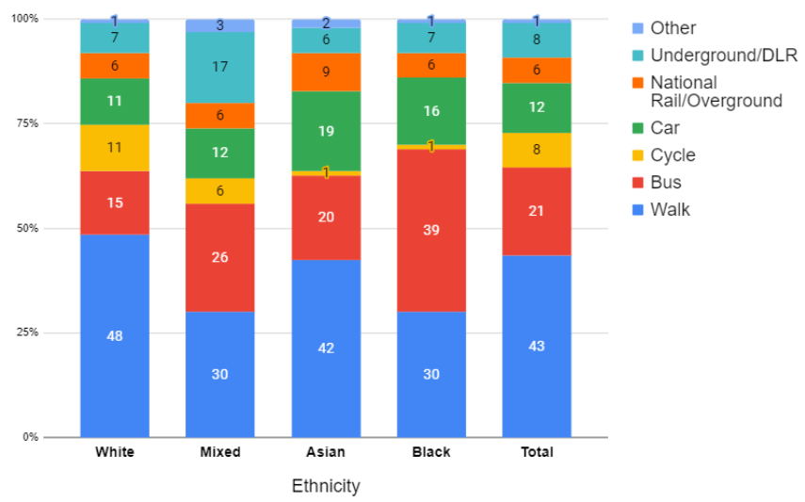

Based on average travel modes in journeys ending in Hackney from the 2018-19 LTDS data, Black or Black British people are much likely to use buses as a mode of transport for a trip ending or beginning in Hackney with 39% of these trips being by bus compared to the 21% average for all groups. Mixed, Other and Arab ethnic Groups are more likely to use buses for transport - 26% of trips by these groups.

Asian people in Hackney have a slightly higher dependency on car trips with car consisting of 19% of trips made by this group compared to average for all ethnic groups of 12%. Black or Black British people are also slightly more car-dependent, recording that 16% of their trips were by car.

Mixed, Asian and Black people also all have a much lower level of cycling trips than people in the borough as a whole with only 1% of trips by Asian people, for example, being by bicycle compared to 8% for the borough as a whole and 11% by white people. Walking is also less prevalent as a means of transport for Mixed/Other/Arab, Asian and Black ethnic groups.

The lower use of walking as a means of transport is not as extreme as the lower cycling rates but still considerable, for instance only 30% of Mixed/Other/Arab and Black ethnic groups trips are by walking compared to 43% for the borough as a whole and 48% among white people. For all of the above statements, it should be noted that these percentages may not be precise due to low sample sizes.

It is important not to read too much into mode choice figures. There are multiple associated factors when choosing cycling, for example, which favours people living in housing with storage, irrespective of their background. It is also the case that a very low level of cycling amongst a group could be taken as meaning it is not relevant. But conversely because of the important health benefits of cycling this could also mean that that group has the greatest potential to increase their use.

Scheme Impacts specifically on the Group protected by Religion & belief and Race

It is the case that Low Traffic Neighbourhoods do make certain private motorised vehicle journeys more indirect, due to the introduction of permeable filters and point closures. This is part of the incentive to create the conditions for positive behavioural change. In the short term this may slightly disproportionately affect those in the ethnic groups that rely more on driving such as Asian and Black communities. However, this should be seen against an overall low level of car ownership in this area.

Research such as TfL’s Analysis of Cycle Potential has shown that there is a greater potential for cycling for people with Culturally and Ethnically Diverse communities. Research has also shown that these groups are also disproportionately affected by Covid-19 and obesity. Therefore, a scheme improving the walking and cycling conditions in an area and enabling more social distancing in a town centre will be beneficial for people with Culturally and Ethnically Diverse communities.

But to realise this potential positive impact also requires insight into, and strong action to address, the barriers to walking and cycling experienced by some ethnic minorities. Hackney has been at the forefront of exploring these barriers through its sponsorship of developing best practice into targeted behaviour change programmes such as its sponsorship of the London Walking and Cycling Conference which in 2020 included themes such as “Walking and cycling whilst Black: barriers, policy and progress” and in 2021 is focussed on the theme of “walking and cycling towards a fair and inclusive city”.

From direct consultation, via focus group for Young Black Men held as part of “Hackney a Place for Everyone” in 2015 that some people in culturally and ethnically diverse groups do experience elevated levels of insecurity. One saying: “I only feel safe in my car”.

Mitigation for the Group protected by Religion & belief and Race

As people from ethnically and culturally diverse communities, especially in Hackney are relatively more reliant on bus services, it is important to check the impact of the scheme on bus services and mitigate any issues.

All of the proposed measures are likely to improve conditions for pedestrians, by reducing conflicts with motorised vehicles and in many cases potentially enabling more space to be allocated to pedestrians. This will disproportionately benefit all people from ethnically and culturally diverse communities, all of whom make more use of walking and cycling than of car trips.

Reducing the dominance of motor vehicles benefits all groups equally, regardless of religion. The proposals in this report do not discriminate against any religious group, as they apply equally to all groups. There is no disproportionate impact on the Muslim or Christian populations as residents or business owners, as schemes never prevent access to shops, places of faith or other cultural or religious institutions. Routes to access these facilities might change, depending on the origins of the journeys.

Protected Groups: Gender, gender reassignment, sexual orientation, and marriage and civil partnership:

The Scheme proposals apply equally to all groups, and thus they do not discriminate against any group, including gender and sexual orientation groups. That being said, it is important to identify any specific impacts on groups with these protected characteristics.

There is a great difficulty in obtaining reliable locally specific data on this group, and their use of transport has not yet been researched.

Protected Groups: Gender, gender reassignment, sexual orientation, and marriage and civil partnership: Impact

Women and people with a non-straight sexual orientation can more frequently be the subject of Anti-Social Behaviour (ASB) and crimes of a sexual nature. Under section 17 of the Crime and Disorder Act 1998, local authorities have to consider the impacts of its proposals on crime and crime prevention.

Reducing traffic on streets can cause divergent impacts on the number of ‘eyes on the streets’. On the one hand, vehicle traffic is decreased whilst on the other hand, enhanced cycling and walking conditions can cause more people to cycle and walk in their local neighbourhood. Together with the Community Safety Team, the impact of all proposals are monitored in terms of crime, safety and the perception of safety. Other measures may be identified through the project to improve (the perception of) safety and reduce the potential for crime. This can include altering the proposed green infrastructure or enhanced lighting in the area

Protected Groups: Gender, gender reassignment, sexual orientation, and marriage and civil partnership: Mitigation

Research such as TfL’s Analysis of Cycle Potential has also shown that there is a greater potential for cycling for women and research has shown that perception of cycle safety differs between women and men. Therefore, enhancing walking and cycling conditions by reducing traffic and improving road safety will be beneficial in particular for women and their cycle uptake. This will be supported by the Council’s ongoing cycle training programme which will include targeted training sessions for various groups, including women.

Recent events have raised the public awareness of street crime and violence against women, in particular. A recent study concludes, for instance that:

“The introduction of the Waltham Forest LTNs was associated with an overall reduction of street crime, particularly more serious crimes involving direct attacks against the person. This supports previous research (Newman 1996), and adds to evidence that LTNs can create safer, more liveable neighbourhoods.

The Council will keep all LTNs and other highway schemes under review and will investigate and take appropriate action if other evidence becomes available.

People experiencing or at risk of poverty:

Although not a group as defined in the Equality act, this group is included for consideration because it represents an important Council priority. For the purpose of this report, ‘poverty’ will be broadly defined as not having enough money to meet basic daily needs, or not benefitting from having what most of the UK population have. Approximately 70% of households in Hackney do not own a car, compared to 44% across the whole of London. This has been showcased in TfL’s Travel in London: Understanding our diverse communities (2019).

While car ownership is not solely dependent on income, there is a correlation between income and car ownership. London-wide, the highest earners are almost 3 times as likely to own one car or more than the lowest earners with 78% of households on £100k or more have one or more car vs 23% at £5k or less, 28% at incomes between £5-10k. Those with incomes of between £15k and £20k have car ownership levels of 44%.

Furthermore, with 70% of residents not owning a car, a significant proportion of Hackney’s population (making up 87.4% of all trips by borough residents in 2020) relies on walking, cycling and public transport for travel and therefore benefits from this proposal regardless of income. At the latest count some 52.1% of trips were by walking or cycling.

Bus use (22.6% of trips) is also very significant. This, once again, highlights the importance of the bus journey time monitoring Given that lockdown restrictions have been removed, it is important that we support the 70% of Hackney Households that do not own a car to walk and cycle instead. If even a small proportion of people who used to travel by public transport switch to using private cars, the public health and road safety implications will be profound for those groups already disproportionately impacted upon by the secondary effects of motor vehicle use, including those on low incomes, BAME groups, the elderly, and children.

Exemptions for the Disabled Community

As part of the LTN experiments across the borough, the Council received feedback from people with disabilities regarding the impacts of those schemes on them. The Council subsequently approved a Delegated Powers Report titled “Exemptions to Traffic Filters on the Borough’s Classified Road Network for Hackney Resident Companion e-badge Holders”. Following that decision, residents with Companion e-badges were able to access through the traffic filters on specific restrictions on classified roads across the borough as set out in the web page Blue Badge holders .

While there are no Bus Gate closures in every LTN scheme, the exemptions to Blue Badge holders on classified road restrictions recognises the fact that Blue Badge holders could be impacted by filters outside the immediate vicinity of where they live.

It has not been possible to exempt all taxis in London from the restrictions without adversely affecting the effectiveness of the scheme. It is recognised that many people with disabilities may use taxis. The Council has undertaken to continue to work with other organisations to try and resolve the issue of how to exempt people with disabilities from traffic filters when using taxis.

Promotion and Monitoring

The equality act specifically mentions that we should “encourage persons who share a relevant protected characteristic to participate in public life or in any other activity in which participation by such persons is disproportionately low.” adding that we should “tackle prejudice... and promote understanding”.

This would appear to support the cause of promoting active and shared travel. The private car is by design a means of avoiding mixing with other people. It follows that anything to promote bus use, and to foster the engagement that can arise when walking or cycling will be a good thing.

The eighteen month trial period for the experimental traffic order has been used to monitor changes in traffic patterns but also in public responses. Particular attention has been paid to any comments on the commonplace platform that mention difficulties faced by protected groups. Even after the trial period has finished, we will continue to monitor and to collect more data and feedback on how best to improve both this scheme and future projects.

Summary

The broad purpose of the equality duty is to integrate consideration of equality and good relations into the day-to-day business of public authorities.

This Appendix is NOT the complete EQIA but should be read in conjunction with the site-specific details contained in the main body of the report. It is, however, a demonstration of the lengths gone to in order to establish the background knowledge essential for the understanding of the specific issues faced by protected groups.

Hackney Council has carefully considered how the function of providing Low Traffic Neighbourhoods can affect different groups in different ways. This will contribute to lower inequality and improved outcomes.

The general equality duty requires equality considerations to be reflected into the design of policies and the delivery of services, including internal policies. This has been done.

The duty requires these issues to be kept under review, which they will be.

Finally, the duty requires organisations to consider how they could positively contribute to the advancement of equality and good relations. The promotion of healthy, active and shared transport represents an important way in which communities can be brought together.

It is not assumed that all impacts on every individual will be positive. There will be some people - within protected groups and without, who will be adversely affected for some specific journeys. These negative impacts are acknowledged, they are understood, and have been quantified as far as is practicable. The LTN scheme proposals are considered to provide, on balance, the best possible benefit to the majority of all residents and all protected groups.

Wheels for wellbeing annual survey 2018: https://wheelsforwellbeing.org.uk/wpcontent/uploads/2019/04/Survey-report-FINAL.pdf
ONS, London Datastore, Births and Fertility Rates by Borough
LTDS 2020
ONS July 2019 to June 2020 estimate. https://www.ons.gov.uk/peoplepopulationandcommunity/populationandmigration/internationalmigration/datasets/populationoftheunitedkingdombycountryofbirthandnationality
LTNs for All?: Mapping the Extent of London’s new Low Traffic Neighbourhoods
Aldred, Rachel et al, Equity in new active travel infrastructure: a spatial analysis of London’s new Low Traffic Neighbourhoods https://osf.io/preprints/socarxiv/q87fu/
ONS 2011 Census, % of resident population
The Impact of Introducing a Low Traffic Neighbourhood on Street Crime, in Waltham Forest, London. https://findingspress.org/article/19414-the-impact-of-introducing-a-low-traffic-neighbourhood-on-street-crime-in-waltham-forest-london
Streetspace funding and guidance - Transport for London (tfl.gov.uk) Appendix 7 - Case-making data for boroughs accessed 1/11/21).
LTDS 2019/20

