DELEGATED POWERS DECISION

STREETSCENE SERVICE
SUSTAINABILITY AND PUBLIC REALM, CLIMATE HOMES AND ECONOMY

Bradstock Road and Cassland Road Junction - Mayor’s Air Quality Fund Super Low Emission Neighbourhood

AGREE TO:

Proceed with the statutory consultation and advertisement of the necessary permanent traffic management orders associated with the changes.

Subject to statutory consultation, to proceed with the improvements at the Bradstock and Cassland road junction, which will include:

Install a blended crossing for pedestrians and cyclists across Cassland Road at the Bradstock Road junction.
Install a raised table on Cassland Road at the junction with Bradstock Road to reduce vehicle speed.
Install sustainable urban drainage, paving, greenery and play-on-the-way features on the footway to the north of Cassland Road.
Blended crossings, where junctions are raised to pavement level to promote pedestrian safety, across Bradstock road.
New motor vehicle access restriction between Cassland Road and Bradstock Road (south).
New no motor vehicle access restriction from Cassland Road into Bradstock Road (north).
Replace 9m of parking spaces on Bradstock Road (south) with double yellow lines to create space for vehicles to turn.
Replace 7m of parking spaces on Bradstock Road (north) with double yellow lines to create space for cyclists and motor vehicles to move safely.
Widen the footway with new planting on Cassland Road with the replacement of 8m of parking spaces.
Widen the carriageway at the junction of Bradstock Road and Gascoyne Road to create space for turning vehicles while maintaining a footway width of >2m.
New cycle stands on the footway at the Bradstock Road and Gascoyne Road junction.
Introduce contraflow cycling on Bradstock Road south of Cassland Road, with specific exemption to pedal cycles for the banned left turn into Bradstock road north.

REASONS

The proposals (Scheme) will create a safer, more pleasant environment for walking, cycling and bus use. They will help make Hackney a more sustainable, greener and safer borough by encouraging users of the borough to give further consideration to using more sustainable modes of transport. This will help improve local air quality, reduce car dominance, traffic speeds and road injuries. It is an important route that brings a high number of pedestrians, who are in conflict with fast moving motor traffic, and the existing crossing provision is non-existent. There have also been many reports of road safety concerns by Wentworth Nursery, reporting many near misses. The TfL collision data map also shows six official collisions including one which involved a cyclist and a car.

Background

  - In its Transport Strategy, Hackney Council has committed to making Hackney’s roads safer for everyone living in, working in and visiting the Borough. These changes are aimed at creating an environment that will encourage more walking and cycling, reduce car dominance and, as an aspiration, help to improve air quality and reduce emissions within the local area.

  - Hackney has extensive experience of reducing motor traffic on residential roads through schemes like Low Traffic Neighbourhoods (LTNs) and Low Emission Neighbourhoods (LENs), so has a unique opportunity to increase benefits from existing low traffic areas by linking them together to form a larger and more cohesive area. Low Traffic/Low Emission Neighbourhoods have now existed in Hackney long enough to begin to influence travel patterns. Pedestrians and cyclists now increasingly benefit from quieter and clean air within these neighbourhoods. A problem arises, however, in that both cyclists and pedestrians can find the connections between areas difficult and unclear due to the need to cross a busy main road. Some connections involve ‘dog leg’ manoeuvres or crossing in the middle of relatively less safe sections of road.
  - Hackney Council received funding from the Mayor’s Air Quality Fund (MAQF) to create a series of safe and attractive connection points, or Gateways, linking together currently separate but adjacent neighbourhoods in order to improve connections that will create seamless journeys and encourage even more people to cycle, walk or wheel. More active travel will mean a reduction in vehicle numbers and improved air quality. The gateways cover a large and densely populated area for which 11,500 properties could benefit, potentially helping 30,000 people. With high quality urban design, Gateways will attract potential users and replace roadspace with greenery and sustainable urban drainage.

  - A combined area (shown in yellow in Figure 1 below) adjoining a Levelling Up Fund project was chosen, which gives access to both match-funding and a team with high level design and project management skills. You can find the junction selected for this decision report in Figure 2 below.
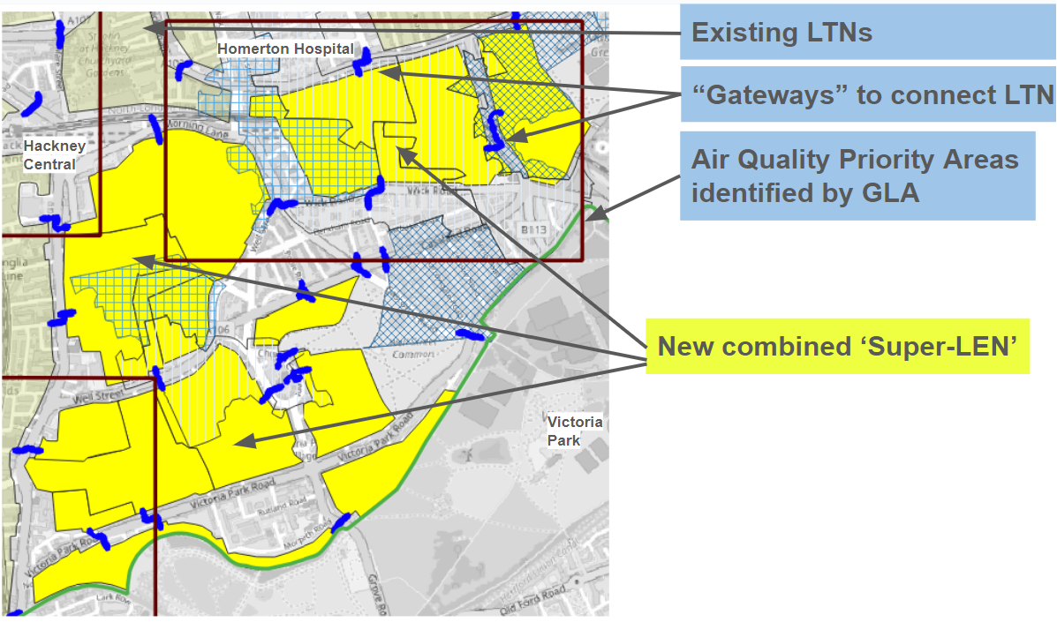
Figure 1: Air quality priority areas

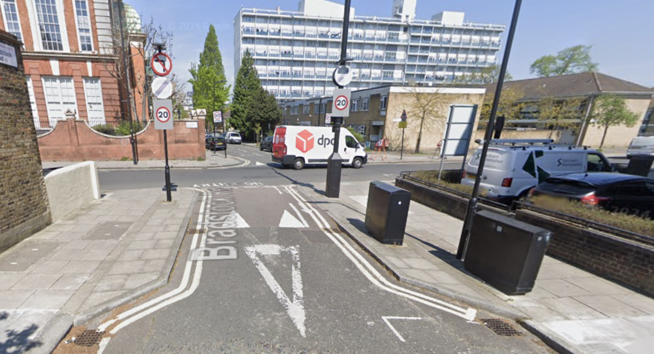
Figure 2: Bradstock and Cassland road junction

  - The junction of Bradstock Road and Cassland Road has been selected for improvement because it is on a key walking and cycling route for local residents. The area is also identified by the Greater London Authority (GLA) as an Air Quality Focus Area and is also at risk of flooding. Local trips that may cross this junction include trips to Homerton Station, Victoria Park, Well Street Common, Wentworth Nursery and Wentworth Children’s Centre, and Gascoyne Community Halls 1 and 2. Hackney’s Transport Strategy includes a Liveable Neighbourhood Plan, which acknowledges that local streets serve more than just a function for parking and driving, walking, or cycling. They are also vital spaces for social interaction and daily living.
  - This junction has also been selected due to its high traffic volumes and speeding creating a feeling of unsafety for pedestrians and cyclists crossing the junction. In July 2024, the 7 day average vehicle traffic count on Cassland Road was 12377 with an average speed of 26 miles per hour on a 20mph road, making it one of Hackney’s busiest roads. We would use this as baseline data and continue to monitor the area to understand how successful the scheme has been.
  - Between the 31st December 2021 and 31st December 2024 there was one slight and one serious casualty at the junction of Bradstock Road and Cassland Road. Both casualties involved a car and cyclist, one impacting the cyclist seriously and the other slightly.
  - This proposal contributes to the Hackney Cycle Campaign Vision Statement. The group has a long history of looking for connectivity for all, rather than just designated space for cyclists.
Three main selection criteria for the Super LEN area were:
- Proximity to GLA NO2 focus areas
- Ability to support equality of opportunity
- A range of connectivity requirements to demonstrate options
  - Hence this proposal offers the chance for high quality interventions, in locations of need, which will be a model for how Low Emission Neighbourhoods across London can be linked together to maximise impact. Maximum benefit will arise from an associated community involvement programme.

  - All Emergency Services vehicles and Council refuse vehicles, as well as pedestrians and cyclists, would be exempt from the restrictions. It would be a traffic offence for non-exempt vehicles to drive through the restrictions, and infractions can carry a penalty charge issued by a CCTV camera.

- Policy Context

  - Hackney Council’s Transport Strategy sets out a coherent set of sustainable transport policies, proposals and actions that aim to further improve walking, cycling and public transport conditions and options for all residents, visitors and people who work in the borough.

  - The Strategy recognises that not only does transport have a critical role to play in Hackney’s continuing physical regeneration, but is also a key factor in achieving other key borough priorities such as promoting transport equality and access to jobs, training and essential services, reducing obesity levels through incidental exercise, supporting the local economy, improving air quality and reducing carbon emissions. In all cases the Strategy recognises that the borough must continue to challenge the potential impacts of greater levels of private car use through greater integration of transport and land use decisions, and through providing sustainable alternatives to meet the aspirations of Hackney’s people while improving social inclusion and combating climate change.

  - This vision supports the broad objectives of the borough for the environment, social inclusion, accessibility, connectivity, health, and supporting the local economy outlined in the Council’s Strategic Plan 2022 to 2026, titled “Working Together for a Better Hackney” and other strategic policy documents, including the Council’s Local Plan LP33 and the Health and Wellbeing Strategy.

  - In addition to securing the necessary public transport improvements to support growth in the borough, Hackney Council wants to encourage its residents to walk and cycle more often and more safely. There are a number of very strong economic, social and environmental reasons why we should seek to do this. Hackney’s population and employment are amongst the fastest growing in London, meaning that future travel patterns and the demand for travel will need to be carefully managed.

  - Creating a travel and transport system that is safe, affordable and sustainable, and that fully supports residents and local businesses, is a key reason for producing the Transport Strategy.

Road Safety Plan

  - Hackney Council is committed to making our streets safer for all users and to reduce road traffic casualties from road traffic accidents. Hackney recognises the role that reducing casualties and improving the perception of the borough as a safe place to walk and cycle has on facilitating modal shift and will continue to seek innovative ways to do this. Any investment from available sources in road safety will be priority based and data led. The borough also understands the need to tackle the relationship between areas of deprivation and high casualty rates, and will seek to address this through the Road Safety Plan. Achieving further casualty reductions will require greater effort and a coordinated approach with TfL, our neighbouring boroughs and engagement with road users, persuading them to behave more safely. This Road Safety Plan 2015-2025 outlines some of the more successful initiatives undertaken by the Council to date.

Cycling Plan

  - The Scheme should help to encourage cycling, which would align generally with Hackney’s Transport Strategy. Hackney is synonymous with cycling in London, with many thousands of trips being made every day on the borough’s streets, parks and towpaths. Hackney has the highest levels of cycling in the capital and has set an ambitious long-term target of 15% of all journeys to be made by bicycle by 2025. Reducing the dominance of the private vehicle will contribute to achieving this aspiration.

  - It is considered that the Scheme would accord with a number of relevant policies set out in the Council’s supporting plans to the Transport Strategy i.e. Walking Plan, Cycling Plan, Public Transport Plan, Liveable Neighbourhoods Plan, Road Safety Plan, and Sustainable Transport Supplementary Planning Document, which form part of the Council’s Transport Strategy:

- LN15/C33: Filtered Streets - reducing motor traffic on residential streets. Hackney Council will continue to work with local residents and key stakeholders to identify, trial and roll out additional filtered streets schemes across the borough to reduce shortcutting and through motor traffic.
- C08: Reallocation of Road Space - the Council will continue to reallocate carriageway road space from private motor vehicles to cycle infrastructure provision, whether it be cycle parking or route provision.
- LN3: Improving air quality - Hackney will continue to tackle poor air quality, seeking to reduce NO₂ emissions to achieve the National Air Quality objective of 40 mg/m3.

  - Hackney Mayoral Priorities The Scheme also aligns with Mayoral Priorities as set out in the Strategic Plan:

- “We will create safe, vibrant, and successful town centres and neighbourhoods”
- “We will continue to lead the way in the fight against climate change, working towards a net zero Hackney, with cleaner air, less motor traffic, and more liveable neighbourhoods”

  - Mayor of London’s Policies It is also considered that the Scheme would accord with a number of the Mayor of London’s policies. The central aim of the Mayor of London’s Transport Strategy (2018) and its 2022 update is to create a future London that is not only home to more people, but is a better place for all of those people to live in. It recognises that the success of London’s future transport system relies upon reducing Londoners’ dependency on cars in favour of increased walking, cycling and public transport use, and that this will bring with it other benefits.

  - The Mayor of London’s aim for 2041 is for 80 percent of Londoners’ trips to be on foot, by cycle or by using public transport. Further, the Mayor of London’s Vision Zero (2018) sets out the goal that, by 2041, all deaths and serious injuries will be eliminated from London’s transport network. One of the ways to achieve this goal is to facilitate and prioritise walking and cycling, which was one of the main objectives of the Scheme.

Climate Emergency Declaration

  - Hackney Council is committed to doing everything within its power to deliver net zero emissions across Council functions by 2040. That’s ten years earlier than the target set by the government.

  - When we made our commitment, the Council’s resolutions include to:

- Tell the truth about the climate emergency we face and pursue our declaration of a climate emergency with the utmost seriousness and urgency.
- Do everything within our power to deliver against the targets set by the The Intergovernmental Panel on Climate Change (IPCC) October 2018 1.50C report, across our functions (including a 45% reduction in emissions against 2010 levels by 2030 and net zero emissions by 2040), and seek opportunities to make a greater contribution.
- Involve, support and enable residents, businesses and community groups to speed up the shift to a zero carbon world. Work closely with them to establish and implement successful policies, approaches and technologies that reduce emissions across our economy while also improving the health and wellbeing of our citizens.

Consultation

  - We have engaged with a number of statutory consultees, as is required for any traffic scheme. Additionally, ward members have been consulted.
  - Our consultation with residents, visitors, and people who work in the area included survey drops and three in-person engagement opportunities.

Local Ward Councillors

  - An initial stakeholder walk around was organised with ward members and community members during which no objections or concerns were received.

Emergency services

  - Emergency Services (and Council refuse vehicles) will not be impacted by the closures in any way as they are open style closures (i.e. no physical gates).

Hackney Council Parking Team

  - The Bradstock Road and Cassland Roads parking stress surveys indicated that there would be an issue as the current level of parking stress on those two roads is 108.6% and the loss on approximately 5 spaces would increase that to 111.7%. However when we include Annis Road, Christie Road and Harrowgate Road, the current stress levels in the area drop to 78.2% (increasing to 79.1 %), and drop even further to 74.3% (increasing to 75%) if we include Danesdale Road and Hedgers Grove. Therefore, the loss of the parking bay will have some impact on the residents in the immediate area. As there is other parking on adjoining roads the impact of this scheme will be kept under review but does not pose a current issue.

Hackney Community Safety

  - Our Community Gangs team advised that while there were historically issues in this area, the problem has since shifted elsewhere. However, seating in this location may encourage individuals to loiter and gather in groups. Additionally, the plants and flower beds, which are often left unmaintained and become overgrown could potentially be used to conceal weapons.

Hackney response:

  - We acknowledge the concerns raised by the Community Gangs team about seating in the design encouraging loitering and, after reviewing the feedback, the seating proposed will be informal tree stubs arranged in a way that prevents anti-social behaviour, see appendix 1.

Hackney Cycling Campaign (HCC)

  - Hackney Cycling Campaign (HCC) responded very positively about the designs for the gateway across Cassland Road. They were pleased that another gateway would be completed and that it would greatly facilitate all age cycling on the route from Chatsworth Road towards the Victoria Park / London Fields area. They particularly appreciate the proposed closure of Bradstock Road, the continuous crossings and the parallel crossing on Cassland Road. They also offered a couple additional considerations, including:
- The plans include a pedestrian island. An alternative design, such as a bollard similar to the one on London Lane/Mare Street, could be considered to save space while offering a comparable pedestrian experience
- Why the junction isn’t a continuous crossing like it is on the southern side

Hackney response:

  - Although we acknowledge the possibility of installing a bollard, Hackney Council will retain the pedestrian island as it creates a safe refuge for pedestrians while crossing. With regards to a continuous crossing, this could be problematic due to the amount of traffic and the load the materials would have to withstand, which would require regular maintenance.

Public consultation

  - On 7 July 2025, Hackney Council delivered around 370 public consultation leaflets and questionnaires to give residents the opportunity to comment on the proposals for the Bradstock Road / Cassland Road junction. The consultation closed on 8 August 2025. The consultation and proposals were also published online, where residents could also share their views: https://consultation.hackney.gov.uk/streetscene/gateways/. Residents were also able to write to streetscene.consultations@hackney.gov.uk.

  - All paper and online responses received between July and August 2025 were analysed and they are shown from Section 3.10.

Public consultation analysis

  - A total of 8 paper responses were received from the questionnaires distributed in July 2025. A total of 50 online responses were received. Figure 2 shows the responses agreeing / disagreeing with the proposals (number and % of responses).

  - 68.4% respondents agreed or strongly agreed to the changes, 24.6% disagreed or strongly disagreed and 7.1% were unsure or did not answer this question.

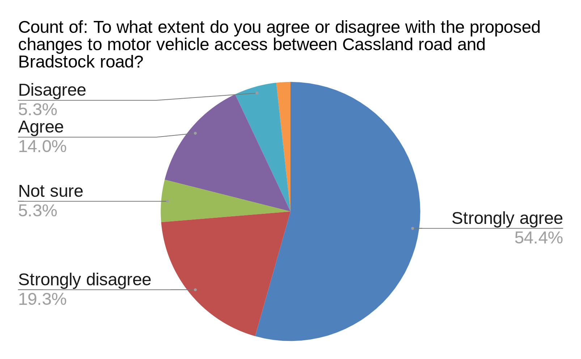
Figure 2: Percentage of respondents that agree or disagree with the Bradstock Road and Cassland Road junction proposals

  - As shown in Figure 2, there is overall more support for the scheme.

  - High levels of dissatisfaction for the junction as it currently is were recorded in the Healthy Streets assessment filled out from the survey. An average of the marks given by respondents was calculated and showed poor rankings in terms of the healthy streets indicators, see Table 1 below.

Healthy Streets Scoring (out of 10, 10 being ‘extremely’) | How clean do you think the air at this junction is? | How intimidated do you feel by the traffic on Cassland Road? | How safe from crime and ASB do you feel at this junction? | How noisy do you find Cassland Road? | How easy do you find it to cross Cassland Road? | How easy is it to find shelter, for example if it was very sunny or raining? | How easy do you think it would be for you to find somewhere to sit or rest on this street if you needed to? | How enjoyable do you find being on this street?
Average /10 | 3.4 | 6.2 | 3.7 | 6.6 | 3.7 | 3.9 | 3.5 | 2.7
Table 1: Healthy Streets assessment of the Bradstock Road/Cassland Road Junction

  - Detailed responses were grouped to represent common themes and issues, related to the scheme. One response may fit into several themes. The themes and Hackney’s responses to those mentioned more than twice are summarised below.

  - Figure 3 shows the summary chart for the themes from the responses.
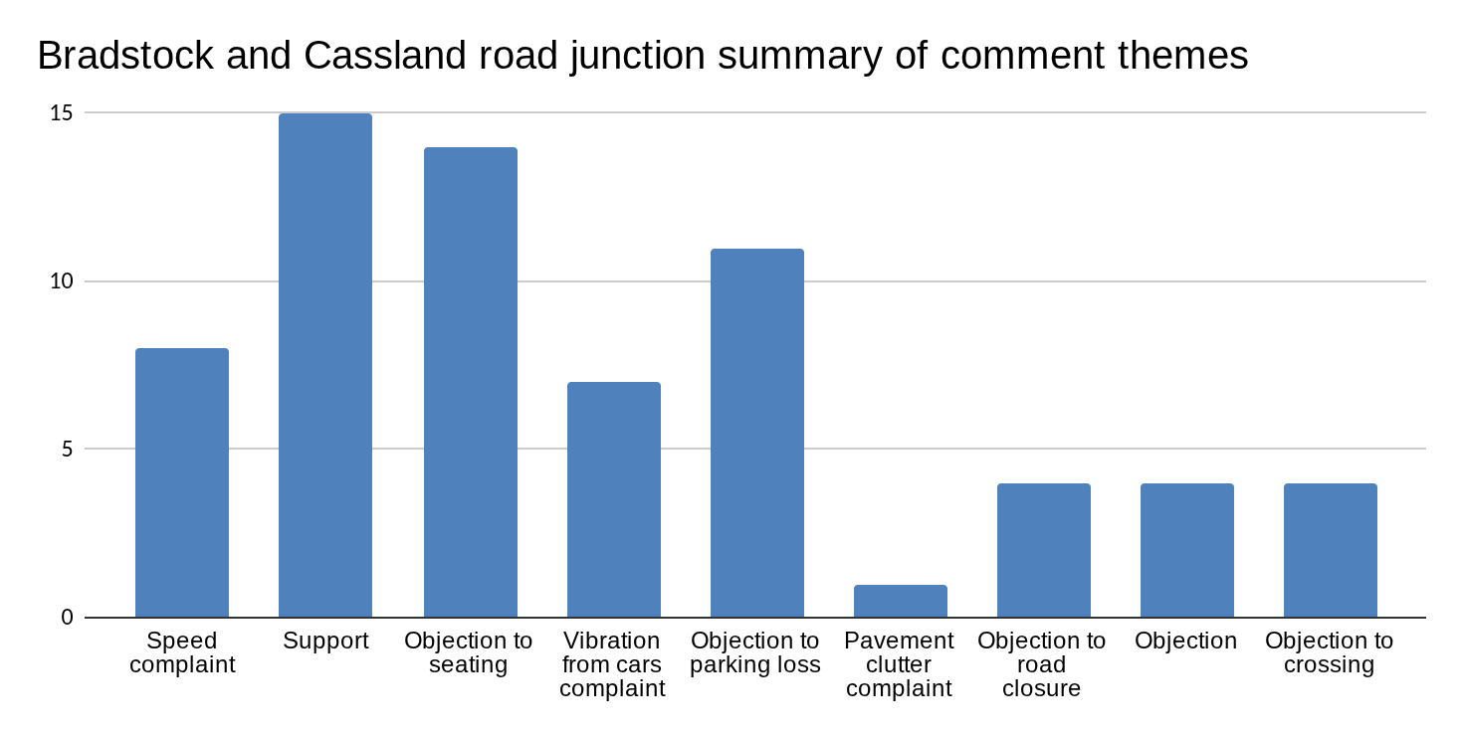Figure 3: Summary of comment themes from responses

Example comments relating to general positivity are provided below:

I broadly speaking agree with the proposal to make this area more pleasant and safe - in particular introducing a parallel crossing for pedestrians and cyclists is definitely a necessity.

Suggestions for urban drainage, paving, greenery are also welcome to make it a more attractive area. The motor vehicle access restrictions are also welcome as it’s a typically very busy area.

I support them wholeheartedly as someone with a toddler. I am frequently walking through here and exposing us both to pollution and fast moving cars that don’t care about pedestrians. I also cycle through here to work.

The new crossing will be a big improvement as it takes too long to walk around to the existing one and people dash across the road here.

I'm very glad these measures are being brought forward, as I have felt for years that this was a potential missing connection between quiet routes in the area. As in, I have found myself naturally heading to cross Cassland Road at this point (on foot or cycling) on a few occasions, and then being surprised that there's no facility to help you unless you head significantly out of your way. Currently it feels like you have to either wait a very long time for there to be absolutely no cars, or take a risk that the cars approaching from a distance don't accelerate unexpectedly.

Example comments objecting to the crossing:

We also have two zebra crossings so not sure why you would find it difficult to cross! Also the cyclists whizz out of Well Street Common with no regard for pedestrians and this plan will make their righteous behaviour even worse.

If there needs to be zebra crossing then this should replace the existing traffic lights which are both within a minute away. It makes no sense to have two traffic light crossings which are fairly close and then a zebra crossing to add to that in the middle

Plant more trees and move zebra crossing on Wick road.

There are already enough crossings in Cassland road between Jenton road onwards.

Hackney response

We believe that the introduction of an uncontrolled pedestrian crossing at this junction will improve visibility for both cyclists and pedestrians as well as encourage drivers to reduce their speed. The current plan represents a balanced approach to improving safety and visibility within the confines of our available resources.

Example of comments against the removal of parking

- Strongly disagree with the loss of parking spaces on Bradstock Road North. There are rarely parking spaces free on the road and it will be prohibitive to residents who pay for parking permits to then park on that road. Two parking spaces have already been lost to electric parking spaces so do not agree with losing even more.
- I understand you are trying to promote fewer drivers, however taking car parking spaces away is going to cause a lot of issues... the road is already full, where would you propose to put the other paying residents and their cars who have paid for yearly parking permits? You would have to extend the parking area to other streets and the build up of parked cars would worsen... How will delivery people come down if it is just a one way system?
- Strongly support the proposal, however Bradstock north has already lost car spaces due to cycle store and two EV parking bays - plans should try to minimise.

Hackney response:

  - The Council’s Parking Services are in agreement with the removal of these parking spaces as this is necessary to achieve pedestrian and cycle improvements.

  - While we recognise that parking may be an issue in some areas in Hackney and the removal of parking spaces can be challenging, our primary goal is to enhance the safety and efficiency of our transport network. The planned improvements, including the relocation of bus stops and the introduction of an uncontrolled pedestrian crossing, are designed to benefit vulnerable road users and improve overall traffic flow.

  - Much of Hackney’s residential areas are very accessible by frequent and reliable public transport, are within easy walking and cycling distance to local amenities and car ownership levels are also amongst the lowest in the country.

  - It is in Hackney’s Transport Strategy and the Mayor of London’s Transport Plan to try to manage parking as a key tool to minimise general car use and promote sustainable modes of transport, particularly in areas of high public transport accessibility levels (PTAL). The reduction of parking bays may encourage some drivers to reconsider their mode of transport for at least some journeys.

  - A full Equality Impact Assessment on ethnicity, children, disability, LGBT is included in Section 5 of this report. Fair treatment of all disadvantaged and protected groups is an important part of our approach. Residents can request a personalised disabled permit parking bay through emailing disabledparking@hackney.gov.uk. The criteria to apply can be found on our website: https://hackney.gov.uk/parking-bays-for-disabled-drivers/#bay.

  - Hackney encourages all road users to walk and cycle more, however it is recognised that some people may not be able to. The impact of the predicted increase of cycling and walking however is that the roads should become quieter and easier for those who do have to make journeys by car. The Council is aware that some groups rely on vehicles. The loss of parking spaces may negatively impact some people when they are in a car, though when walking the same people will see an improvement.

  - Example of comments relating to requests for speed control measures

- These proposals look good but more measures to slow traffic on Cassland Road would be helpful as vehicles speed along here often and I usually avoid walking down here as it feels traffic dominated and the air is dirty.
- Cars accelerate down Cassland Road past Wentworth Nursery School like it’s a motorway. It’s very frightening when you have small children.
- This is a bad junction for cyclists as we are not seen by the always busy traffic that comes in speed and abundant, it is always difficult to cut through as it seems the cars don't have any traffic light nearby to make them stop and allow them to cross.
- The speed the cars come down from the traffic lights/ junction at Cassland Road/Gascoyne Road is extremely dangerous.

Hackney response:

  - Hackney Council understands that speeding vehicles, both cars and motorbikes, contribute to a sense of danger and stress for pedestrians and cyclists. We believe that the introduction of the crossing and the raised table will help deter drivers from speeding.

  - The council is committed to exploring all available options to ensure the safety of road users. While immediate additional changes may not be feasible due to funding constraints and logistical considerations, we are continuously working towards creating a safer and more pleasant environment for everyone.

  - Example of comments relating to objections to the road closure

- There is no need to close the road to an already high crime and anti-social behaviour area, as this is likely to only make this increase more!!!!
- Do whatever you need to do to make the road safer but please do not place a road closure. I.e build a zebra, puffin/toucan crossing but there is no need to block the road. It is unnecessary.
- Blocking roads will increase anti-social behaviour
- Shop messing up the roads. You are causing pollution making cars idle creating unnecessary traffic.

Hackney response:

  - Hackney Council’s community safety and gang team has informed that anti-social behaviour is not an issue in this area. Regarding loitering, the removal of seating in the design was advised and will be adopted.

  - The new no entry into Bradstock road north aims to limit rat running through residential roads so residents can enjoy quieter roads with better air quality. This traffic restriction will have minimal impact on traffic as the road is still accessible from the south and north. All addresses will still be accessible by residents.

  - Example of comments relating to objections to seating proposals

- As a resident i think the seating area outside of the block i live in is a awful idea, we live in studio flats, pretty sure im not the only one who doesn't want more people then there already is hovering around our front doors, also a play space on a main road seems odd when there's a grass space in between the block of flats with nothing there but a path, that would seem a safer place to use for play things.
- Strongly disagree with the path seating and planting area on the side of Cassland Road. There is already an issue with large groups of people congregating outside the corner shop on Bradstock Road and we do not want to encourage more people to gather beside Cassland Road as well. It is not only intimidating but it is noisy and disruptive.
- Strongly oppose benches/seating on Cassland. The area already has an issue with public drinking and anti-social behaviour. Seating on this road will
- I don't see the need to provide seating along a major road, which would only encourage anti-social behaviour, where it encourages drinking and noisy behaviour which is already happening in Bradstock Road. Cyclists hardly ever use the cycle lane in Bradstock Road; they prefer to ride in the road. Waste of money!

Hackney response:

  - We acknowledge the concerns raised by residents about seating in the design encouraging loitering, after reviewing the feedback, will remove the seating from the current design proposal.

  - Examples of comments relating to vibration and noise from cars

- Something is needed to control noise and building vibration when trying to sleep at night. Might heavy vehicles be restricted to waking hours, and fast cars & motorcycles prevented from accelerating loudly down Cassland Road, from the traffic lights with Kenton Road?
- Anti-noise asphalt should be used on roads to minimise traffic from accelerating traffic from crossing.

Hackney response:

  - While we are not able to implement anti-noise asphalt, the length of the ramps will be extended to 1:20 (to allow for buses to navigate unhindered) to reduce the noise of vehicles when they pass the junction of Bradstock and Cassland road.

  - Examples of comments relating to pavement clutter and size reduction

- Please don't ever reduce pavement width. We need to make them wider if anything. Also, there is so much clutter on the pavement. Sign posts, lights, trees, parking meters all take up space and make walking with children a nightmare.

Hackney response:

  - This section of the pavement needs to be reduced to improve access of emergency vehicles. The width of the pavement including objects on it is still compliant with pedestrian accessibility.

  - Examples of comments objecting to the entirety of the scheme

- Please don’t do this. It’s not necessary. And please stop doing surveys with leading questions that get the answers you want to hear. That is not meaningful consultation.
- Leave the road alone. The changes to Hackney roads are crazy and never ending. Build council homes and house the homeless.
- Strongly disagree with these changes. As someone who lives within one of the flats between 92-96 Cassland Road this new change is a major disruption to mine and my children's life.

Hackney response:

  - We acknowledge that some questions in this consultation may be leading. However, we believe that there is sufficient space to give feedback on the scheme in its entirety in the ‘other comments’ section. The design has been changed following the consultation including the removal of seating and the design of the crossing to minimise noise of vehicles driving through.

  - While Hackney Council believes in housing the homeless and the need for council homes, this scheme is funded by the Mayor’s Air Quality Fund which is bound by specific criteria for schemes that aim to improve air quality and increase active travel.

  - Please refer to section 1 and 2 to understand the rationale behind this project.

- Impact Assessment - potential impacts of proposals

Permanent Impacts

  - Better visibility for cyclists would improve road safety and the overall travel experience, encouraging more people to cycle. The accessibility for pedestrians, road safety and overall travel experience would be improved.

  - Better facilities would encourage more people to walk and cycle, improving personal mobility by the use of sustainable transport with the associated health benefits.

  - The proposals would require the removal of 15m of parking bays to accommodate better visibility for pedestrians, cyclists and drivers.

  - The changes would support Transport for London’s (TfL) ambitions for “Healthy Streets” and help to deliver on a number of key indicators, including encouraging residents to walk and cycle and reducing the worry about road dangers.

  - The changes would improve the Cycling Level of Service (CLoS) in the area as set out by TfL’s London Cycle Design Standards (LCDS) which describes the objective of efficiently delivering safer, more comfortable, direct, coherent, attractive and adaptable cycling infrastructure.

Temporary Impacts

4.7 All works would be carried out under normal working hours of 08:30am to 4:30pm Monday to Friday. No works would be carried out on Saturdays in line with local practices, unless considered necessary to minimise disruptions in the area.

4.8 The majority of construction works would be undertaken under lane closures. Access for residents and emergency access would be maintained.

4.9 Implementation of the proposals are programmed to start in Winter 2025 subject to approvals.

Air Quality Impacts

4.10 The proposals help to encourage more people switching from private car use to walking or cycling. Overall we believe the proposals would have a neutral impact on emissions of nitrogen dioxide.

Road Safety Impacts

4.11 The improved visibility at the junction will impact pedestrians positively in that there will be a reduced risk of collision between vehicles and pedestrians when crossing Bradstock and Cassland road.

4.12 Cyclists will be positively impacted by increased road safety at the junction.

4.13 The new step-free pedestrian crossings would also be a benefit for vulnerable road users such as wheelchair users, pram users and children travelling to and from school, who will be impacted positively.

5.0 Equalities Impact Assessment (EQIA)

5.1 Hackney Council and its delegated authority decision-makers must comply with the Public Sector Equality Duty set out in Section 149 of the Equality Act (2010), which requires us to have due regard to the need to eliminate discrimination, advance equality of opportunity and foster good relations by reference to people with protected characteristics. As part of our decision-making process on the proposal for this scheme, consideration has been given to the impact on all groups with protected characteristics, especially disability, pregnancy and maternity, age, and religion and belief.

5.2 An equality impact assessment (EqIA) is a process designed to ensure that a policy, project or scheme does not unlawfully discriminate against any protected characteristic. This section describes how we ensured that the design for each scheme serves all users.
5.3 A full analysis has been done and made available online here in which knowledge about protected groups has been examined from a variety of sources. This reaches the following conclusions:

- The benefits of reduced car use include improved air quality, safer streets and increased health. All of these strongly benefit all road users.
- At the aggregate level, all of the protected groups do, as far as evidence is available, have lower car use than the population average.
- Groups that tend to have lower incomes and higher health needs will benefit even more from reduced car use.
- It is the case that some members of some groups will be disadvantaged for some journeys. This is accepted and recognised. Where this results in a disadvantage that is not compensated for by other advantages then changes to scheme design will be considered.
- Some groups will have a higher reliance on driving a private car. Others will use taxis or rely on car-bound visitors and carers. It is important to recognise this and if necessary to put in place measures to mitigate their specific difficulties.
- Benefits will vary within groups and even within individuals. Some people may be disadvantaged whilst driving but gain substantially when they are walking or cycling.
- Most Hackney residents (around 70%) do not own a car. This should be considered when appraising the impact on any group.

5.4 The evidence strongly supports, therefore, the conclusion that any project that has the result of lowering car use, improving conditions for walking and buses is likely to be positive for the whole population and will, if anything, be disproportionately beneficial to people with protected characteristics.
5.5 Full reference has been made to the particular composition and demographics of the Ward as set out in the Ward Profiles here: https://hackney.gov.uk/hackney-ward-profiles. Also the joint health needs as detailed here https://cityhackneyhealth.org.uk/. Importantly the views of organisations known to represent protected groups have been used to help prepare this scheme. Particular attention was paid to inviting such groups to comment on this scheme as part of the stakeholder consultation.
EQIA Summary Table

Key: P - Positive Impact, N - Neutral Impact, A- Adverse Impact

Protected Characteristic
Disability | Pregnancy  & Maternity | Age | Religion & Belief |  |  | Gender | Race &  Ethnicity
P | P | P |  | P |  | P | P
Positive |  | The scheme would provide improved pedestrian facilities, making it safer to cross the road.  The proposals would encourage more people switching from private car use to walking or cycling with the associated health benefits.  The planting of trees and urban drainage systems would enhance the public realm and help improve air quality.  Road safety improvements are beneficial to all protected groups.
Adverse |  | As part of the proposals, the removal of 15m of parking spaces is necessary to improve drivers, pedestrians and cyclist’s visibility. This would affect a number of residents who need to park their cars.  No disabled parking bays would be removed as part of these proposals.
Comments |  | The Council believes that the benefits introduced by this scheme outweigh the negative impact. The removal of parking would help to encourage more people to switch to more sustainable modes of transport, helping to improve air quality and people’s health. The 70% of Hackney households who do not own a car rely on walking, cycling and public transport for travel.  Improving road safety, the environment and measures that help achieve better air quality benefits the majority of people living in, working in or passing through the area.  Overall it is believed that the scheme is beneficial in terms of equalities. Walking and cycling enhancements have benefits for all protected groups.

6.0 Legal implications

6.1 The Council's powers to implement the measures proposed in this report are set out in the Highways Act 1980 (HA80) and Road Traffic Regulation Act 1984 (RTRA) and will require the making of new Traffic Management Orders (TMO).

6.2 Statutory consultation as part of the TMO process is required to permanently change Traffic Orders that affect the function of a road or any waiting and loading restrictions.
6.3 In making such Orders, the Council must follow the statutory consultation procedures set out in the Local Authorities Traffic Orders (Procedure) (England and Wales) Regulations 1996. The said Regulations, prescribe inter alia, specific publication, consultation and notification requirements that must be strictly observed. It is incumbent on the Council to take account of any representations made during the consultation stage and any material objections received to the making of the Order, must be reported back to the decision maker before the Order is made. Any subsequent objections received during the consultation period would need to be resolved prior to scheme implementation.

7.0 Authority to make decisions
7.1 The scheme of delegation for Climate, Homes and Economy, delegation for making permanent orders under s.6 of the Road Traffic Regulation Act (RTRA 1984) falls under: Making “permanent” orders for prescribed routes, waiting and loading restrictions, bus stop and school clearways, disabled persons’ parking places, doctors’ parking places, free parking places, loading bays, bus and cycle lanes, pedestrian zones, weight, height and length restrictions, delegated to the Assistant Director for Streetscene.
7.2 The Assistant Director for Streetscene would use his delegated powers to take forward the scheme.

8.0 Financial Implications

8.1 The Super LEN scheme at Bradstock and Cassland road junction will be funded by the Mayor’s Air Quality Fund. There is an allocation of £350K for implementation of this scheme. There is also match funding from Thames Water to implement SuDS at this location at the sum of £70k.

8.2 Maintenance costs will be added to the Council’s maintenance budget.

9.0 Recommendations

9.1 This scheme will improve safety, and more than 60% of people who responded to this consultation supported the proposals.

It is recommended that the Assistant Director for Streetscene:

9.2 Uses his delegated powers to agree that the Council proceeds with the proposals for the Bradstock and Cassland road junction as detailed in this report.

10.0 Approval

I have noted the contents of this summary and agree with the recommendations contained therein.

Signed 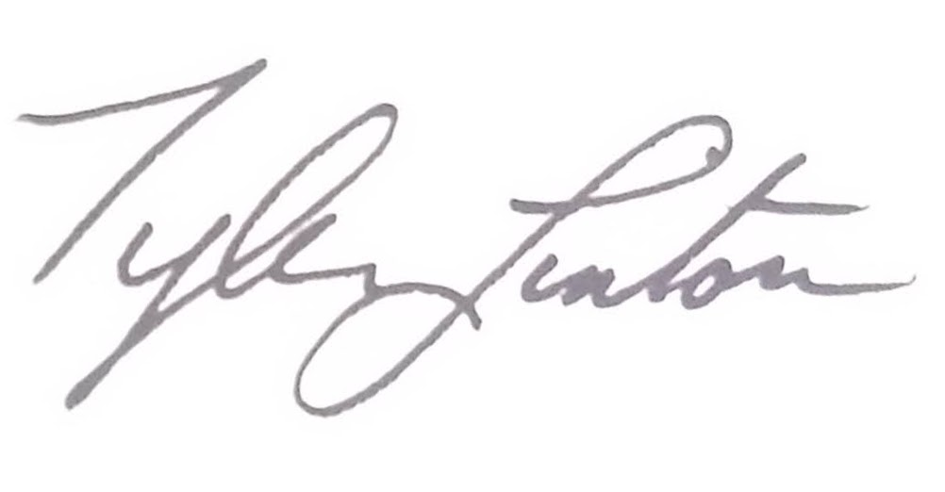

Dated 03/12/25

Tyler Linton - Assistant Director, Streetscene

cc Sarah Young - Cabinet Member for Climate Change, Environment and Transport

cc Geeta Subramaniam-mooney – Director of Environment and Climate Change - Climate, Homes and Economy

cc Maryann Allen – Group Engineer – Design & Engineering Group

APPENDIX: Scheme plans
