DELEGATED POWERS DECISION

STREETSCENE SERVICE

PUBLIC REALM DIVISION - CLIMATE, HOMES AND ECONOMY

SCHEME:

LUKE STREET
PROPOSED PUBLIC REALM IMPROVEMENTS

AGREE TO:

- Proceed with the statutory consultation and advertisement of the necessary permanent traffic management orders to:

- Remove 2 parking bays to allow for proposed Sheffield bicycle stands on Phipp Street (10 m south of Christina Street).

- Remove 3 parking bays on Luke Street to allow space for Sustainable Urban Drainage (SuDS), (between 74a and 78 Luke Street).

- Introduction of “Waiting and Loading restriction” on Luke Street from its junction with Ravey Street to its junction with Phipp Street.

- Subject to the outcome of the statutory consultation, to proceed with the improvements at the section of Luke Street west of its junction with Phipp Street for the creation of two Sustainable urban Drainage System (SuDS) planters, an informal crossing and additional cycle parking provision along Phipp Street as detailed on drawing DE-01-23_SP (Appendix I).

REASONS

The proposals will:

- Reduce car dominance and improve the public realm in Luke Street

- Reduce potential road accidents by reducing the carriageway width on Luke Street to help slow down the traffic and by introducing a new informal crossing at the junction with Phipp Street

- Improve the character of the area for residents and visitors, change the way the road feels, looks and is used by primarily planting more trees and resurfacing the carriageway to the extents of the scheme.

- Introduce a new layout with two build outs to install SuDS areas (rain gardens) with trees and low level planting to capture surface water.

- Implement carriageway and footway resurfacing within Luke Street

- Provide improved pedestrian facilities by introducing one uncontrolled crossings at the junction of Luke Street with Phipp Street

- Plant up to 5 new trees and install 8 new Sheffield stands with protective islands on either side on Phipp Street

- Create a safer, more pleasant environment for walking and cycling along the street and help improve air quality.

- BACKGROUND

  - These proposals form part of the long term vision for streets in Shoreditch and Hoxton which reflect our aspirations for this thriving and dynamic area of London. Hackney Council wants to create streets that are safe, easy to walk or cycle on, reduce vehicle dominance and help to improve air quality. The particular location, Luke Street and its junction with Phipp Street, has been also identified as an opportunity for a public realm project within the Draft Future Shoreditch Area Action Plan.

  - The Council’s Transport Strategy recognises that roads and streets in our neighbourhoods are not just places to park vehicles or drive, walk and cycle on; they make up the largest element of the public realm of the city and are the places where people socialise and live their lives. The Council would like to transform Hackney’s neighbourhoods into the most attractive and liveable neighbourhoods in London. This aspiration can only be achieved by reducing the dominance of the private vehicle primarily through managing on-street parking and reducing traffic flows.

  - The Council recognises the detrimental impact of air pollution in the City Fringe. Air pollution is responsible for the early death of approximately 10,000 Londoners each year and causes alarming rates of asthma and other respiratory illnesses in children. This has led to us creating a Low Emission Neighbourhood (LEN) in the City Fringe, made possible through funding partly from the Mayor’s Air Quality Fund. This scheme is part of a package of measures focussed on reducing emissions and promoting sustainable travel to improve local air quality.

  - The approach taken by the Council includes a series of schemes intended to improve walking and cycling conditions within Shoreditch and Hoxton. Works to improve the environment for pedestrians while enhancing public realm have recently been completed at Pitfield Street Triangle, Worship Square and Leonard Street while similar works to enhance the public realm and make it easier, safer and more pleasant to walk and cycle are currently being implemented at New Inn Broadway.

  - From 15 May 2023 to 11 June 2023 Hackney Council consulted on proposals for improving this section of Luke Street. The Council is committed to promoting and encouraging cycling and walking as they are sustainable, healthy and efficient ways to travel.

  - Due to the extensive work that the Council has undertaken to make cycling a major mode of transport, Hackney now has high levels of cycling amongst residents and visitors and has a long-standing reputation as a cycling borough.

  - In its Transport Strategy the Council has also committed to making Hackney’s roads safer for everyone living, working and visiting the Borough. These changes are aimed at creating an environment that will encourage more walking and cycling, reduce car dominance, traffic speed and, as an aspiration, help to improve air quality and reduce emissions within the local area. This can only be achieved by reducing the constant presence of the private vehicle. Poor air quality resulting from vehicle emissions is finally being recognised for the damage it inflicts upon the health of the people of London. Even more disturbing is the direct impact it is having on children’s health with evidence proving that it is directly responsible for asthma and other respiratory illnesses amongst children.

- EXISTING CONDITIONS

  - In the vicinity of Luke street both the Telephone House and Development House building sites are subject to redevelopment. Planning applications have been submitted to the Council’s planning service for the development schemes (see planning applications 2022/1165 and 2022/1680 respectively for further details). Streetscene is a statutory consultee for the applications and is working with the planning team to finalise comments and agreed mitigation measures. The applications will be reviewed at the Planning Sub-Committee meeting. In addition, 49 - 51 Paul Street to the south of Development House has been granted planning approval to provide a hotel (C1 Use Class) and ground floor cafe/restaurant (A3 Use Class; see planning application 2018/2104 for further details).

  - The proposed scheme is also located to the west of Leonard Circus, a public realm improvement project implemented in 2015 to a new shared flexible space with trees planted in the carriageway encouraging all users and most importantly motorised vehicles to be more cautious when driving through.

  - One serious collision was recorded over a five year period (May 2017 – April 2022) in the vicinity of the proposed scheme which is not considered to influence the proposals as it was located about 130m from the scheme. The collision occurred in September 2020 near Paul Street and involved a female cyclist. The conditions of the collision were recorded as unknown. The collision report and map can be found in Appendix VI.

- PROPOSALS

  - The proposals include:

- Reducing carriageway space to create a mini park space within this junction of quiet roads to aid local character and encourage pedestrian movements.

- Incorporating an informal crossing at the junction of Luke Street and Phipp Street to aid north-south pedestrian movements.

- Introducing two large sustainable urban drainage system (SuDS) rain gardens which will be complemented by tree planting. A SuDS mimics natural drainage and is designed to capture surface water to prevent overloading of the sewer system. A rain garden is a type of SuDS designed to capture rainfall before it enters the piped network and use the water to sustain planting and help to increase biodiversity. It can have a major impact on surface water runoff by preventing flooding, particularly in urban areas.

- Approximately 25 meters (equivalent to 4.5 parking spaces) of parking provision would need to be removed to allow for the implementation of the rain gardens and additional cycle parking provision.

- Eight new Sheffield cycle stands would be provided on Phipp Street just south of the junction with Christina Street to accommodate the increased demand for cycle parking in the area

- These proposals do not change vehicle or bike access to the area.

  - The scheme proposals are included as Appendix I of this document.

- POLICY CONTEXT

  - Hackney Council’s Transport Strategy 2015-2025

    - Hackney Council’s Transport Strategy sets out a coherent set of sustainable transport policies, proposals and actions that aim to further improve walking, cycling and public transport conditions and options for all residents, visitors and people who work in the borough.

    - The Strategy recognises that not only does transport have a critical role to play in Hackney’s continuing physical regeneration but is also a key factor in achieving other key borough priorities such as promoting transport equality and access to jobs, training and essential services, reducing obesity levels through incidental exercise, supporting the local economy, improving air quality and reducing carbon emissions. In all cases, the Strategy recognises that the borough must continue to challenge the potential impacts of greater levels of private car use through greater integration of transport and land use decisions and through providing sustainable alternatives to meet the aspirations of Hackney’s residents while improving social inclusion and combating climate change.

    - This vision supports the broad objectives of the borough for the environment, social inclusion, accessibility, connectivity, health, and supporting the local economy outlined in the Council’s Corporate Plan to 2018 ‘A Place for Everyone’ and other strategic policy documents including the Hackney’s Local Plan 2033 (adopted July 2020) and Health and Wellbeing Strategy.

    - In addition to securing the necessary public transport improvements to support growth in the borough, Hackney Council wants to encourage its residents to walk and cycle more often and more safely. There are a number of very strong economic, social and environmental reasons why the Council should seek to do this. Hackney’s population and employment are amongst the fastest growing in London, meaning that future travel patterns and the demand for travel will need to be carefully managed.

    - Creating a travel and transport system that is safe, affordable and sustainable and that fully supports residents and local businesses is a key reason for producing this scheme.

  - Mayor of London’s Transport Strategy

    - The central aim of the strategy – the Mayor’s vision – is to create a future London that is not only home to more people, but is a better place for all of those people to live in. It recognises that the success of London’s future transport system relies upon reducing Londoners’ dependency on cars in favour of increased walking, cycling and public transport use.

    - This simple aim of a shift away from the car will help address many of London’s health problems, by reducing inactivity and cleaning up the air.

    - It will help to: eliminate the blight of road danger; limit the city’s contribution to climate change; help to develop attractive local environments; and reconnect communities by creating places where people are prioritised over cars.

  - Mayor’s Vision Zero

    - The Mayor’s Vision Zero aims to make streets in London safer for all and it is an aspiration that the Council has committed to.

    - It recognises that minimising road danger is fundamental to the creation of streets where everyone feels safe walking, cycling and using public transport.

    - Under this vision, no-one will be killed in an incident involving a London bus, and that by 2041 deaths and serious injuries resulting from road traffic collisions in the city will have been totally eradicated.

    - The proposals outlined in this document will help contribute to achieving the above policies.

- STAKEHOLDER CONSULTATION

  - As part of the consultation process, stakeholder consultation was carried out. These include key stakeholders including Living Streets in Hackney (LSiH), London Cycling Campaign in Hackney (LCCiH), The London Fire Brigade (LFB), the London Ambulance Service, Hackney Parking Services, London Travel Watch, the Metropolitan Police Service and the Royal National Institute of Blind People (RNIB).

  - The consultation material was approved by the Streetscene Head of Service and shared with the Cabinet Member and ward members before it was distributed.

  - No objections to these proposals were received from any of the above-mentioned stakeholders. However, it is worth mentioning the following feedback which the scheme has taken into consideration.

- The emergency services wish to continue to have access to the street. It was made clear that the proposed plans have allowed for this.

- The Secured by Design team (Designing out crime) of the MET police department also provided specific comments in relation to planting, lighting, cycle stands and CCTV. The response can be found in Appendix II.

- Our internal Community Safety, Enforcement and Business Regulation Service also made a comment for CCTV operation in the area. Proposed trees should not obstruct the operation of the CCTV camera installed on Phipp Street (south east of the proposed SuDS). The design has been reviewed carefully and there is no obstruction of the CCTV.

- PUBLIC CONSULTATION

  - A total of 950 leaflets were distributed to residents and businesses around the Luke Street proposed scheme extents, as shown on the distribution map attached as Appendix III - which also includes the consultation document. The public consultation started on 15 May 2023 and ended on 11 June 2023. Both residents and local businesses have been consulted.

  - A copy of this public consultation was also uploaded to the Council’s website which gave an opportunity for others outside the consultation area to respond.

  - Residents were also able to submit their comments via the Council’s Citizen Space website.

  - Analysis of the public consultation

    - The consultation results are summarised and tabulated below. A total of 28 responses were received to this consultation, of which 21 supported the measures, 3 opposed and 4 said they neither support or oppose.

Freepost Replies - 16
On-line Replies – 12

Total Replies (Freepost and Online) - 28

Support | Oppose | Don’t know
75 (%)  [21] | 10.72 (%)  [3] | 14.28(%)  [4]

- Main comments raised from those who responded to the proposals

  - From all the comments that were received, the analysis presented in Appendix III provides a summary of the main comments and concerns that were found within the responses, alongside with the officers responses.

  - The officer comments to the respondents objecting to the scheme can also be found in Appendix V of this report. The main objections raised were a) proposed measures may not be the best solution, considering the potential negative impacts on safety, parking availability, and the character of the area. They also express concerns about maintaining the area's cleanliness and safety in the long term.

  - Safety Concerns: We acknowledge your concern about potential safety risks caused by road users turning into the path of oncoming vehicles in Phipp Street. The safety of all road users, including pedestrians and cyclists, is a top priority. As part of the proposal, detailed traffic studies and safety assessments were conducted to ensure that any changes made do not compromise road safety.

  - Parking Space Reduction: We understand that parking spaces in Luke Street are essential for residents and businesses alike. The proposed landscaping aims to enhance the environment and promote cycling, but we will also take into account the need for parking spaces.

  - Concerns about Maintenance: Proper maintenance of the landscaped areas is essential to ensure their longevity and prevent them from becoming dumping grounds. The Council will implement a maintenance plan for a period of 18 months that includes regular cleaning, waste management, and other necessary upkeep activities. After the 18 months maintenance period the landscaped area will be handed over to parks to maintain.

- IMPACTS

  - Permanent Impacts

    - Reduce carriageway width to 3.4 m (minimum width) to create a mini park space within this junction of quiet roads to aid local character and encourage pedestrian movements.
    - Install an informal crossing at the junction of Luke Street and Phipp Street to aid north-south pedestrian movements.
    - Introducing two large sustainable urban drainage system (SuDS) rain gardens which will be complemented by tree planting.
    - Remove approximately 25 meters (equivalent to 4.5 parking spaces) of parking provision would need to be removed to allow for the implementation of the rain gardens and additional cycle parking provision.
    - Implement eight new Sheffield cycle stands would be provided on Phipp Street just south of the junction with Christina Street to accommodate the increased demand for cycle parking in the area
    - As mentioned earlier in the report, these proposals do not change vehicle or bike access to the area.

  - Temporary Impacts

    - All works would be carried out under normal working hours of 08:30am to 4:30pm Monday to Friday and Saturdays from 8:30am to 1:00pm. No works would be carried out on Saturdays in line with local practices, unless considered necessary to minimise disruptions.

    - A road closure will not be required to undertake the works. Instead, one side of the carriageway will be fenced off, adequate measures for signing and guarding will be in place to ensure a safe route is provided for pedestrians during implementation.. A full closure of the street will be required towards the end of the scheme implementation to resurface the carriageway.

    - Implementation of the proposals is programmed to start December 2023 subject to statutory consultation.

  - Air Quality Impacts

    - Officers believe the proposals would help to encourage more people switching from private car use to walking or cycling. This can help to reduce emissions as well as reducing exposure (people are exposed to higher levels of air pollution when in their motor vehicles compared to being in the open air).

    - Overall officers believe the proposals would have a neutral impact on emissions of nitrogen dioxide emitted by traffic using the associated stretch of Luke Street.

    - Officers aim to focus our air quality monitoring on those areas where exposure to poor air quality is likely to occur. This area in Shoreditch suffers from poor air quality and this scheme is trying to improve it. The closest monitor (diffusion tube) is located at Leonard Street and Great Eastern Street. The table below shows NO2 concentrations at these sites over the last few years.

Site no. | Site name | Site type | 2019 | 2020 | 2021 | 2022
6 | 44 Great Eastern Street | Roadside | 50 | 37 | 38 | 33
117 | Leonard Street | Roadside | 42 | 28 | 28 | 28

  - Leonard Street is located on the eastern arm of the Leonard Street/Paul St junction. These concentrations are likely to be most representative of the Luke Street scheme although traffic is likely to be even lower around Luke Street, as a result of other traffic management in the area. The 44 Gt Eastern Street site is located just off Great Eastern Street, which is much busier.

  - The data from the above table shows a decrease in pollutants in 2022, compared to previous years, which is below the Air Quality Objective of 40μg/m3.

    - Hackney Council’s Air Quality Action Plan 2021-2025 sets out actions to improve air quality in the borough: https://drive.google.com/file/d/1g2gQvKM71Fto95rw0rdYo8sPtJAM1kjo/view . London Borough of Hackney Air Quality Annual Status Report for 2021 published in May 2022 can be found here: https://drive.google.com/file/d/1fZziVZ9UwY3XvxXVAGhb8L0KYZV8SGhY/view

    - Hackney Council is currently consulting on a new Air Quality Action Plan (AQAP) for 2020-25. A draft plan has been produced as part of the Council’s duty under London Local Air Quality Management (LLAQM) and has regard to the Greater London Authority’s (GLA) guidance on air quality. The draft plan outlines the actions we would take to improve air quality in Hackney between 2020 - 2025.

Air Quality Reports
https://hackney.gov.uk/air-quality-reports

Air Quality Action Plan Matrix
https://drive.google.com/file/d/11u2i0y5CBapLnFWggJdqI2Knw5omNKJ2/view

- Equalities Impact Assessment

  - Introduction

    - In developing these proposals, consideration has been given to the impact in terms of equalities. While the planting of trees can have some benefits, the positive impacts from individual trees on local air quality are fairly minimal. We are positioning them mainly along the southern side of the carriageway to allow enough space for pedestrians to walk and as a segregation feature between disabled users that wish to use the footway instead of the carriageway.

    - The Council’s overall objectives are set out in the Equality Impact Assessment (EqIA) for the Hackney Local Implementation Plan 3 and Transport Strategy, which stress the Council's desire to see all schemes developed to provide a high quality environment for all residents. This scheme prioritises walking, cycling and improves road safety and pollution, suggesting that the overall equalities impact would be generally positive. While those cycling and walking would be the primary beneficiaries, the schemes would have positive impacts for all vulnerable users of the borough’s road network from a road safety perspective .

  - Disability

    - Hackney has lower than average rates of residents who identify as having a disability. In November 2017, 4.1% of the local population (11,234 people) were claiming Disability Living Allowance or Attendance Allowance. The main modes of transport used by disabled Londoners at least once a week are walking (78%), bus (55%), car as a passenger (44%) and car as a driver (24%). Therefore, the number of mobility impaired residents potentially affected by these proposals is low. It should also be pointed out that the scheme would improve pedestrian facilities. The scheme does not remove any disabled parking bays. Blue badge holders are eligible to park in all shared use bays (pay and display and permit) and pay and display only bays for an unlimited amount of time and on single and double yellow lines for a maximum of 3 hours, provided there are no loading restrictions in place and that the vehicle is not causing an obstruction. Blue badge holders may also use any disabled bay. Companion badge holders can park in the same bays as Blue Badge holders, but have the added advantage of being able to park in resident and permit parking bays within their home parking zone.

    - No shared surfaces are proposed as part of this scheme. A kerb face of at least 100mm will be kept between carriageway and existing footway to ensure that there is a level of segregation between the SuDS/footway and carriageway. The SuDS will act as an additional safety measure; proposed trees will be located within the planters but will ensure that they do not obstruct natural surveillance or CCTV operation on site. Tactile paving will be used at the proposed pedestrian crossing point to aid safe navigation for visually impaired users.

  - Pregnancy / maternity

    - The positive benefits of reducing the dominance of motor vehicles would benefit the most vulnerable road users, including parents and children who disproportionately suffer the harmful effects of air pollution. Prams and pushchairs put children at the level of exhaust fumes when navigating the streets. Air pollution has been linked to low birth weight and underdeveloped lung capacity in children, as well as higher incidences of lung conditions such as asthma. Tree planting is important for achieving the aims of reducing air pollution, which would have a marginal positive impact on mothers and children.

  - Age

    - This scheme positively impacts children as it is designed to create a safer and less polluted environment with the introduction of road narrowing to slow the traffic, dropped kerbs for crossings and tree planting to help clean the air. Children are among the most vulnerable groups in terms of road danger and pollution, and this scheme helps to address that vulnerability.

    - Older adults are also vulnerable to road danger and air pollution and benefit from reduced traffic dominance and the introduction of greenery and trees. However, older adults are more likely to travel by car or taxi as mobility declines with age. Older adults who live within the vicinity of the area will continue to be able to access their homes in the same way as they currently do.

  - Religion and belief

    - Consideration has been given to the impact of these proposals in terms of religion or belief. Reducing the dominance of motor vehicles benefits all groups equally, regardless of religion. The proposals in this report do not discriminate against any religious group, as they apply equally to all groups.

  - Gender, gender reassignment, sexual orientation, and marriage and civil partnership

    - It is considered that this protected characteristic group would not be impacted by this scheme.

  - Race and ethnicity

    - The 2011 Census estimates that 40% of Hackney’s population are black and minority ethnic groups, with the largest group (around 20%) being black or black British. TfL data for Greater London, reported in TfLs ‘Travel in London: Understanding our diverse communities 2019’ summary of research, shows that walking is the most commonly used type of transport by Black, Asian or Ethnic Minorities (BAME) Londonders (96% of BAME Londoners walk at least once a week, compared to 95% of white Londoners), followed by bus (65% BAME compared to 56% white). The data also indicates that both Mixed or Multiple Ethnic groups, and Other Ethnic Groups, are much more likely to walk (48% and 45%, respectively), whilst mixed and multiple ethnic groups are more likely to cycle (7%), and Asian or Asian British are more likely to drive (6%).

- FINANCIAL IMPLICATIONS

  - The ‘Luke Street proposed public realm improvements’ will be funded by S106 funding. There is an allocation of £100,000 for implementing this scheme. Maintenance costs will continue to be through the Council’s maintenance programme.

- LEGAL IMPLICATIONS

  - The Council's powers to implement the measures proposed in this report are set out in the Highways Act 1980 (HA80) and Road Traffic Regulation Act 1984 (RTRA) and will require the making of new Traffic Management Orders (TMO).

  - Statutory consultation as part of the TMO process is required to permanently change orders that affect the function of a road or any waiting and loading restrictions. In this case, parking removals and new double yellow lines will apply as part of this scheme.

  - In making such Orders, the Council must follow the statutory consultation procedures set out in the Local Authorities Traffic Orders (Procedure) (England and Wales) Regulations 1996. The said Regulations, prescribe inter alia, specific publication, consultation and notification requirements that must be strictly observed. It is incumbent on the Council to take account of any representations made during the consultation stage and any material objections received to the making of the Order, must be reported back to the decision maker before the Order is made. Any subsequent objections received during the consultation period would need to be resolved prior to scheme implementation.

- AUTHORITY TO MAKE DECISIONS

  - The scheme of delegation for Neighbourhoods and Housing, delegation for making permanent orders under s.6 of the Road Traffic Regulation Act (RTRA 1984) falls under: NH256 - Making “permanent” orders for prescribed routes, waiting and loading restrictions, bus stop and school clearways, disabled persons’ parking places, doctors’ parking places, free parking places, loading bays, bus and cycle lanes, pedestrian zones, weight, height and length restrictions, delegated to Director, Public Realm and Head of Streetscene.
  - The Head of Streetscene would use his delegated powers to take forward the schemes.

- RECOMMENDATIONS

  - 75% of people who responded to this consultation supported the proposals and 14.28% of the respondents did not support the proposals while 10.72% had a neutral response. These results include all the online and paper responses to the end of the consultation period on 11 June 2023. The public realm improvements proposed at this location would provide a number of benefits as described in section 8.0 and the officer’s responses in section 7.

  - It is recommended that the Assistant Director for Streetscene use his delegated powers to agree that the Council proceeds with the proposals for public realm improvements along this section of Leonard Street as detailed in this report.

- APPROVAL

- I have noted the contents of this summary and agree with the recommendations contained therein.

Signed: 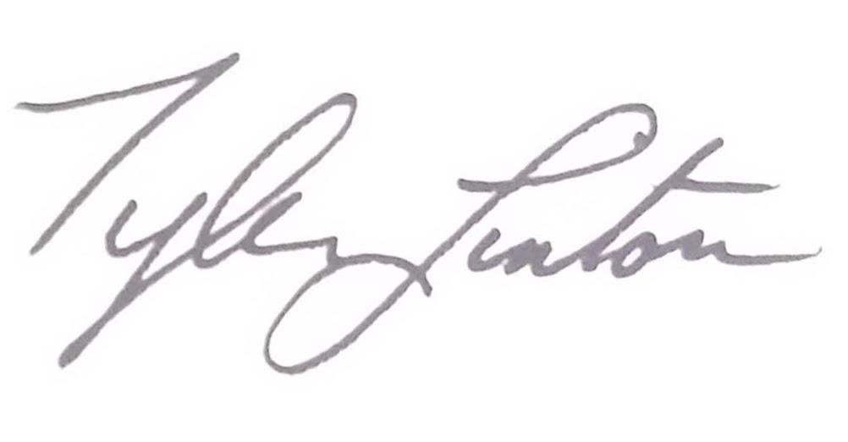

Dated: 10/11/2023

Tyler Linton - Assistant Director for Streetscene

cc Cllr Mete Coban - Cabinet Member for Environment and Transport

cc Maryann Allen – Group Engineer – Design & Engineering Group

APPENDICES

Appendix I: Scheme Drawing DE-01-23_SP

Appendix II: Summary of the Consultation Analysis

Appendix III: Consultation map

Appendix IIII: Copy of Public Consultation Document

Appendix V:Public Consultation response

Appendix VI: Report and map extract of recorded collisions between May 2017 - April 2022

Appendix I: Scheme Drawing DE-01-23_SP

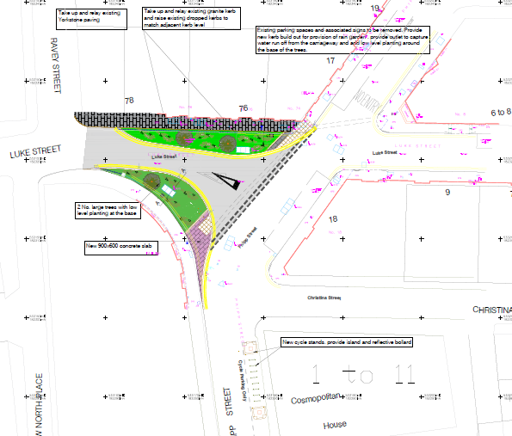

Appendix II

Stakeholder’s comments

London Ambulance Service:

Ambulance services are concerned if the Luke Street area will continue to have vehicle access for emergency vehicles. The changes aim to introduce green verges and Sustainable Drainage Systems (SuDS).

Response: This is not a closure, and all emergency vehicles will still be able to access the area. The necessary swept path analysis has been conducted to ensure that emergency vehicles can pass through without any issues.

Metropolitan Police:

Planting: On initial review we are concerned regarding the image provided with the engagement material. Whilst it is appreciated that this is a computer generated image it does indicate sightlines along Luke Street are being severely compromised?

Low level planting should be no higher than 1m to ensure sightlines are maintained. We always encourage clear lines of sight in order to prevent any situation where someone can hide behind items of street furniture or plantings with the intention of committing crime. Any planting, lighting and CCTV should all be done in tandem to prevent one key element adversely affecting the other.

Response: Proper tree maintenance will be in place to ensure that low-level planting is limited to a maximum height of 1 metre.

Lighting:
The proposed area of public realm improvement already incorporates a public highway therefore this should be to the latest lighting standard of BS5489. This will provide uniformity across the area with no dark spaces. Regular maintenance and servicing should be in place to ensure this area is appropriately lit at all times.

Response: Regular maintenance and servicing will be implemented to guarantee that the public realm remains well-lit at all times.

Cycle Stands
Eight cycle stands are proposed for Phipp Street. Stands should be placed in areas that offer good natural surveillance from nearby residential addresses, local business and next to busy footpaths. If possible, formal surveillance should also be considered such as CCTV, or consideration should be made to position stands within a current CCTV covered area. Users should be provided with the option of have three points of locking for cycles and the proposed stands, such as Sheffield Stands,
should be fixed to the floor with anti-tamper fixings. Additionally consideration needs to be made with regards to whether these stands may provide impromptu sitting areas and if so who this might impact.

Response: Sheffield cycle stands will be fixed to the ground for stability and security.

The installation of CCTV covering the developed area would assist in providing a level of formal surveillance. If this is not an immediate requirement, possibly due to cost, consideration should be made to pre-installing commando sockets within suitable lampposts at the locations for quick fitting of temporary/permanent CCTV at a later date should the location become a hotspot area for crime.

Response: Budget considerations may impact the implementation of certain measures. We will explore alternative options and work within the available resources to optimize the proposed improvements.

Internal Consultation:

Concerning trees and planting in the area, it is important to ensure that the planting is kept low so that tree canopies do not obscure CCTV cameras. The goal is to maintain adequate natural surveillance during Night-Time Economy (NTE) hours. Excessive planting or tree growth could obstruct the camera's coverage, potentially affecting the personal safety of pedestrians walking through the area.

Response: A proposed tree within the CCTV coverage area has been removed to ensure that there is no obstruction of the CCTV.

Appendix III

Consultation Map

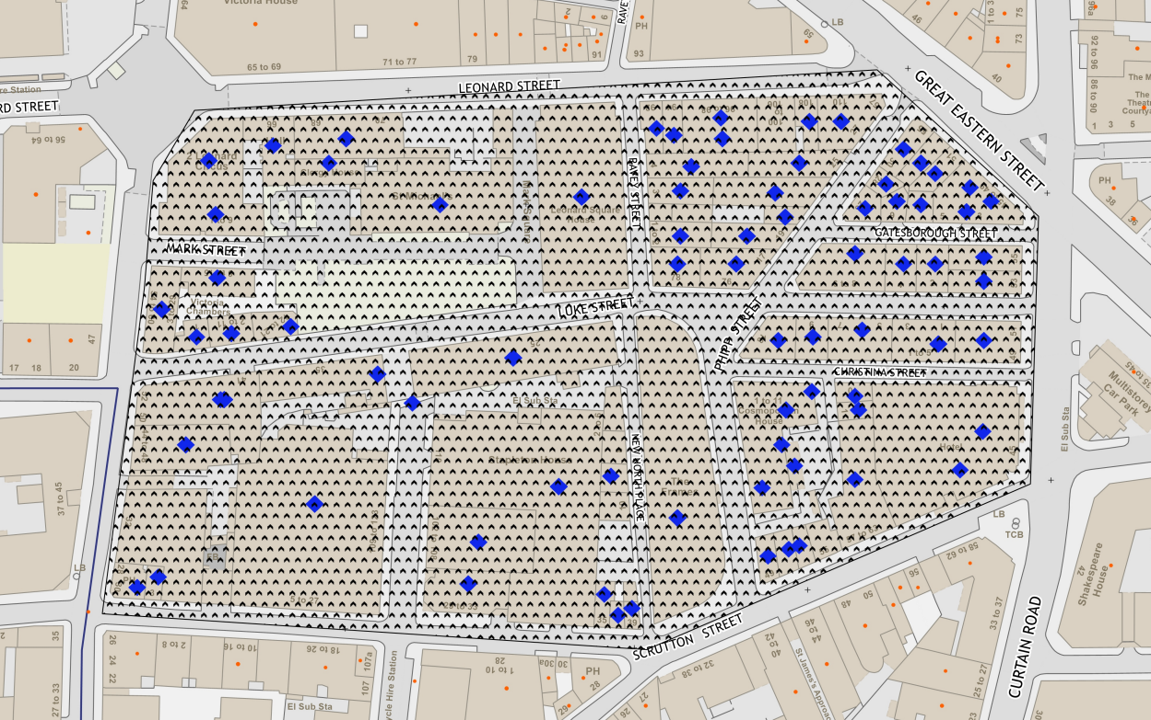

Appendix IIII

Consultation document

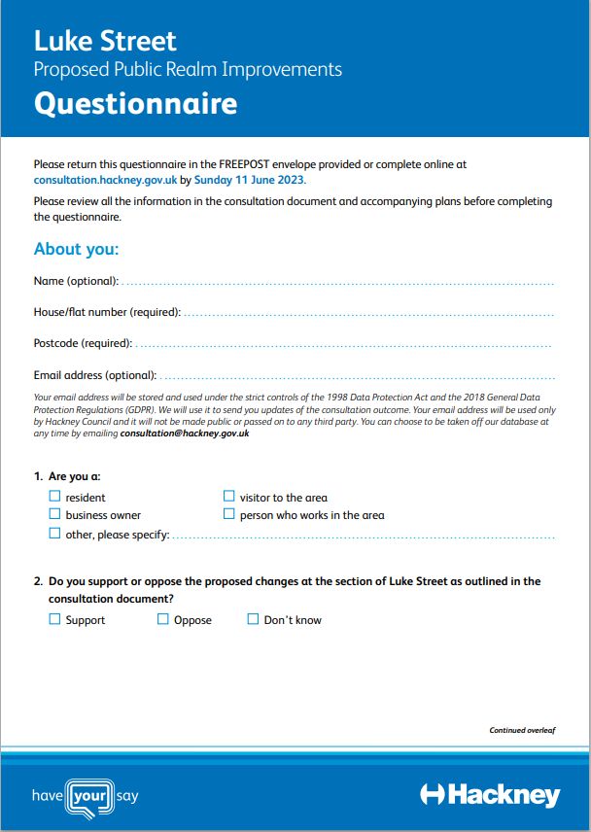
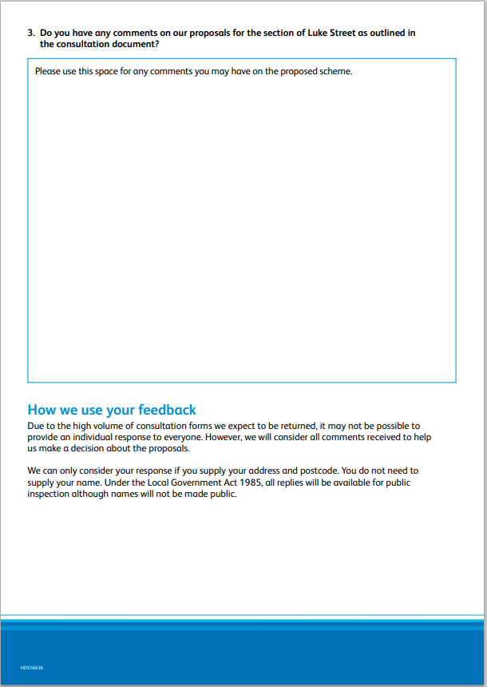
Appendix V

Public consultation responses:

Negative or Neutral Consultation Comment | Officer’s response
“Safety Concerns: Respondentworries that the proposed landscaping in Luke Street will cause road users to turn directly into the path of oncoming vehicles in Phipp Street, potentially endangering drivers and pedestrians.  Parking Space Reduction: Removing parking spaces in Luke Street, while converting some parking bays in Phipp Street to cycle parking, is seen as excessive. The opponent argues that this will negatively impact businesses, as there are already limited parking options in the area.  Viability of "Liveable" Shoreditch: The opponent questions the validity of making Shoreditch a "liveable" area, stating that it primarily serves commercial and entertainment purposes. They believe the area's significant number of luxury flats are often unoccupied or used for short-term rentals like AirBnBs.  Negative Effects of Nighttime Economy: While Hackney's attempts to boost the nighttime economy have been successful, the opponent argues that it leads to problems such as public urination, littering, and security barriers.  Concerns about Maintenance: The opponent questions how the proposed area will be maintained and expresses worries about it becoming a dumping ground, citing a previous instance when Christina Street became a haven for drug addicts during construction.  The roads around Leonard Street and Luke Street are in a shocking condition, and are strewn with rubbish and beer bottles. Rather than waste money on this pointless tinkering, resurface existing roads, fix the broken pavements and increase street cleaning and fines for littering. Most of the detritus comes from licensed premises and businesses in the area - try some enforcement. This were suburbanisation of what is and industrial area is inappropriate and serves no purpose. Maintaining the public realm would be much better idea, though a lot less glamorous than grans schemes like this. It would improve the environment though.  1. Concerns post proposed improvements can you please consider a caveat?  Whilst this area Phipp and Christina Street appear mostly commercial it is actually a high residential area. What we don't want is to encourage so-called Street Food stalls as this would have a direct issue with our homes; we do not want to be subjected to fumes from charcoal, diesel, food et al. There is already a plethoria of eateries and indeed street food in the area.  2. Concerns regarding Informal crossing pedestrian/cyclist area - Pedestrians should take priority.  Cycling is encouraged however, we are concerned at the speed many cyclists already come through the area without consideration, for instance Mark's Square is supposed be a shared space yet pedestrians especially disabled/partially sighted/blind people it can be hazzard. We already have seen and experienced aggressive cycling and delivery drivers whom especially through no fault of their own are on strict deadlines in order to earn a living. The delivery companies should be more responsible but this will not be a solution, therefore, can the area be made safe for both pedestrians and cyclists to enjoy? Is it possible to somehow slow the cyclist down? A sign is futile and we need something physical that will naturally cause a safe slow down.  3. Extra Cycling Stands  We agree that extra cycling stands to be provided and unsure if this is removing ALL the ‘pay for parking’ in Christina Street which we would hope for as this already has an impact on our home life.  We were about to contact our local councillors due to the current 'pay for parking and residents parking' times which unfortunately is attracting anti social behaviour. Patrons park in Luke Street and Christina Street, drinking, taking drugs and sometimes fighting, urinating before they go to presumably a club nearby they then return 2/3pm and wake up the whole neighbourhood blasting music with their car windows open. A solution would be to extended to midnight as the other side of Great Eastern Street in the Hoxton area as it currently is. Please consider | Safety Concerns: As part of the proposal, detailed traffic studies and Road Safety Audits have been conducted to ensure that any changes made do not compromise road safety.  We understand that parking spaces in Luke Street are essential for residents and businesses alike. The proposed landscaping aims to enhance the environment and promote cycling, but we will also take into account the need for parking spaces.  Shoreditch is known for its vibrant commercial and entertainment scenes, it is also home to a growing number of residents. Our goal is to create a better community that caters to the needs of all individuals, whether they are working, visiting, or residing in the area.  We are committed to working with local businesses and residents to address issues related to public order, cleanliness, and safety. The improvement works will not result in any negative effects, such as the problems associated with the nighttime economy.  The Council will implement an 18- months maintenance plan that includes regular cleaning, waste management, and other necessary upkeep activities, thereafter will be transferred to park department to maintain  Existing highway conditions will be inspected separately and should there be a need for highway improvement it will fall within our Highways Maintenance team responsibilities, the group manager of highway will be informed of these comments and will take necessary actions  The Environmental enforcement team will review the littering issues and liaise with licensed premises to promote responsible waste management and discourage littering.  There is no proposal for a market place and shared area for cyclists/pedestrians and hence potential hazards will be minimised.  The speed limit for Phipp Street and Luke Street is 20 mph,  The Environmental enforcement team will review the littering issues and liaise with licensed premises to promote responsible waste management and discourage littering.

Appendix VI

Accident Data

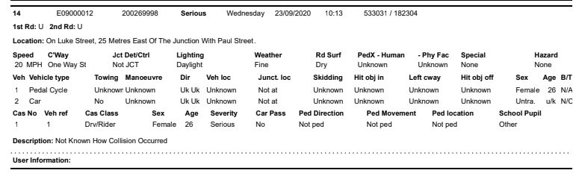

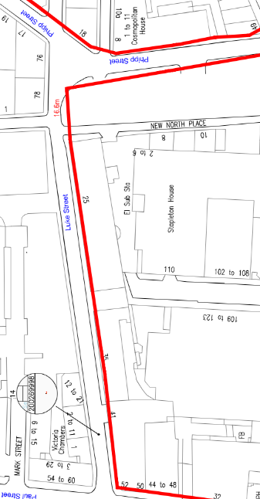

https://hackney.gov.uk/future-shoreditch

